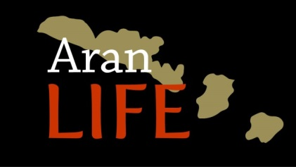

7.2.8b Update to Machair Report

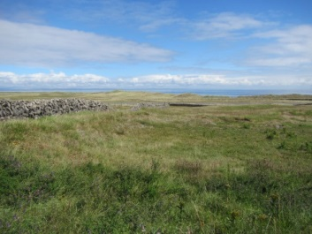

December 2018

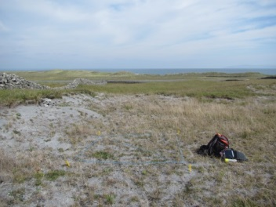 | September 2014
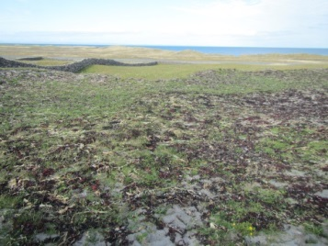 | April 2015
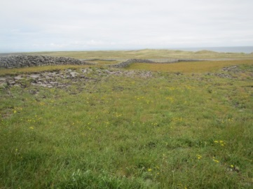 | June 2015
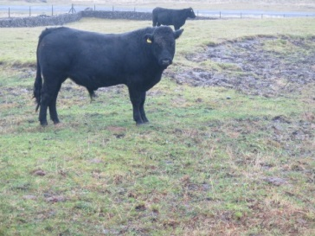 | November 2015
 | August 2018

Table of Contents

Background 3
Introduction 3
Location of treatment plots 5
Methodology 5
Results and Discussion 7
Machair vegetation 7
Seaweed plots 11
Conclusions 25
References 26
Appendix 1. National Monitoring Methods for assessing *21A0 Machairs 28
Appendix 2. Machair relevés and targets for conservation assessment 30

Background
Machair is a qualifying Interest of both Inis Mór and Inis Meáin SACs. An ‘unfavourable-inadequate’ conservation status was given to the machair habitat at Eararna (Trá Mór, Inis Mór) by the Coastal monitoring Project (CMP) (Ryle et al., 2009), owing to overgrazing, impact of rabbits and dominance of mosses and lichens. On Inis Méain the CMP noted that species diversity was low and moss cover was very high throughout the machair. These issues have to be addressed by the AranLIFE project in order to bring 29ha of machair habitat to favourable conservation status.

The AranLIFE project trialled the application of seaweed to machair sites to address issues such as over-dominance of bryophytes and reduction in species-diversity. The sandy soil lands that occur on particular parts of the islands such as the machair are free-draining and so have little capacity to retain nutrients for grass growth. The application of seaweed is necessary, both to supply some plant nutrients and improve organic matter of soil, and at the same time improving the water retaining capacity.

While bryophytes are an important component of machair vegetation, over-dominance of Rhytidiadelphus squarrosus in particular may have been the result of long term nutrient loss from the habitat. Moss over-dominance is having a deleterious impact on both the forage available to cattle as well as the species diversity of the habitat. This issue prevails at all the proposed trial sites. The application of seaweed on these habitats was part of the traditional farming system on the islands, according to the farmers who own these lands.
These issues have been discussed with NPWS as part of the AranLIFE project, and the trials are directly connected to improving understanding as to how to best manage the site.

Introduction
In Phase 1 of the seaweed trials, eight seaweed plots were set up in March/April 2015 when seaweed was applied to 20x10m plots. AranLIFE Machair Report (AranLIFE 2016) documents the results of phase 1 of the seaweed trials.
This update report documents the seaweed plots set up since 2016 and shows some impacts of one or two or three years of consecutive applications of seaweed as well as the impacts on different machair habitat of varying quality and condition.

The 8 plots vary in their habitat quality and structure.

From the initial machair report the following conclusions were made:

- Machair vegetation is highly variable owing to the dynamic nature of the habitat and this is shown in the variation between machair habitat between Inis Mór and Inis Meáin.

- The cover of bryophytes appears to be reduced in most of the seaweed treated plots. In particular Rhytidiadelphus squarrosus and Scleropodium purum are more abundant in the untreated areas.
- There is an apparent increase in sedge and grass cover in seaweed treated areas in 50% of the plots
- There is an apparent decrease in % broadleaf cover in seaweed treated areas in 60% of the plots
- Vertigo angustior is absent from the seaweed trial plot sites (Browne 2016).

- The dry matter yield is greater in 50% of the seaweed plots than in the corresponding untreated areas

- The machair soils have a high pH, and are very low in Phosphorous. Low potash is also a feature of these soils as are high magnesium levels.

- The application of seaweed increases the water holding capacity of the soil and the organic content of the soil, which facilitates the development of vegetation cover in previously bare areas.

This update to the report focuses on how the machair vegetation both within seaweed plots and control plots meets the national monitoring targets for favourable conservation status (Delaney et al. 2013).

Location of treatment plots
Machair sites on Inis Mór (Trá Mór) and Inis Méain have been selected for this action. The initial phase 1 trials consisted of 8 plots as documented in the machair report (2016). Subsequent phases consist of a further 6 plots. Phase 2 (2016) included 3 new plots at Kilmurvey, Inis Mór as well as new plots at Inis Meáin and Phase 3 (2017) included 1 new plot on Inis Meáin. Phase 2 also included reapplication of seaweed on most Phase 1 plots.

Table 1. Seaweed plots on Inis Mór and Inis Meáin. Phase 1 (2015), Phase 2 (2016), Phase 3 (2017)
Phase | Island | Townland | Ownership | No. of 20x10m² seaweed plots
1 | Inis Mór | Trá Mór | Commonage (unwalled) | 3 plots
1 | Inis Meáin | Ceann Gainimh | Private (walled) | 5 plots
2 | Inis Mór | Kilmurvey | Private (walled) | 3 plots
2 | Inis Meáin | Ceann Gainimh | Private (walled) | 3 plots
3 | Inis Meáin | Ceann Gainimh | Private (walled) | 1 plot

Plot locations were chosen for the most part in areas that were damaged or degraded or where forage from machair was considerably reduced. In many cases the areas where seaweed was spread was in a degraded state from the surrounding machair vegetation, as a result the control relevés were sited in machair that was in better condition than the vegetation in the seaweed plots.

Methodology

The first phase of seaweed application began in March/April 2015. As these machair sites are known lapwing nesting sites care was taken to avoid areas and times where and when lapwings were active. Each seaweed plot is approximately 20mx10m. Seaweed collected form the strandline was applied to plots by hand ensuring even coverage throughout.

The selection of plots for seaweed application was primarily based on the farmers input as to where the forage available for cattle was particularly low. Areas were also selected that showed obvious signs of damage through erosion where bare sand predominates.
Seaweed was applied by hand ensuring even coverage throughout the plot, however, it is not possible to ensure similar coverage between different plots as seaweed was spread by different landowners.

Permanent monitoring quadrats (4m²) were set up within the 20mx10m plots by the AranLIFE team as well in adjacent untreated areas. These quadrats were surveyed for their floristic composition and monitored annually over the duration of the project and any changes in vegetation noted.

Monitoring followed national monitoring methodologies (Ryle et al. 2009; Delaney et al. 2013) (Appendix 1). A relevé size of 4m² is used for machair grassland monitoring.

Relevés were recorded in July and August 2015, 2016 and 2017 to analyse the impact of the seaweed applications on the grassland vegetation.
The percentage cover of all plant species within the relevé is estimated and a cover-abundance number from the Domin cover-abundance scale is assigned to each species identified (Table 2).
Table 2. The Domin cover/abundance scale
% cover/abundance | Domin scale
A single individual. No measurable cover | +
1 to 2 individuals. No measurable cover. Individuals with normal vigour | 1
Several individuals but less than 1% cover | 2
1-4% cover | 3
5-10% cover | 4
11-25% cover | 5
26-33% cover | 6
34-50% cover | 7
51-75% cover | 8
76-90% cover | 9
91-100% cover | 10

The following additional information is also recorded in each relevé: % cover of bare rock, % bare soil, % litter, % grass/sedge layer, % broadleaf layer, % bryophyte layer, median grass and herb height.

A series of fixed point photos are taken of each relevé and a close up photo of the relevé vegetation is taken.
These relevés are analysed as monitoring stops according to the criteria for assessing conservation status (Ryle et al. 2009; Delaney et al. 2013) (Appendix 1).

Four criteria and targets were used to assess vegetation at a relevé level (Table 3).

Table 3. Criteria and targets used to assess vegetation at relevé level.
Criteria | Targets
Positive Indicator Species | At least 3 species in every stop
Negative Indicator Species | Combined cover less than 5%
% cover of bryophytes | At least 1% in every stop
Sward height | At least 8cm in July and August

Results and Discussion

Machair vegetation
A total of 141 relevés were recorded in Machair vegetation over the 5 years of the Aran LIFE project (Appendix 2) and 67% (118 relevés) received an overall fail (Fig. 1), while 16% (23relevés) passed all four targets for favourable conservation assessment (Fig. 2). Sward height (Fig. 3), % negative species cover (Fig. 4) and insufficient positive indicator species (Fig. 5), were the targets which caused most relevés to fail the assessment process (Fig. 1.). This mirrors the national assessment in which sward height was the criterion which caused most sites to fail the assessment; this is followed by negative indicator species (Delaney et al. 2013).

Fig. 1. Criteria targets for favourable conservation status that received a ‘fail’ in the 118 relevés that received an overall fail.
The criterion for positive indicator species also received a high level of ‘fails’ within the AranLIFE data (28%) (Fig. 1).

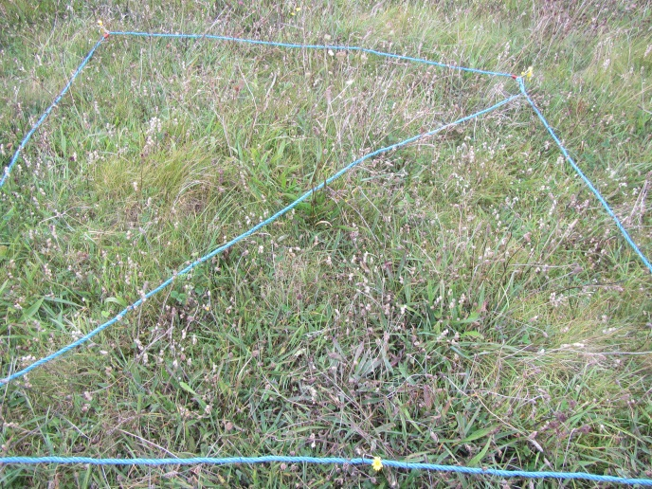 | 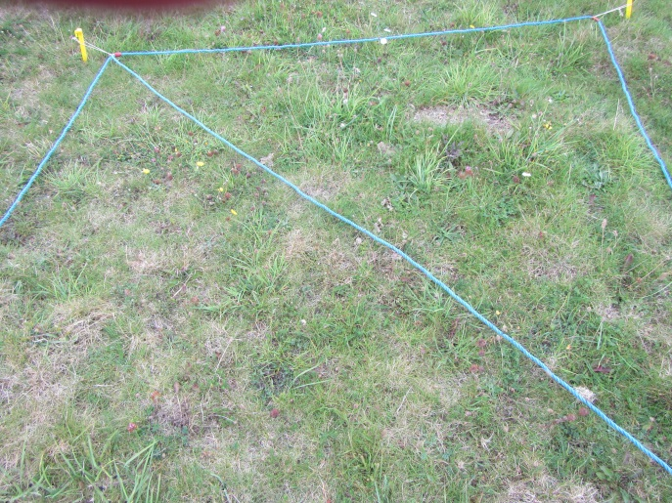
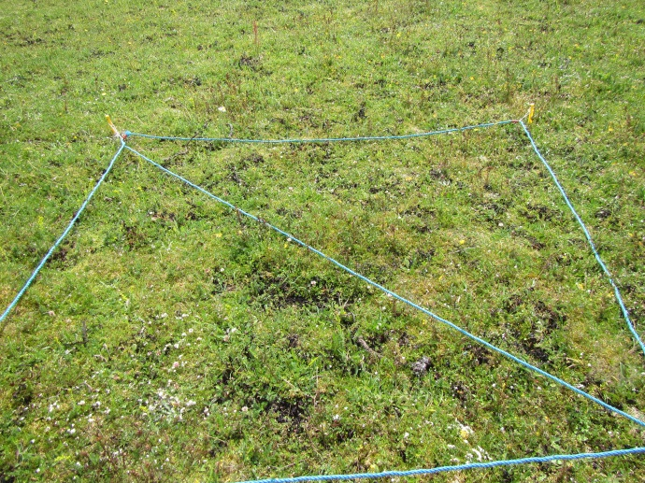 | 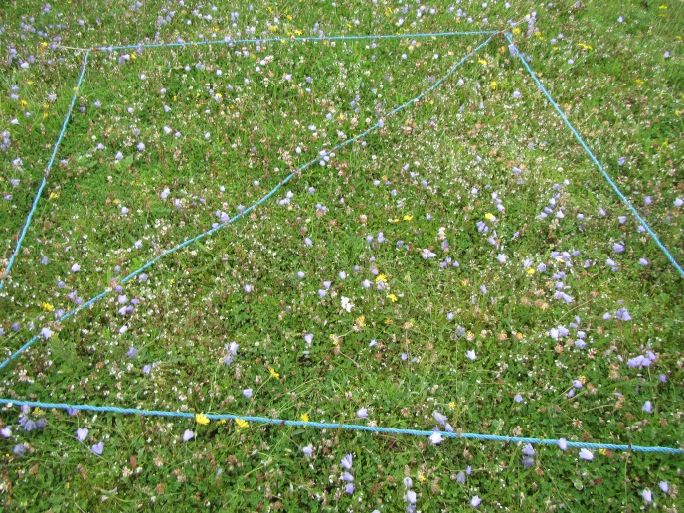
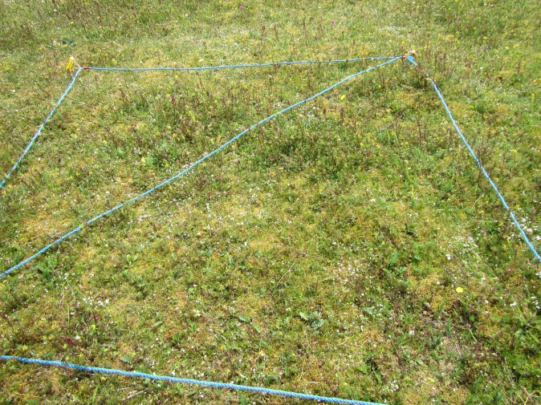 | 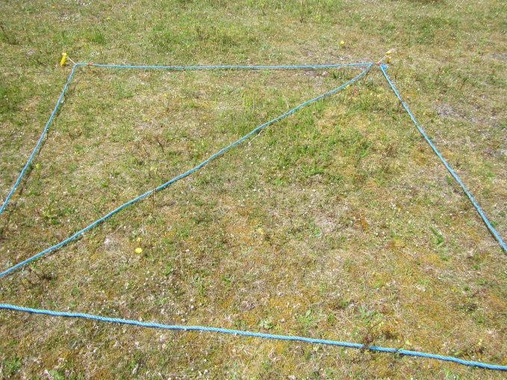
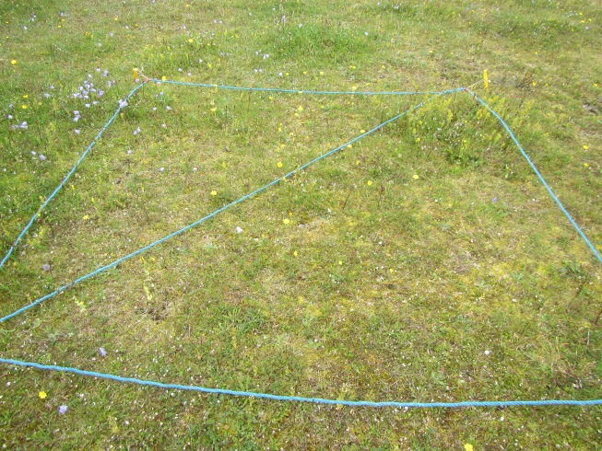 | 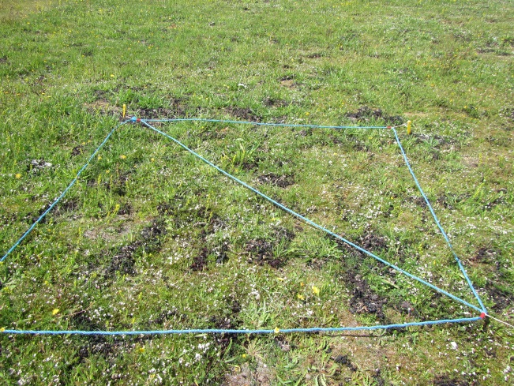
Fig. 2. Examples of relevés that passed all 4 targets for favourable conservation status.
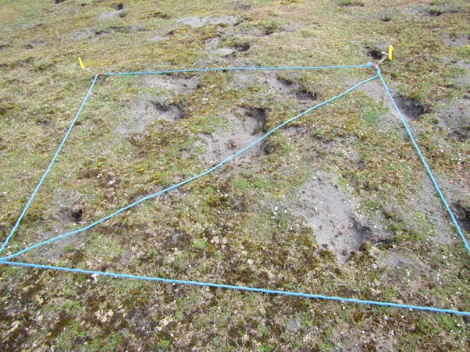 | 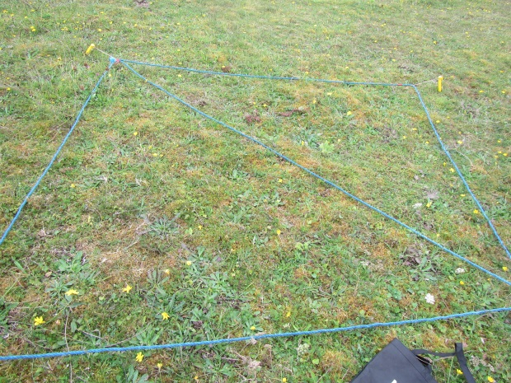
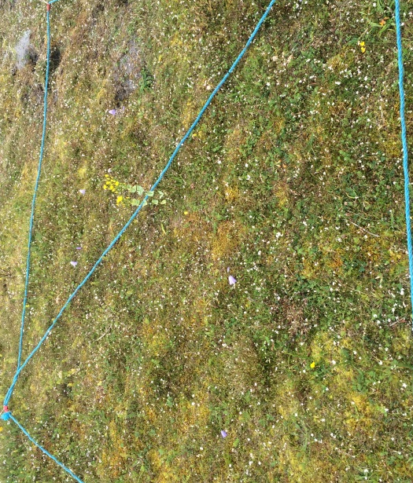 | 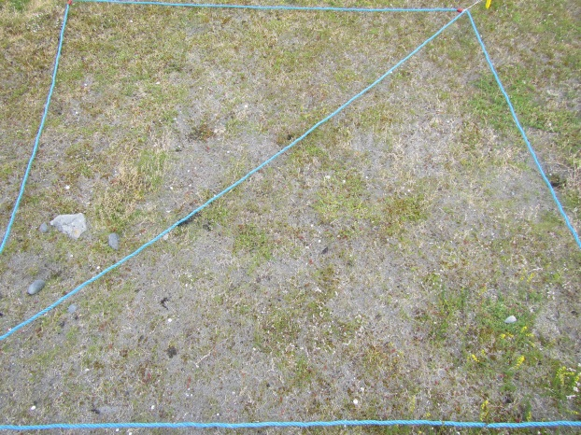
Fig.3. Examples of relevés that failed only because the sward height was less than 8cm
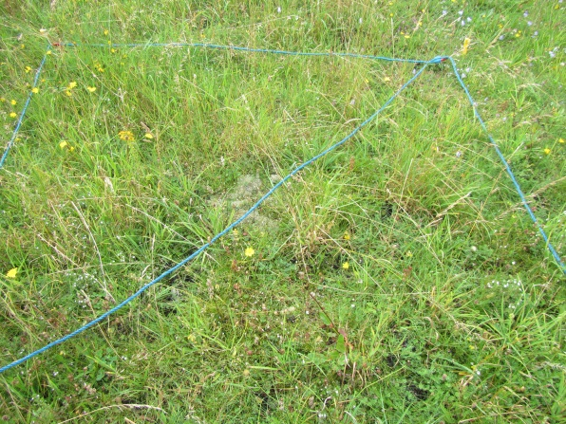 | 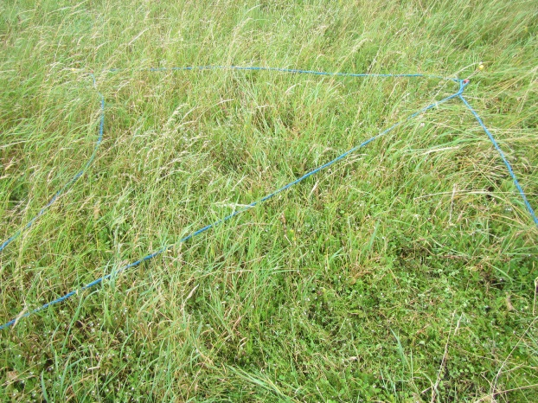
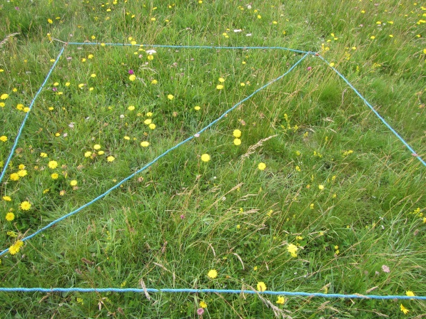 | 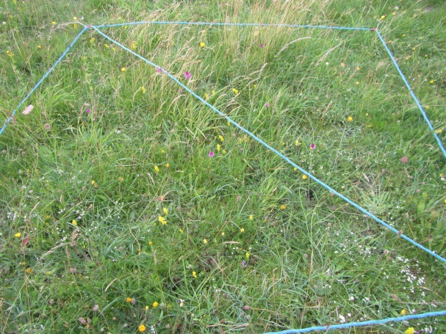
Fig. 4. Examples of relevés that failed only because of too high cover of negative indicator species

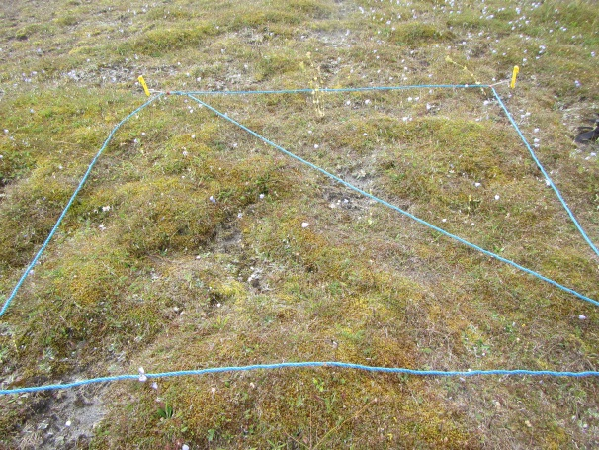 | 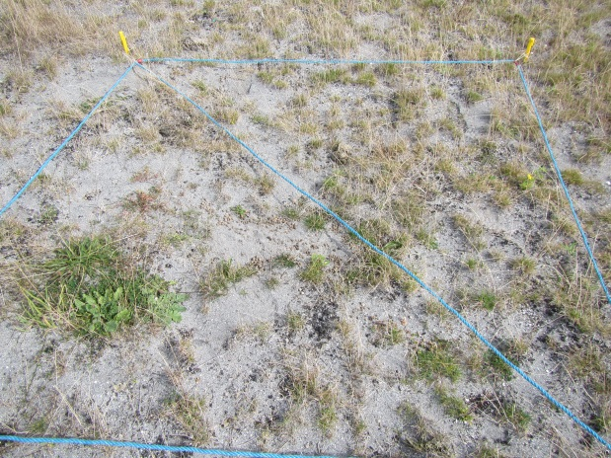
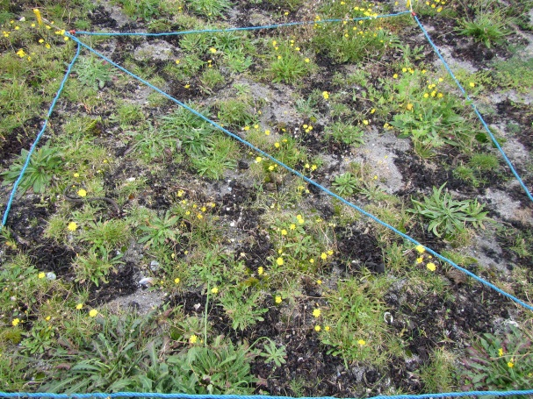 | 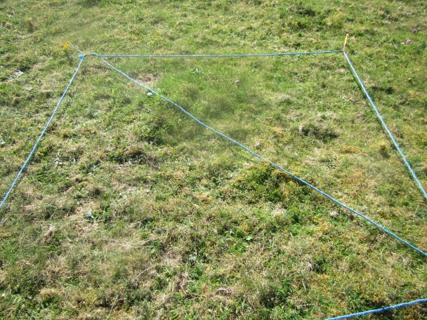
Fig. 5. Examples of relevés that failed only because of insufficient positive indicator species

Seaweed plots
Plot 1 | Trá Mór, Inis Mór | Moss-rich , short sward, heavily grazed by rabbits, small patches of eroded machair adjacent to plot.(August 2015). This plot received three annual applications of seaweed
2015  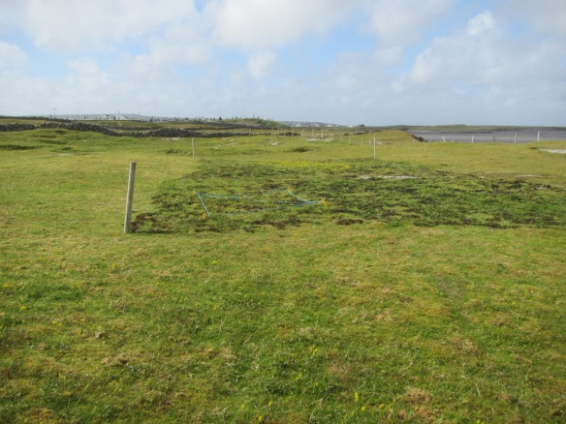 |  |  | 2017  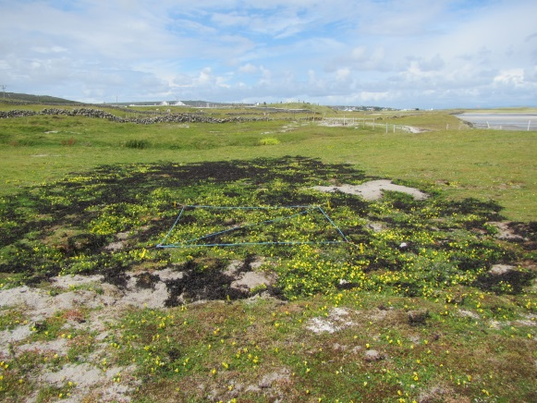

 |  | Seaweed |  |  |  | Control
 |  | 2015 | 2016 | 2017 |  | 2015 | 2016 | 2017
R41IMR | Pos sp. | Pass | Pass | Pass | R43IMR | Pass | Pass | Pass
 | % bryos | Pass | Pass | Pass |  | Pass | Pass | Pass
 | Neg sp. | Pass | Pass | Pass |  | Pass | Pass | Pass
 | Sward ht | Fail | Fail | Fail |  | Fail | Fail | Fail
R42IMR | Pos sp. | Pass | Pass | Pass | R44IMR | Pass | Fail | Pass
 | % bryos | Pass | Pass | Fail |  | Pass | Pass | Pass
 | Neg sp. | Pass | Pass | Pass |  | Pass | Pass | Pass
 | Sward ht | Fail | Fail | Fail |  | Fail | Fail | Fail

Conclusions
Despite being sited in heavily rabbit grazed machair vegetation with an over dominance of the bryophyte Rhytidiadelphus squarrosus, the vegetation passes targets for positive indicator species, percentage cover of bryophytes and percentage cover of negative indicator species for the most part, however, all relevés fail the sward height target. Seaweed has little impact on sward quality owing to the impact of grazing rabbits.

Plot 2 | Trá Mór, Inis Mór |  | Moss-rich , short sward, Over grazing by rabbits not as evident here as elsewhere at this site. One application of seaweed applied to this plot.
2015  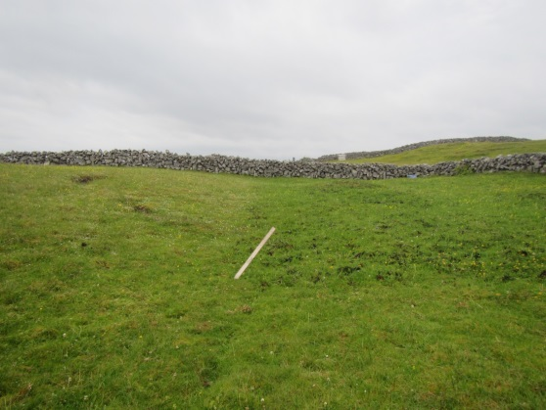 |  | 2016  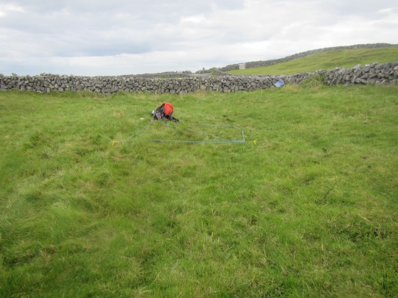

 |  | Seaweed |  |  | Control
 |  | 2015 | 2016 |  | 2015 | 2016
R34MR | Pos sp. | Pass | Fail | R33IMR | Pass | Pass
 | % bryos | Pass | Pass |  | Pass | Pass
 | Neg sp. | Fail | Pass |  | Pass | Pass
 | Sward ht | Pass | Pass |  | Pass | Pass
R35IMR | Pos sp. | Fail | Pass | R36IMR | Pass | Pass
 | % bryos | Pass | Pass |  | Pass | Pass
 | Neg sp. | Pass | Pass |  | Pass | Pass
 | Sward ht | Pass | Pass |  | Pass | Pass

Conclusion
Sward growth in this part of the machair is not as degraded as elsewhere at this site. So seaweed application did not have as positive impact as it does on eroded and degraded sites as long as overgrazing is not occurring.

Plot 3 | Trá Mór, Inis Mór | Very eroded part of the machair, Erosion caused by a combination of sand removal, disturbance and wind. Rabbits also active in this area (July 2015). Two years of seaweed applications was applied to this plot.
2015  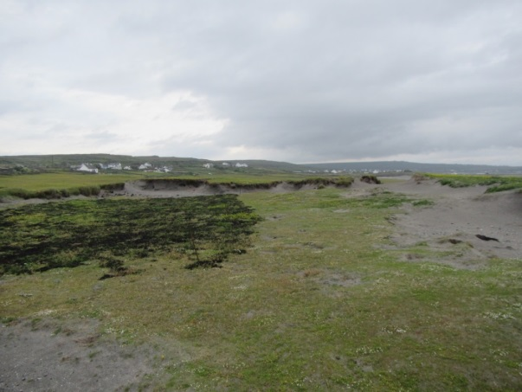 |  |  | 2016  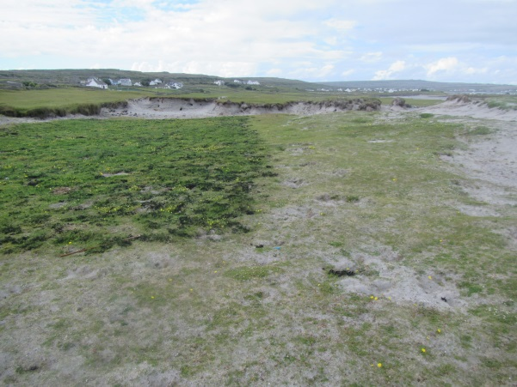

 |  | Seaweed |  |  | Control
 |  | 2015 | 2016 |  | 2015 | 2016
R37MR | Pos sp. | Pass | Pass | R38IMR | Pass | Pass
 | % bryos | Pass | Fail |  | Pass | Pass
 | Neg sp. | Pass | Pass |  | Pass | Pass
 | Sward ht | Fail | Fail |  | Fail | Fail
R40IMR | Pos sp. | Pass | Fail | R39IMR | Pass | Pass
 | % bryos | Fail | Fail |  | Pass | Fail
 | Neg sp. | Pass | Pass |  | Pass | Pass
 | Sward ht | Fail | Fail |  | Fail | Fail

Conclusion
Despite obvious visual improvement in vegetation cover, the quality of the vegetation does not meet the targets for favourable conservation status. The impact of grazing rabbits is likely to be having a deleterious effect.

Plot 4 | Inis Meáin | Thick sward of vegetation, rich in grasses and mosses (May 2015). One application of seaweed applied.
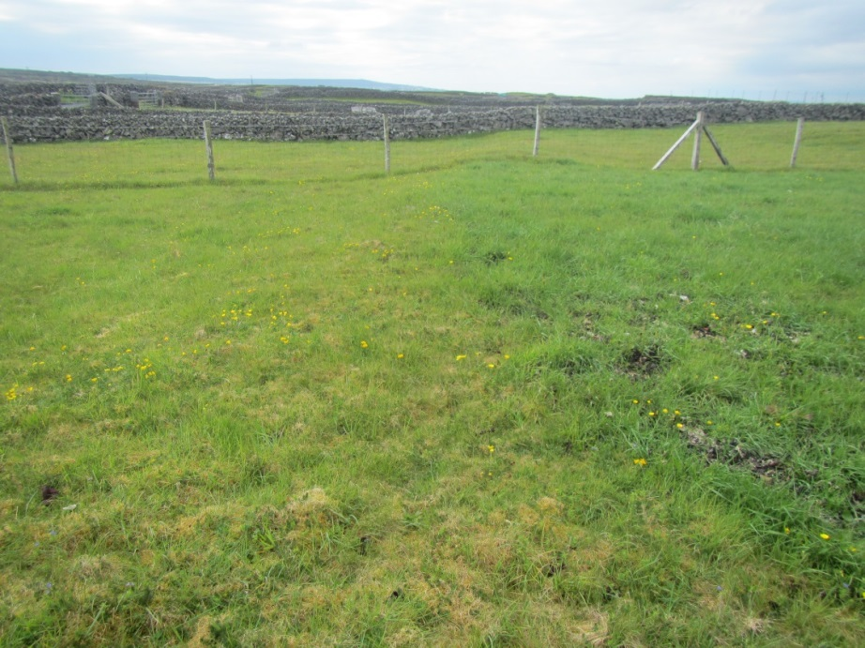

 |  | Seaweed |  | Control
 |  | 2015 |  | 2015
R91IMN | Pos sp. | Pass | R90IMN | Pass
 | % bryos | Pass |  | Pass
 | Neg sp. | Fail |  | Fail
 | Sward ht | Pass |  | Pass

Conclusion
Both the control relevé and the relevé in the seaweed plot fail the target for negative indicator species. The high percentage cover of Arrhenatherum elatius is responsible for the failure of this target.

Plot 5 | Inis Meáin | Short sward of vegetation, rich in mosses. Bare unvegetated patches present (May 2015). Seaweed applied two years in a row.
2015  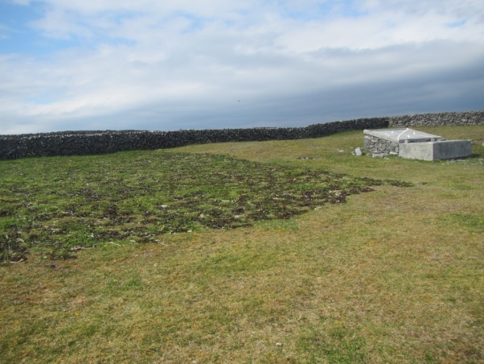 |  |  | 2016  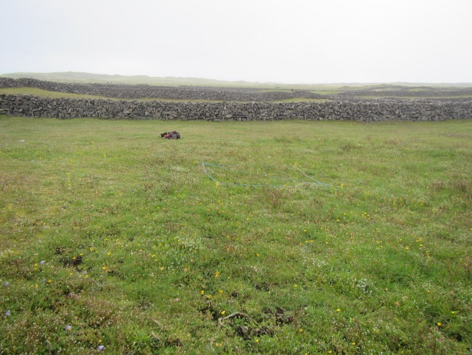

 |  | Seaweed |  |  | Control
R33/67 IMN |  | 2015 | 2016 | R32/68 IMN | 2015 | 2016
 | Pos sp. | Pass | Pass |  | Pass | Pass
 | % bryos | Pass | Pass |  | Pass | Pass
 | Neg sp. | Pass | Pass |  | Pass | Pass
 | Sward ht | Pass | Pass |  | Pass | Fail
R66IMN | Pos sp. |  | Pass | R69IMN |  | Pass
 | % bryos |  | Pass |  |  | Pass
 | Neg sp. |  | Pass |  |  | Pass
 | Sward ht |  | Pass |  |  | Fail

Conclusion
Vegetation outside the seaweed plot fails because of insufficient sward height. The application of seaweed assists vegetation growth without impacting on species composition.

Plot 6 | Inis Meáin | Low grass cover and sward height and high moss cover. One and Two years of seaweed treatment. In 2016 plot area was extended
2015  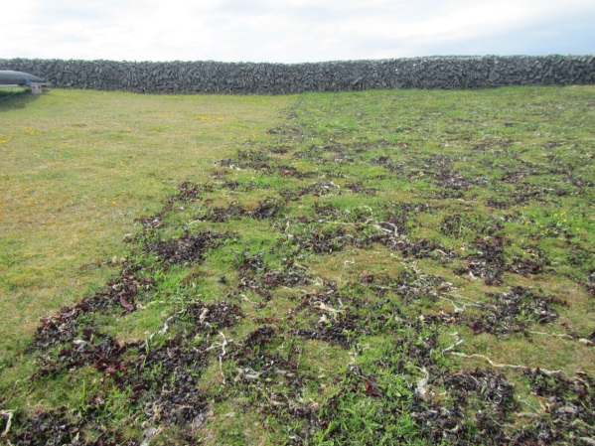 |  |  | 2016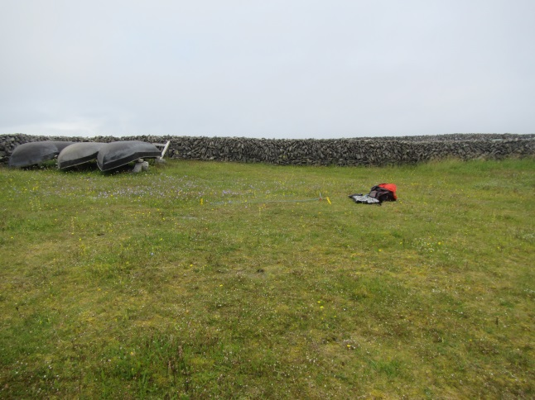

1YR OF seaweed | Seaweed |  |  | Control
 | R28IMN | R29IMN |  | R30IMN | R31IMN
 | 2015 | 2015 |  | 2015 | 2015
Pos sp. | Pass | Pass |  | Pass | Fail
% bryos | Pass | Pass |  | Pass | Pass
Neg sp. | Fail | Pass |  | Pass | Fail
Sward ht | Pass | Pass |  | Pass | Pass

 | 1yr of seaweed |  | 2yrs of seaweed |  | Control
 | R72IMN | R73IMN | R70IMN | R71IMN | R74IMN | R75IMN
Pos sp. | Pass | Fail | Fail | Pass | Fail | Pass
% bryos | Pass | Pass | Pass | Pass | Pass | Pass
Neg sp. | Pass | Fail | Fail | Pass | Fail | Fail
Sward ht | Pass | Pass | Pass | Pass | Pass | Pass

Conclusions
Most of the releves (both control and seaweed plot) fail the negative species target, owing to the presence of Arrhenatherum elatius. The sward height target is attained in all relevés indicating that the sward may not have been as impoverished at this site as in other sites and therefore not as in need of nutrient input as more degraded sites. This series of fields is cultivated for potatoes and vegetables and rye in rotation so would have received some nutrient input intermittingly in the past. The seaweed applications do not seem to have had an impact on the presence of positive indicator species as both control and seaweed plot relevés pass and fail this target.

Plot 7 | Inis Meáin | Very impoverished and degraded machair site. Area disturbed in the past with low sward cover. This area received 3 years of seaweed applications in 2015, 2016 and 2017.
2015  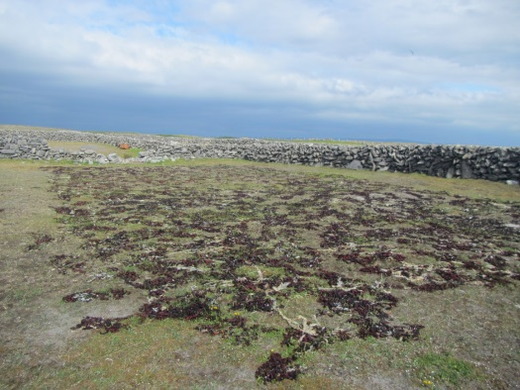 |  |  | 2016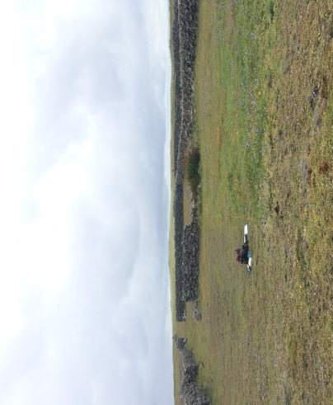 | 2017  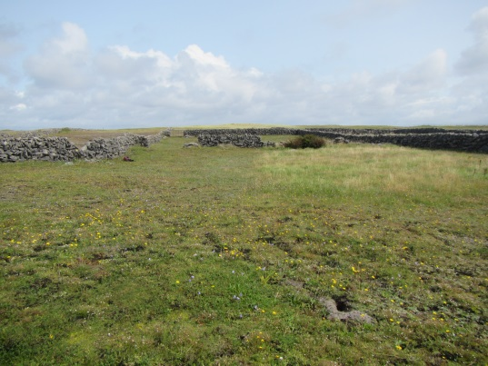

 | 1 yr seaweed | Control
 | R35IMN | R34IMN
Pos sp. | Fail | Fail
% bryos | Fail | Pass
Neg sp. | Pass | Pass
Sward ht | Pass | Fail

 | 2yrs seaweed |  |  | Control
 | R60IMN | R61IMN |  | R62IMN | R63IMN
Pos sp. | Pass | Pass |  | Fail | Pass
% bryos | Fail | Fail |  | Pass | Pass
Neg sp. | Pass | Pass |  | PAss | Pass
Sward ht | Fail | Pass |  | Fail | Pass

 | 3yrs seaweed | Control
 | R61IMNR | R62IMNR
Pos sp. | Pass | Pass
% bryos | Pass | Pass
Neg sp. | Pass | Pass
Sward ht | Pass | Pass

Conclusions
The absence of positive indicator species and too low a sward height are the main targets that are failed in this plot. After 3 consecutive years of seaweed applications, on this very impoverished and degraded site, all targets for assessing favourable conservation status have been passed. The seaweed applications adds both organic matter to the soil as well as improving the water retention capacity of the substrate.

Plot 8 | Inis Meáin | Disturbed area of machair owing to sand removal. Seaweed plot covers entire disturbed area. Vegetation cover is low in 2015. Seaweed applied in 3 consecutive years 2015, 2016 and 2017.
2014 (before seaweed)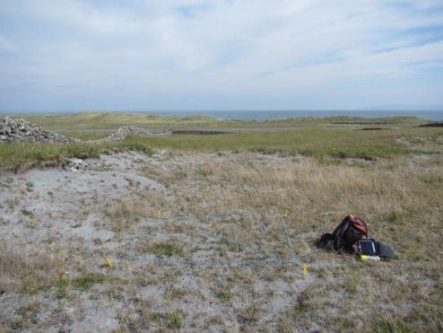 |  |  | 2016  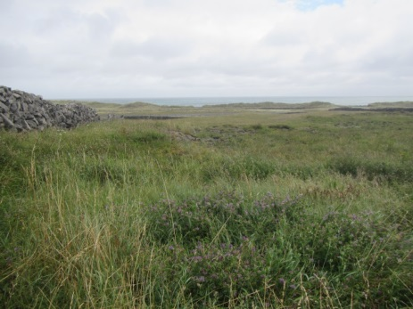 | 2018  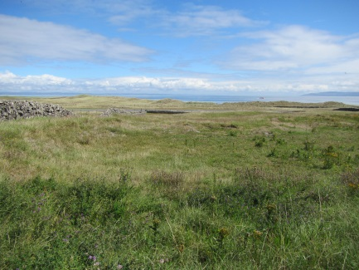

 | before seaweed | Control
2014 | R14IMN | R59IMN
Pos sp. | Fail | Pass
% bryos | Pass | Pass
Neg sp. | Pass | Pass
Sward ht | Pass | Pass

 | 2015 | 2016 | 2017
 | Seaweed | Seaweed | Seaweed
 | R54IMN | R86IMN | R14IMNRRR
Pos sp. | Fail | Fail | Fail
% bryos | Pass | Pass | Pass
Neg sp. | Pass | Pass | Fail
Sward ht | Pass | Pass | Pass

Conclusions
For this trial plot, the control relevé was recorded from undamaged machair. Before the seaweed application the obviously damaged and degraded machair passes all targets except for the positive indicator species target. On damaged machair the application of seaweed adds organic matter to the sandy substrate and improves the water retention capacity which enables vegetation to colonise the bare ground. After the three years of seaweed application the vegetation cover has visibly improved, however, the cover of Arrhenatherum elatius has increased which causes the plot to fail the negative indicator species target.

Plot 9 | Inis Mór | Disturbed area of machair owing to sand removal. Vegetation cover is low in 2015. Seaweed applied in 1 year (2016)
2015 (before seaweed)  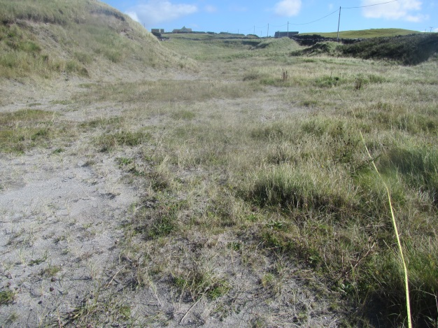 |  |  | 2016  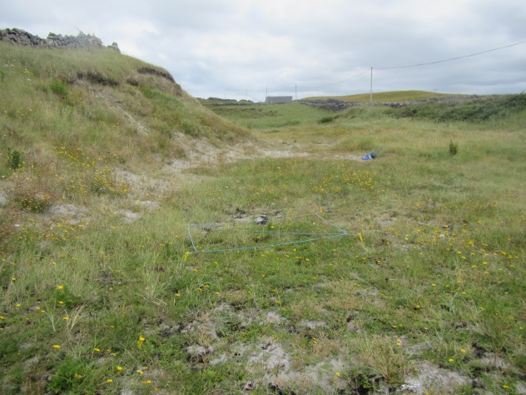

 | 2015 | 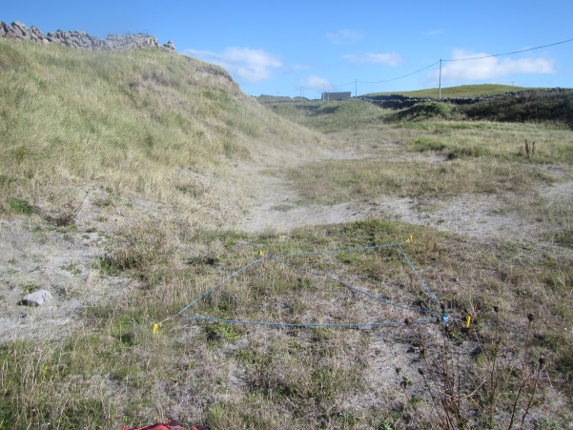
 | Before Seaweed
 | R56IMR
Pos sp. | Pass
% bryos | Fail
Neg sp. | Pass
Sward ht | Pass

 | 2016 | 2016 | 2016 | 2016
 | Seaweed | Seaweed | Control | Control
 | R57IMR | R58IMR | R59IMR | R60IMR
Pos sp. | Pass | Pass | Fail | Fail
% bryos | Fail | Fail | Fail | Fail
Neg sp. | Pass | Pass | Pass | Pass
Sward ht | Pass | Pass | Pass | Pass

Conclusions
The relevé recorded before seaweed applications passed all targets except for the percentage cover of bryophytes, despite being obviously degraded and poor quality. Applications of seaweed helped increase vegetation cover by adding organic matter and increasing the water retention capacity of the substrate. Positive indicator species also increased in diversity following seaweed applications.

Plot 10 | Inis Mór | Area of machair with decreased forage potential owing to the high cover of Rhytidiadelphus squarrosus. Vegetation cover is low in 2015. Seaweed applied in 1 year (2016)
2015 (before seaweed & after grazing)  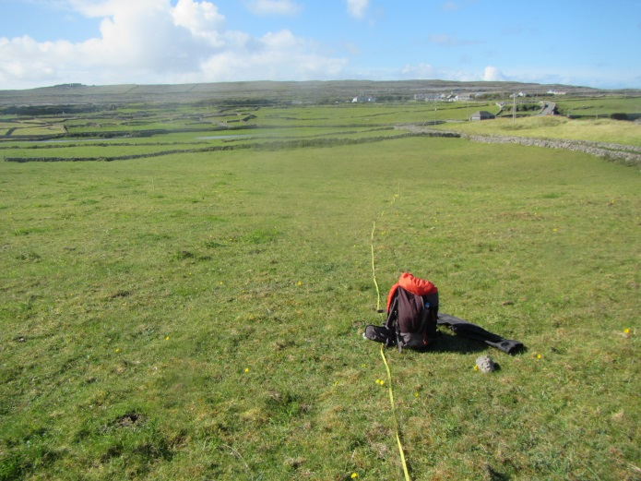 |  |  | 2016  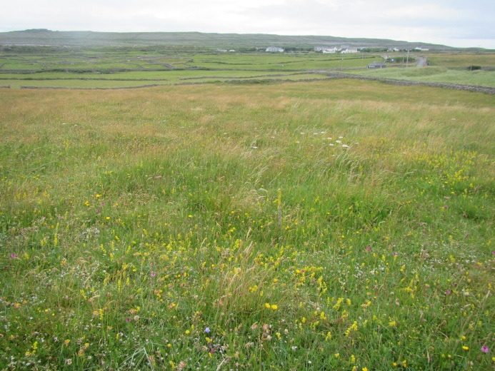

 | 2015
 | Before Seaweed (after grazing)
 | R54IMR
Pos sp. | Fail
% bryos | Pass
Neg sp. | Pass
Sward ht | Pass

 | 2016 | 2016 | 2016 | 2016
 | Seaweed | Seaweed | Control | Control
 | R61IMR | R62IMR | R63IMR | R64IMR
Pos sp. | Pass | Pass | Fail | Pass
% bryos | Pass | Pass | Pass | Pass
Neg sp. | Fail | Fail | Pass | Pass
Sward ht | Pass | Pass | Pass | Pass

Conclusions
Seaweed application increases the cover of Arrhenatherum elatius which causes the relevés to fail the negative indicator species target. Positive indicator species abundance in the seaweed plot has increased. Over abundance of Rhytididadelphus squarrosus was cited as an issue by the landowner at this site as it was a consequence of the reduction in available forage at this site. Over dominance of mosses is not recognised as a target threshold in the national monitoring criteria, but impact of moss cover may be picked up by reduction in positive indicator species and a fail for this target before seaweed application.
Plot 11 | Inis Mór | Area of machair with decreased forage potential owing to the high cover of Rhytidiadelphus squarrosus. Vegetation cover is low in 2015. Seaweed applied in 1 year (2016)
2015 (before seaweed & after grazing)  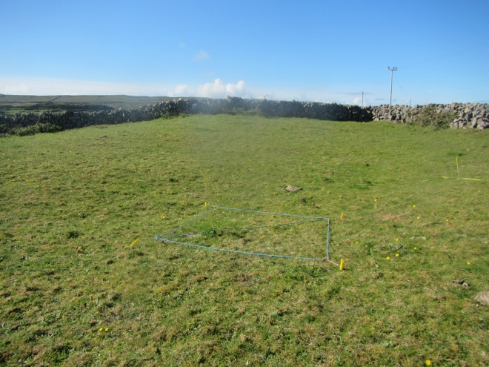 |  |  | 2016  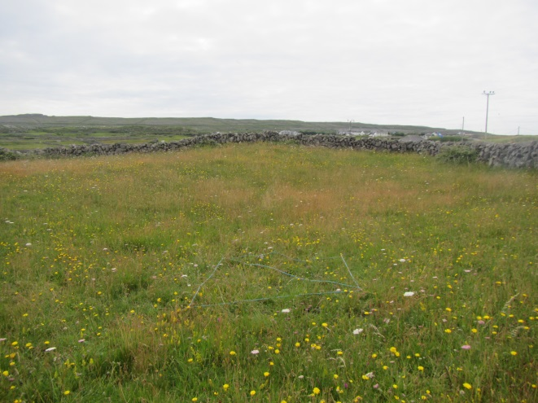

 | 2015
 | Before Seaweed (after grazing)
 | R55IMR
Pos sp. | Fail
% bryos | Pass
Neg sp. | Pass
Sward ht | Pass

 | 2016 | 2016 | 2016 | 2016
 | Seaweed | Seaweed | Control | Control
 | R66IMR | R67IMR | R65IMR | R68IMR
Pos sp. | Pass | Pass | Pass | Pass
% bryos | Pass | Pass | Pass | Pass
Neg sp. | Fail | Fail | Pass | Fail
Sward ht | Pass | Pass | Pass | Pass

Conclusions
The overdominance of Rhytididadelphus squarrosus may be seen in the before seaweed application by the fail for the positive indicator target. The application of seaweed seems to promote growth of Arrhenatherum elatius, and hence a fail in the negative indicator species target. The increase in Arrhenatherum elatius has not effected the positive indicator species diversity, however, as this target is passed.

Plot 12 | Inis Meáin | Area of machair with decreased forage potential and poor vegetation growth. Seaweed applied in 1 year (2016)
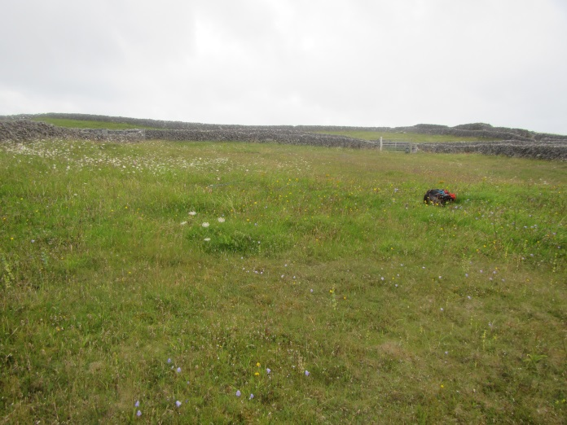

 | 2016 | 2016
 | Seaweed | Control
 | R84IMN | R85IMN
Pos sp. | Pass | Pass
% bryos | Pass | Pass
Neg sp. | Fail | Pass
Sward ht | Pass | Pass

Conclusions
Addition of seaweed causes in an increase in grass species such as Arrhenatherum elatius and Phleum pratense which are negative indicator species. This increase in negative species is not correlated with a decrease in positive indicator species and this target is passed.

Plot 13 | Inis Meáin | Area of machair with bare ground, decreased forage potential and poor vegetation growth. Seaweed applied for 2 years (2016 & 2017)
2016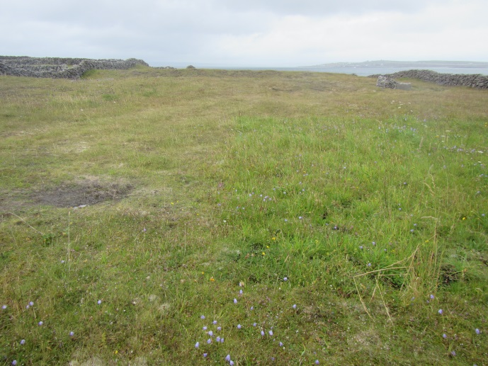 |  |  | 2017  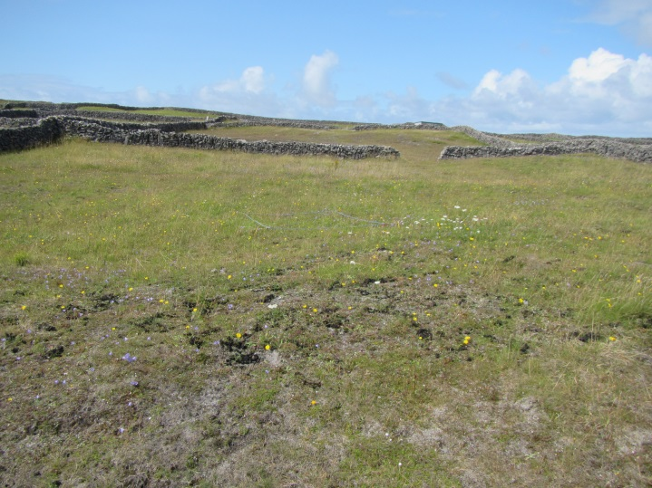

 | 2016 | 2016
 | Seaweed | Control
 | R82IMN | R83IMN
Pos sp. | Pass | Fail
% bryos | Pass | Fail
Neg sp. | Fail | Pass
Sward ht | Pass | Fail

Conclusion
The untreated areas fail all targets owing to degraded nature of the machair. Seaweed treated area fails negative indicator species target owing to the increase in cover of Arrhenatherum elatius.

Plot 14 | Inis Meáin | Area of machair with bare ground, decreased forage potential and poor vegetation growth. Seaweed applied for 1 year (2016)
2016
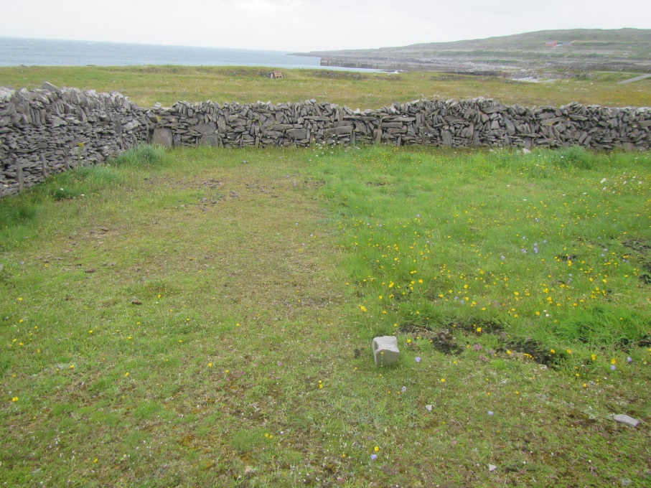

 | 2016 | 2016
 | Seaweed | Control
 | R78IMN | R79IMN
Pos sp. | Pass | Fail
% bryos | Fail | Pass
Neg sp. | Pass | Pass
Sward ht | Pass | Fail

Conclusion
The application of seaweed at this site reduced the cover of bryophytes, but increased the diversity of positive indicator species and sward height.

Conclusions
From analysis of the relevés recorded in Machair habitat using the national monitoring assessment methods (Delaney et al.2013), only 16% passed the four conservation criteria for assessment: positive indicator species, percentage cover of negative indicator species, sward height and percentage bryophyte targets. Most of the relevé sites were selected so as to highlight the areas of machair on the islands that required some intervention to improve the conservation status. Issues such as over dominance of bryophytes and overgrazing by rabbits have contributed to this low pass rate. The over grazing of machair by rabbits is discussed further in the report ‘Rabbit exclusion trials report’ (AranLIFE 2017).
Most of the relevés failed owing to too low sward height, insufficient positive indicator species or to high percentage cover of negative indicator species.
Seaweed treatment was highly effective for improving the conservation status of degraded areas of machair with limited vegetation cover. Seaweed applications helps to add some organic matter and improve the water retention capacity of the substrate. These factors aid the colonisation of bare, damaged areas.
Following seaweed application, an increase in Arrhenatherum elatius cover was noted and was responsible for some relevés failing to reach the target for cover of negative indicator species. The threshold used was combined cover of 5% or less in each relevé. Following seaweed treatment, careful management of grazing must be implemented so as to prevent grass species from out-competing the herbaceous and sedge species characteristic of machair.
Grazing times on machair should be left as late as possible (September) to allow flowers to set seed free from grazing during the summer months. Machair that is overgrazed by rabbits suffers from reduced species diversity because of the all year round grazing by rabbits
Over dominance of Rhytidiadelphus squarosus was noted as an issue of concern in a significant area of the Aran Islands machair and usually was indicative of degraded machair that had limited nutrients and insufficient forage potential resulting in abandonment. The national monitoring target for percentage bryophyte cover has a lower threshold that must exceed 1% per relevé, however there is no maximum threshold of bryophyte cover. Perhaps other targets would be failed as a consequence of this, e.g. relevés with excessive bryophyte cover would have failed owing to insufficient positive indicator species.
Many important species, such as Vertigo angustior, Lapwing and Chough is depend on the machair grassland. Lands that are poor for grazing due to lack of vegetation, land that farmers consider would benefit from improvement in fertility and vegetation growth response through seaweed application, would also not have the thatch and litter build up that most snail species require for food and shelter (Browne 2016). Lapwing nest at machair habitat on Inis Mór and Inis Meáin and nest sites are more prone to predation if sward height is not sufficient to camouflage nests.
Continued Improvements in the conservation status of Machair habitat on the islands requires multiple elements which must be constantly managed, such as:
- Balancing nutrient input so degraded and impoverished machair can improve its species diversity,
- Maintaining adequate forage so that low intensity grazing is maintained and abandonment is prevented and species diversity is maintained,
- Controlling overgrazing by rabbits.

The Actions of AranLIFE have initiated the conservation management of Machair on the islands and this must be continued and maintained in future schemes to further the conservation of this habitat.

References
AranLIFE (2016). Machair Report.
AranLIFE (2017). Rabbit exclusion trials
Browne, N. (2016) First monitoring survey for Vertigo angustior and other molluscs at sites chosen for seaweed application trials, AranLIFE project – 2015 survey.
Delaney, A. Devaney, F.M., Martin, J.M. and Barron, S.J. (2013). Monitoring survey of Annex I sand dune habitats in Ireland. Irish Wildlife Manuals, N0.75. National Parks and Wildlife Service, Department of the Arts, Heritage and the Gaeltacht, Dublin Ireland.
Ryle, T., Murray, A., Connolly, K. and Swann, M. (2009). Coastal Monitoring Project 2004-2006. A report submitted to the National Parks and Wildlife Service, Dublin

Appendix 1. National Monitoring Methods for assessing *21A0 Machairs
The following table shows the criteria used to assess the conservation status at a monitoring stop and site level (Delaney et al. 2013) (Table 3). A monitoring stop or relevé must support greater than 6 positive indicator species, a low percentage cover of negative indicator species and more than 1% cover of bryophytes as well as have a sward height greater than 8cm to pass and have favourable conservation status.
Table 3. Criteria to pass/fail monitoring stops in the assessment of conservation status
1a. Positive species indicators: At least six must be present in more than 20% stops to pass
Agrostis stolonifera
Aira praecox
Bellis perennis
Carex arenaria
Carex flacca
Carex nigra
Cerastium fontanum
Crepis capillaris
Euphrasia officinalis agg.
Festuca rubra
Galium verum
Hydrocotyle vulgaris
Linum catharticum
Lotus corniculatus
Orchid spp.
Plantago lanceolata
Potentilla anserina
Prunella vulgaris
Rhinanthus minor
Sedum acre
Thymus polytrichus
Trifolium repens
Viola canina
Viola riviniana
Viola tricolor
1b. Lowest number of positive indicator species in a monitoring stop: At least three species present in each stop

2. Cover of bryophytes: Always over 1%
3. Negative Indicator species: No species present in more than 40% of stops. L. perenne and P. pratense not present in more than 20% of the stops. Combined cover of negative indicators 5% or less
Arrenatherum elatius
Cirsium arvense
Cirsium vulgare
Senecio jacobaea
Urtica dioica
Lolium perenne
Phleum pratense
Pteridium aquilinum
4. Non-Native species: no species present in more than 20% of the stops
5. Flowering and fruiting of positive indicator species: present in more than 40% of stops
6. Sward Height: mean height should be at least 8cm in July and August

Appendix 2. Machair relevés and targets for conservation assessment
 | ISGS 21A0 Pos (Pass/fail) | cover of bryos >1% | combined cover of neg species <5% | sward height >8cm
R1IMR | Pass | Pass | Pass | Fail
R2IMR | Fail | Pass | Pass | Pass
R21IMR | Pass | Pass | Pass | Pass
R22IMR | Pass | Pass | Pass | Pass
R9IMN | Pass | Fail | Fail | Pass
R10IMN | Fail | Pass | Pass | Pass
R14IMN | Fail | Pass | Pass | Pass
R54IMN(R14IMNR) | Fail | Pass | Pass | Pass
R86IMN (R14IMNRR) | Fail | Pass | Pass | Pass
R14IMNRRR | Fail | Pass | Fail | Pass
R15IMN | Pass | Pass | Fail | Pass
R15IMNR | Pass | Pass | Fail | Pass
R15IMNRR | Pass | Pass | Fail | Pass
R16IMN | Fail | Pass | Pass | Pass
R17IMN | Pass | Pass | Fail | Pass
R17IMNR | Pass | Pass | Pass | Fail
R17IMNRR | Fail | Pass | Pass | Pass
R19IMN | Fail | Fail | Fail | Pass
R20IMN | Pass | Pass | Fail | Pass
R21IMN | Pass | Pass | Fail | Pass
R22IMN | Pass | Pass | Fail | Pass
R23IMN | Fail | Pass | Fail | Pass
R28IMN | Pass | Pass | Fail | Pass
R28IMNR (R70IMN) | Fail | Pass | Fail | Pass
R29IMN | Pass | Pass | Pass | Pass
R71IMN (R29IMNR) | Pass | Pass | Pass | Pass
R30IMN | Pass | Pass | Pass | Pass
R74IMN (R30IMNR) | Fail | Pass | Fail | Pass
R31IMN | Fail | Pass | Fail | Pass
R75IMN (R31IMNR) | Pass | Pass | Fail | Pass
R32IMN | Pass | Pass | Pass | Pass
R68IMN (R32IMNR) | Pass | Pass | Pass | Pass
R33IMN | Pass | Pass | Pass | Pass
R67IMN (R33IMNR) | Pass | Pass | Pass | Pass
R34IMN | Fail | Pass | Pass | Fail
R63IMN (R34IMNR) | Pass | Pass | Pass | Fail
R35IMN | Fail | Fail | Pass | Pass
R60IMN (R35IMNR) | Pass | Fail | Pass | Fail
R56IMN | Pass | Pass | Fail | Pass
R57IMN | Fail | Fail | Pass | Pass
R58IMN | Pass | Pass | Pass | Pass
R59IMN | Pass | Pass | Pass | Pass
R87IMN (R59IMNR) | Pass | Pass | Fail | Pass
R59IMNRR | Pass | Pass | Pass | Pass
R33IMR | Pass | Pass | Pass | Pass
R100IMR (R33IMRR) | Pass | Pass | Pass | Pass
R34IMR | Pass | Pass | Fail | Pass
R101IMR (R34IMRR) | Fail | Pass | Pass | Pass
R35IMR | Fail | Pass | Pass | Pass
R102IMR (R35IMRR) | Pass | Pass | Pass | Pass
R36IMR | Pass | Pass | Pass | Pass
R103IMR (R36IMRR) | Pass | Pass | Pass | Pass
R37IMR | Pass | Pass | Pass | Fail
R104IMR (R37IMRR) | Pass | Fail | Pass | Fail
R38IMR | Pass | Pass | Pass | Fail
R105IMR (R38IMRR) | Pass | Pass | Pass | Fail
R39IMR | Pass | Pass | Pass | Fail
R106IMR (R39IMRR) | Pass | Fail | Pass | Fail
R40IMR | Pass | Fail | Pass | Fail
R107IMR (R40IMRR) | Fail | Fail | Pass | Fail
R41IMR | Pass | Pass | Pass | Fail
R112IMR (R41IMRR) | Pass | Pass | Pass | Fail
R124IMR (R41IMRRR) | Pass | Pass | Pass | Pass
R42IMR | Pass | Pass | Pass | Fail
R113IMR(R42IMRR) | Pass | Pass | Pass | Fail
R125IMR (R42IMRRR) | Pass | Fail | Pass | Fail
R43IMR | Pass | Pass | Pass | Fail
R114IMR (R43IMRR) | Pass | Pass | Pass | Fail
R126IMR(R431MRRR) | Pass | Pass | Pass | Fail
R44IMR | Pass | Pass | Pass | Fail
R115IMR (R44IMRR) | Fail | Pass | Pass | Fail
R127IMR(R44IMRRR) | Pass | Pass | Pass | Fail
R54IMR | Fail | Pass | Pass | Pass
R55IMR | Fail | Pass | Pass | Pass
R56IMR | Pass | Fail | Pass | Pass
R61IMN | Pass | Fail | Pass | Pass
R61IMNR | Pass | Pass | Pass | Pass
R62IMN | Fail | Pass | Pass | Fail
R62IMNR | Pass | Pass | Pass | Pass
R64IMN | Fail | Pass | Fail | Pass
R64IMNR | Fail | Pass | Fail | Pass
R64IMNRR | Fail | Pass | Fail | Pass
R65IMN | Fail | Pass | Fail | Pass
R65IMNR | Pass | Pass | Fail | Pass
R65IMNRR | Pass | Pass | Fail | Pass
R66IMN | Pass | Pass | Pass | Pass
R69IMN | Pass | Pass | Pass | Fail
R72IMN | Pass | Pass | Pass | Pass
R73IMN | Fail | Pass | Fail | Pass
R76IMN | Fail | Pass | Fail | Pass
R76IMNR | Pass | Pass | Fail | Pass
R76IMNRR | Pass | Pass | Fail | Fail
R77IMN | Pass | Pass | Fail | Pass
R77IMNR | Fail | Pass | Pass | Pass
R77IMNRR | Fail | Pass | Fail | Fail
R78IMN | Pass | Fail | Pass | Pass
R79IMN | Fail | Pass | Pass | Fail
R80IMN | Pass | Fail | Fail | Pass
R81IMN | Pass | Pass | Pass | Pass
R82IMN | Pass | Pass | Fail | Pass
R83IMN | Fail | Fail | Pass | Fail
R84IMN | Pass | Pass | Fail | Pass
R85IMN | Pass | Pass | Pass | Pass
R88IMN | Pass | Pass | Pass | Pass
R88IMNR | Pass | Pass | Pass | Pass
R89IMN | Pass | Pass | Pass | Pass
R89IMNR | Fail | Pass | Pass | Pass
R90IMN | Pass | Pass | Fail | Pass
R91IMN | Pass | Pass | Fail | Pass
RI04IMN | Pass | Fail | Pass | Pass
R105IMN | Pass | Pass | Pass | Pass
R112IMN | Fail | Fail | Pass | Pass
R113IMN | Pass | Fail | Pass | Pass
R57IMR | Pass | Fail | Fail | Pass
R58IMR | Pass | Fail | Pass | Pass
R59IMR | Fail | Fail | Pass | Pass
R60IMR | Fail | Fail | Pass | Pass
R61IMR | Pass | Pass | Fail | Pass
R62IMR | Pass | Pass | Fail | Pass
R63IMR | Fail | Pass | Pass | Pass
R64IMR | Pass | Pass | Pass | Pass
R65IMR | Pass | Pass | Pass | Pass
R66IMR | Pass | Pass | Fail | Pass
R67IMR | Pass | Pass | Fail | Pass
R68IMR | Pass | Pass | Fail | Pass
R108IMR | Pass | Pass | Pass | Fail
R109IMR | Pass | Pass | Pass | Fail
R110IMR | Pass | Pass | Pass | Fail
R111IMR | Pass | Pass | Pass | Fail
R116IMR | Fail | Pass | Pass | Fail
R116IMRR (R128IMR) | Pass | Pass | Pass | Fail
R117IMR | Pass | Pass | Pass | Pass
R117IMRR (R129IMR) | Pass | Fail | Pass | Fail
R118IMR | Pass | Pass | Pass | Fail
R119IMR | Fail | Pass | Pass | Fail
R120IMR | Pass | Pass | Pass | Fail
R121IMR | Fail | Pass | Pass | Pass
R122IMR | Fail | Fail | Pass | Pass
R116IMN | Pass | Pass | Pass | Pass
R117IMN | Pass | Pass | Pass | Pass
R118IMN | Pass | Pass | Pass | Fail

