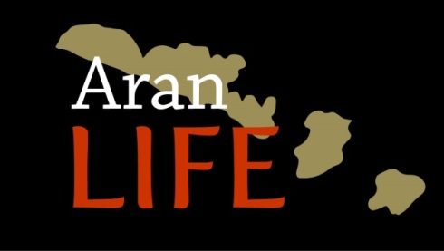

7.2.4b Field condition assessment and associated management advice to improve or maintain the conservation status of the field

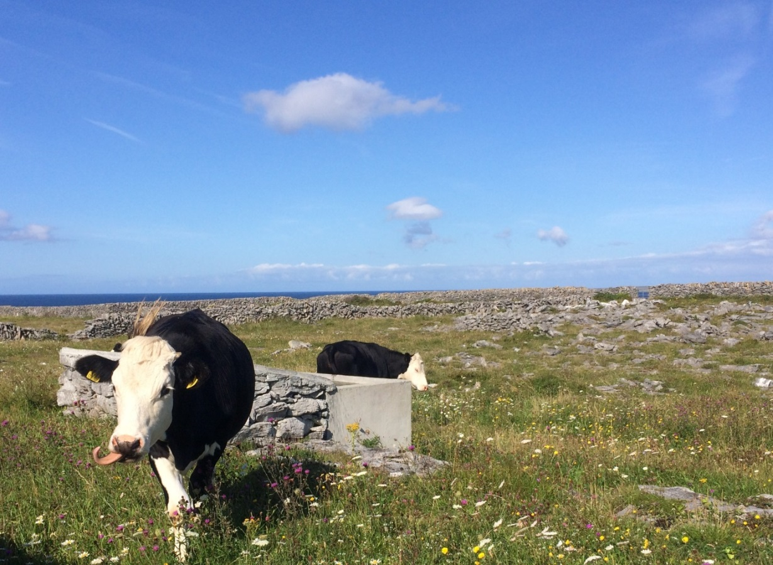

December 2018

A score of 1 to 5 is given to the land parcels to determine the condition of the habitat and relate to grazing level. This is a visual assessment method, which is intuitive and quick to apply in the field that links in with the scientific monitoring across the range of habitats.

The score:

Farm Plot scores for grazing action
Score | Rationale
5 | Priority habitat perceived to be very well managed, indicated by a high number of positive indicator species and an appropriate grazing regime (lacking indicators of undergrazing and overgrazing)
4 | Priority habitat with a high number of positive indicator species and an appropriate grazing regime (lacking indicators of undergrazing and overgrazing) but with scrub or bracken encroachment an issue
3b | Priority habitat with reduced numbers of positive species indicators. Habitat is not optimally grazed and scrub encroachment may be an issue. Habitat may also supports negative indicator species.
3a | Areas of priority habitat either not in agricultural use or where grazing is not occurring or where the grazing rate is so low it there is a substantial build-up of grass
2 | Semi-improved habitat with limited indicators of priority habitat, grass dominated, usually with higher levels of fertility or more recently made grasslands in an island context
1 | Non-priority habitat and therefore not covered by the LIFE project

Assessment
The score is based on the LPIS land parcel unit. However this can be further broken down to management units or habitat units where there is variance within a LPIS land Parcel. The unit will be classed as:
Calcareous grassland (Cal)
Limestone Pavement (LP)
Calcareous grassland/Limestone Pavement (Cal/LP dominant habitat goes first)
Machair (M)
Semi-improved grasslands/Improved/Arable (IMP)
Coastal rock and ineligible areas (NE)
Semi-improved and Improved/Arable will automatically receive a score of 2 whilst areas of shoreline, lane ways etc., will receive a score of 1. For parcels with a percentage of semi-improved/improved, where this area is less than 30% then the dominant score will be given to the whole area, areas greater than 30% will be scored as separate units

Agricultural Activity
The area should have clear signs of grazing visible from the condition of sward, these include areas cleared of vegetation or a range of vegetation height covers including tightly grazed patches, indications of livestock tracks, faecal material, lying areas. No signs of agricultural activity indicates land is not in agricultural use and the area should be given a Score 3a. Where the field is an ungrazed winterages, the farmer should consider grazing this area to move the score to a 3b.
Presence of scrub/bracken
Is there encroaching scrub/bracken present on the area, briars, blackthorn, hawthorn or bracken? (Areas of mature scrub should be excluded). Is the area greater than 10% of the overall field and is it encroaching on to existing habitat?
Grazing condition
Despite being grazed are there still areas of dead vegetation reducing the diversity of the field?
Damage assessment
Are there areas of damaged vegetation, excessive poaching, damage as a result of feeding troughs, excessive vehicle damage.
Sward condition
Using the presence and abundance of specific indicator species it will be possible to determine an overall score for the field. This method will also identify the presence of negative indicator species, areas of scrub/bracken and agricultural grasses. The procedure involves taking a line transect across the field diagonal and identify the species located in an area of 1m² in a total of 10 random points within the transect. For grazed areas of limestone pavement the survey points should concentrate on the grazed outcrops within the limestone.
Where the field contains one or less positive indicator present in an area of one square metre at six out of ten random points in the area it is likely a semi-improved or improved field with a grass dominant over herds and so will have a score of 2
A field having between two and four positive indicators present in an area of one square metre in at least six out of ten random points in the area is indicative of a moderately species-rich field and will have a score of 3. The presence or absence of grazing will determine if it is 3a or 3b.
Where four or more, positive indicators are located in an area of one square metre at five out of ten random points in the field, it would have score of 4. The remaining five points will likely to consist of scrub, course grass or semi-improved grassland
If five or more positive indicators are located in an area of one square metre at eight out of ten random points in the field then the area will have a score 5. Fields with 5 indicator species between at 5 to 8 random points will have a score of 4 with the remaining random points likely to consist of scrub, course grass or semi-improved grassland.

Farm Plot scores for grazing action
Score | Rationale
5 | Continuation of the existing management is main action required here, ensuring no increase or decrease in stocking levels. Maintain all water structures and access points to ensure stocking levels can be maintained. Small pockets of scrub control may still be required in some areas to prevent further encroachment.
4 | Targeted Scrub removal will be main action required her with follow up treatment. A slight increase in stocking level may be required post scrub cutting. Ensure adequate water supplies.
3b | Increase current grazing levels, the main aim is to remove excess vegetation to allow species diversity. This may mean supplying adequate water facilities by either construction of new raincatcher/spring catchment or using facilities in adjacent fields. For winterage a flash grazing during the summer could be considered early enough to allow regrowth. Areas of encroaching scrub should be removed with retreatment as required. For fields with high levels of Molinia (Purple Moor grass), consider spring grazing when the grass is palatable to livestock. Remove any features that increase likelihood of damage, e.g feeders.
3a | Reintroduction of adequate grazing is first step, best achieved through grazing with higher number of cattle over a short period. Areas of dead grass avoided by livestock should then be cut back and removal of areas of scrub. Ensure adequate water supplies for livestock which may mean construction of rain catcher
2 | Short term improvements in biodiversity unlikely. Determine whether semi-improved area is part of overall farming systems, supporting sensitive management of grazing areas elsewhere. If farmer willing to improve species content, reduction of fertility levels is likely first step. Consider taking a hay crop from field, followed by grazing to reduce fertility. No extra added fertility to be added.
1 | Non-priority habitat and therefore not covered by the LIFE project

Scoring Sheet
LPIS No. | Main Habitat | Agric. Activity Y/N | Scrub greater than  10% | Damage  Assessment | Sward Condition | Management Advice | Score

The final score given should reflect the other variables, for example a field could score highly under the Sward Condition but could include excessive damage, and in such cases the field would drop a score.

Positive Indicator species
The following are the top species which will be useful in scoring at stops within the fields. They are for the most part easy to recognise and most are in the AranLIFE flower booklet.
 | Flower booklet | Highly positive | Positive
Briza media (Quaking grass)  Geranium sanguineum (Bloody Cranesbill)  Anthyllis vulneraria (Kidney Vetch)  Primula veris (Cowslip)  Carlina vulgaris (Carline Thistle)  Campanula rotundifolia (Harebell)  Antennaria dioica (Catspaw, Mountain Everlasting)  Blackstonia perfoliata (Yellow-wort)  Sanguisorba minor (Salad Burnet)  Linum catharticum (Fairy flax)  Sesleria cerulean (Blue Moor grass)  Lotus corniculatus (Birdsfoot trefoil)  Galium verum (Ladies Bedstraw)  Thymus praecox (Wild Thyme)  Carex species (Sedges)  Orchid species  Euphrasia officinalis (Eye bright)  Succisa pratensis (Devils bit Scabious) | X | *
 | X | *
 | X | *
 | X | *
 | X | *
 | X | *
 | X | *
 | X | *
 |  | *
 |  | *
 | X |  | √
 | X |  | √
 | X |  | √
 | X |  | √
 | x
 | X
The variables used for assessing status in the ISGS include:
7 positive species+ 2 highly positive species
Broadleaf cover of 40%-90%
Sward height 30% of sward between 5cm and 40cm
Litter cover < 25%
Negative indicators < 20%
Scrub cover < 5 (not including juniper and burnet rose)

