7.2.8a Report on seaweed trials on Machair

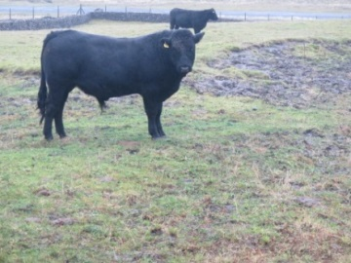

January 2016

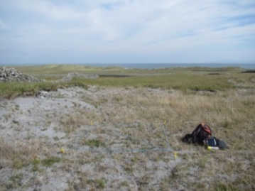 | September 2014
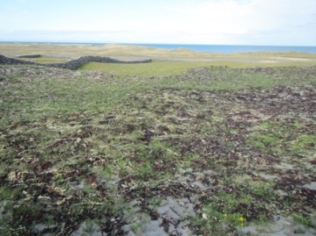 | April 2015
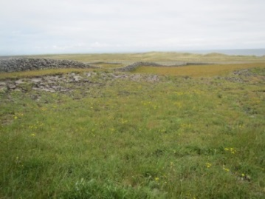 | June 2015
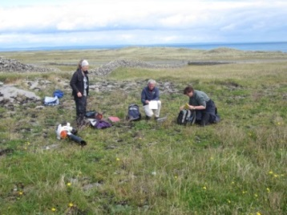 | September 2015
 | November 2015

Contents

Summary 4
Background 5
Vertigo angustior study and Machair 5
Location of treatment plots 6
Methodology 6
The seaweed study 6
Plot descriptions 9
Results 13
Vegetation 13
Dry matter yields in machair plots 23
Soils 24
Conclusions 24
References 26
Appendix 1. Inis Mór Seaweed treatment plots 27
Appendix 2: Seaweed Plots Inis Meáin 36
Appendix 3. National Monitoring Methods for assessing *21A0 Machairs 48
Appendix 4. Vertigo angustior survey of seaweed trial plot sites 50

Summary
In Phase 1 of the seaweed trials, eight seaweed plots were set up in March/April 2015 when seaweed was applied to 20x10m plots. This report documents the results of phase 1.

The 8 plots vary in their habitat quality and structure.

Seaweed was applied by hand ensuring even coverage throughout the plot.

Plots were monitored in July and August 2015, 3 or 4 months after seaweed application.

From Bray Curtis ordination of the relevé data there is no obvious trends observable in the vegetation data that are particular to seaweed treated and untreated areas at this stage.

Machair vegetation is highly variable owing to the dynamic nature of the habitat and this is shown in the variation between machair habitat between Inis Mór and Inis Meáin.

The cover of bryophytes appears to be reduced in most of the seaweed treated plots. In particular Rhytidiadelphus squarrosus and Scleropodium purum are more abundant in the untreated areas.
There is an apparent increase in sedge and grass cover in seaweed treated areas in 50% of the plots
There is an apparent decrease in % broadleaf cover in seaweed treated areas in 60% of the plots
Vertigo angustior is absent from the seaweed trial plot sites (Browne 2016).

The dry matter yield is greater in 50% of the seaweed plots than in the corresponding untreated areas

The machair soils have a high pH, and are very low in Phosphorous. Low potash is also a feature of these soils as are high magnesium levels.

The application of seaweed increases the water holding capacity of the soil and the organic content of the soil, which facilitates the development of vegetation cover in previously bare areas.

Phase 2 will incorporate further seaweed applications on existing plots, as well as setting up new application plots. The 3 plots at Kilmurvey will also be analysed and monitored in the coming months. Seaweed was applied to these sites in October 2015, following the mollusc survey.

Background
Machair is a qualifying Interest of both Inis Mór and Inis Meáin SACs. An ‘unfavourable-inadequate’ conservation status was given to the machair habitat at Eararna (Trá Mór, Inis Mór) by the Coastal monitoring Project (CMP) (Ryle et al., 2009), owing to overgrazing, impact of rabbits and dominance of mosses and lichens. On Inis Méain the CMP noted that species diversity was low and moss cover was very high throughout the machair. These issues have to be addressed by the AranLIFE project in order to bring 29ha of machair habitat to favourable conservation status.

The AranLIFE project proposes to trial the application of seaweed to machair sites to address issues such as over-dominance of bryophytes and reduction in species-diversity. The sandy soil lands that occur on particular parts of the islands such as the machair are free-draining and so have little capacity to retain nutrients for grass growth. The application of seaweed is necessary, both to supply some plant nutrients and improve organic matter of soil, and at the same time improving the water retaining capacity.

While bryophytes are an important component of machair vegetation, over-dominance of Rhytidiadelphus squarrosus in particular may have been the result of long term nutrient loss from the habitat. Moss over-dominance is having a deleterious impact on both the forage available to cattle as well as the species diversity of the habitat. This issue prevails at all the proposed trial sites. The application of seaweed on these habitats was part of the traditional farming system on the islands, according to the farmers who own these lands.
These issues have been discussed with NPWS as part of the AranLIFE project, and the trials are directly connected to improving understanding as to how to best manage the site.

This report documents the results of the first year of seaweed treatment on machair sites (phase 1).

Vertigo angustior study and Machair
The Annex II snail species Vertigo angustior is a qualifying interest species of Inis Mór SAC (Moorkens & Killeen, 2011). It lives in the decaying grass understorey in machair habitat and is sensitive to drying out, requiring appropriate habitat for a successful long term population (Moorkens & Gaynor, 2003). The improvement of machair habitat conditions should improve the density and spread of this small protected species. It is important to understand how the application of seaweed would positively or negatively affect V. angustior. To this end we have commissioned a survey of Vertigo angustior to accompany the seaweed trials and vegetation survey of Machair on both Inis Mór and Inis Meáin.

This Vertigo survey is being conducted by a research student, Neil Browne under the supervision of Dr Evelyn Moorkens. The objective of the study is to assess the changes to the molluscan fauna before and after the affects of the seaweed application. The methods are designed to assess the distribution of V. angustior (via hand sampling along walking transects) and changes to the molluscan composition and abundance, through semi-quantitative sampling comparisons between equivalent seaweed applied and control quadrats at each application site. The initial results of this research are presented in Appendix 4.

Location of treatment plots
Machair sites on Inis Mór (Trá Mór) and Inis Méain have been selected for this action. The initial proposed location of phase 1 are presented on Map 1. This is Phase 1 of the experiment. Phase 2 will include 3 new plots at Kilmurvey, Inis Mór as well as new plots at Inis Meáin. Phase 2 will also include reapplication of seaweed on Phase 1 plots.

Table 1. Phase 1 seaweed plots on Inis Mór and Inis Meáin.
Island | Townland | Ownership | No. of 20x10m² seaweed plots
Inis Mór | Trá Mór | Commonage (unfenced)  (9 farmers) | 3 plots
Inis Méain | Ceann Gainimh | Private (fenced) | 5 plots

Methodology

The seaweed study
The first phase of seaweed application began in March/April 2015. As these machair sites are known lapwing nesting sites care was taken to avoid areas and times where and when lapwings were active. Each seaweed plot is approximately 20mx10m. Seaweed collected form the strandline was applied to plots by hand ensuring even coverage throughout. It was envisaged that once applied the application rate on each plot could be calculated, however this proved difficult owing to varying water content of the seaweed at time of application (the variability of the seaweed depending on how long it had been on the strandline) as well as the difficulties of being on site at the exact time of application. Initial trials results produced 3, 4, 5 and 6kg of seaweed wet matter per m², at four different sites. Further trials will continue to get approximate application rates in terms of dry matter weight.

Machair LIFE in Scotland commissioned a report (Ferguson 2012) in which the nutritive quality of seaweed was analysed and different stages of composition: fresh, semi-rotten and rotten.
 | Fresh | Semi | Rotten
Dry Matter | 14.7% | 18.8% | 17.0%
pH | 6.6 | 6.36 | 8.41
Total Nitrogen | 0.38% | 0.016% | 0.79%
Total Phosphate | 0.14% | 0.17% | 0.20%
Total Potash | 1.35% | 1.06% | 0.74%

This Machair LIFE report concluded that the average nutritive quality of seaweed in terms of NPK is (0.55:0.17:1.05). (Ferguson 2012)

The selection of plots for seaweed application was primarily based on the farmers input as to where the forage available for cattle was particularly low. Areas were also selected that showed obvious signs of damage through erosion where bare sand predominates.

Permanent monitoring quadrats (4m²) were set up within the 20mx10m plots by the AranLIFE team as well in adjacent untreated areas. These quadrats were surveyed for their floristic composition and will be monitored annually over the duration of the project and any changes in vegetation noted.

Monitoring will follow national monitoring methodologies (Ryle et al. 2009; Delaney et al. 2013) (Appendix 3). A relevé size of 4m² is used for machair grassland monitoring.

Relevés were recorded in July and August 2015 to analyse the impact of the seaweed applications on the grassland vegetation.
The percentage cover of all plant species within the relevé is estimated and a cover-abundance number from the Domin cover-abundance scale is assigned to each species identified (Table 2).

Table 2. The Domin cover/abundance scale
% cover/abundance | Domin scale
A single individual. No measurable cover | +
1 to 2 individuals. No measurable cover. Individuals with normal vigour | 1
Several individuals but less than 1% cover | 2
1-4% cover | 3
5-10% cover | 4
11-25% cover | 5
26-33% cover | 6
34-50% cover | 7
51-75% cover | 8
76-90% cover | 9
91-100% cover | 10

The following additional information is also recorded in each relevé: % cover of bare rock, % bare soil, % litter, % grass/sedge layer, % broadleaf layer, % bryophyte layer, median grass and herb height.

A series of fixed point photos are taken of each relevé and a close up photo of the relevé vegetation is taken.

Appendix 1 & 2 details the relevé descriptions from Inis Mór and Inis Meáin.

These relevés are analysed as monitoring stops according to the criteria for assessing conservation status (Ryle et al. 2009; Delaney et al. 2013) (Appendix 3).

A total of 13 relevés were recorded within seaweed plots and 13 were recorded in adjacent untreated plots. One relevé was recorded within a plot prior to seaweed application. (In total 44 relevés recorded in machair on Inis Meáin and Inis Mór as part of the overall AranLIFE monitoring programme and 27 of these relevés are associated with the seaweed trials.)

Forage samples and soil samples were taken to accompany the relevé data. Dry Matter Yield t/ha was calculated from the forage samples and soil samples were analysed for pH, Phosphorus, Magnesium and Potassium. Initially Morgan’s Test was used as used by Teagasc for determining available Phosphorus, however, due to the high pH of the soils the results were unreliable and subsequent samples using Olsens’s method appear to be more accurate.

Phase 2 will involve monitoring seaweed plots at Kilmurvey (seaweed has been applied in October 2015), re-applying seaweed on Phase 1 plots and selecting new plots on both Inis Meáin and at Trá Mór, Inis Mór.

Plot descriptions
Eight seaweed plots were set up on Inis Meáin and Inis Mór and seaweed applied in March/April 2015.

Plot 1 CS1 | Trá Mór, Inis Mór | Moss-rich , short sward, heavily grazed by rabbits, small patches of eroded machair adjacent to plot.(August 2015)
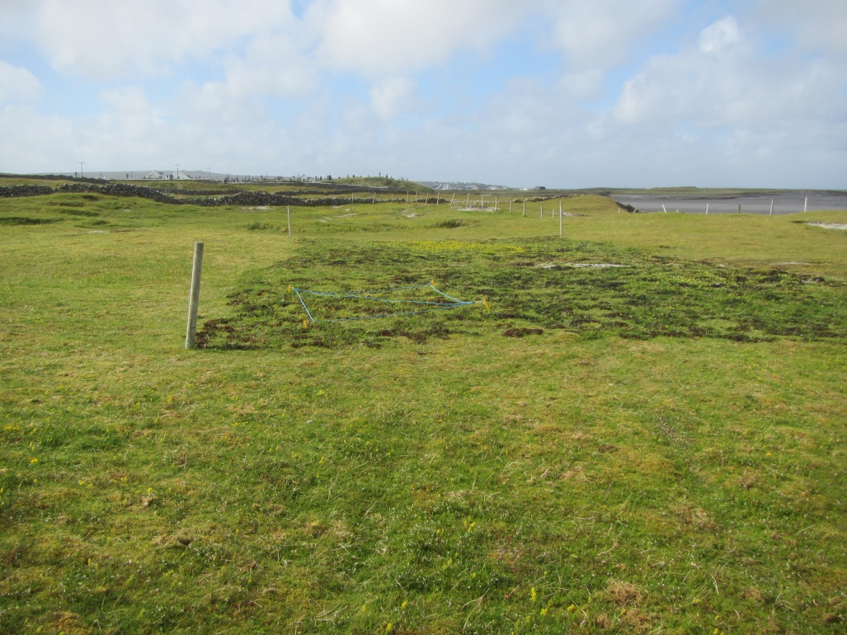

Plot 2 PN1 | Trá Mór, Inis Mór | Moss-rich , short sward, heavily grazed by rabbits.(July 2015)
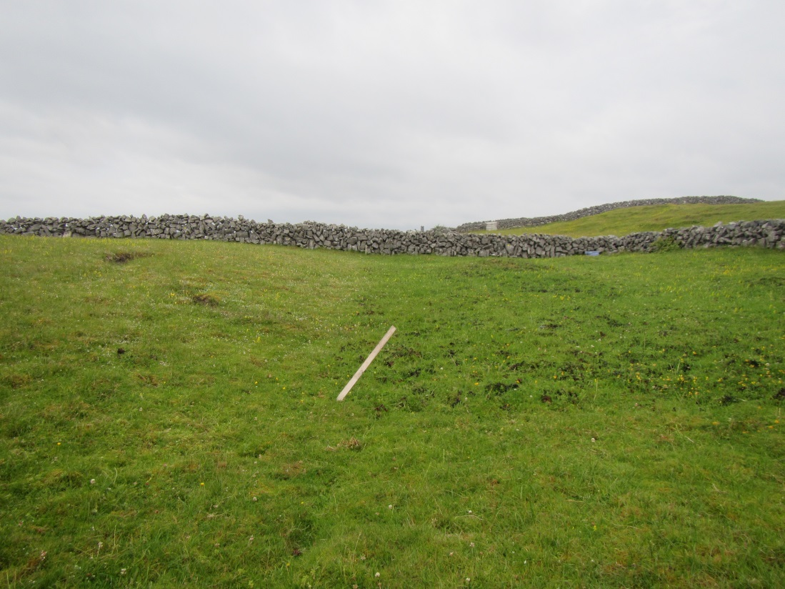

Plot 3 PN2 | Trá Mór, Inis Mór | Very eroded part of the machair, Erosion caused by a combination of sand removal, disturbance and wind. Rabbits also active in this area (July 2015)
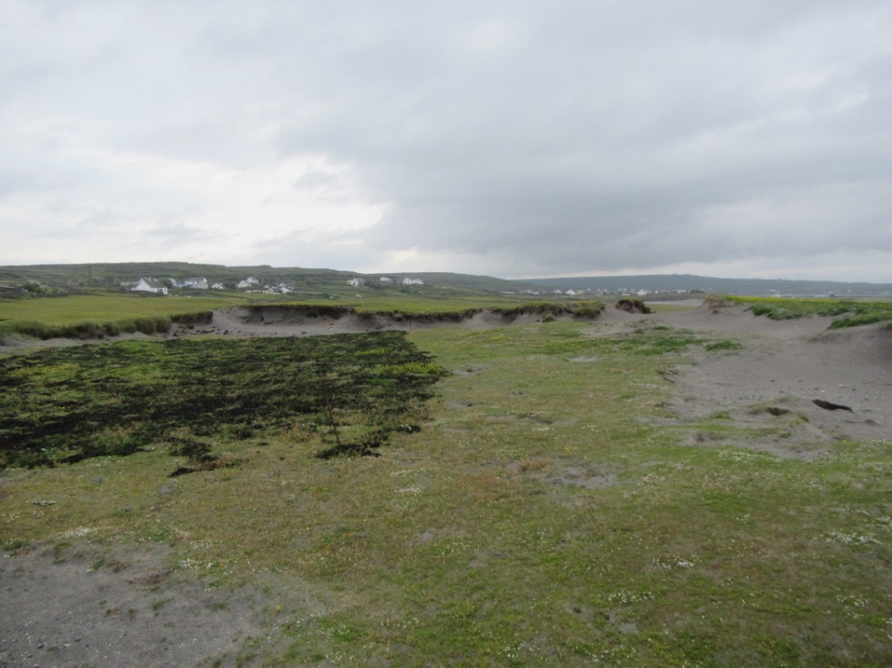

Plot 7 PM1 | Inis Meáin | Thick sward of vegetation, rich in grasses and mosses (May 2015).
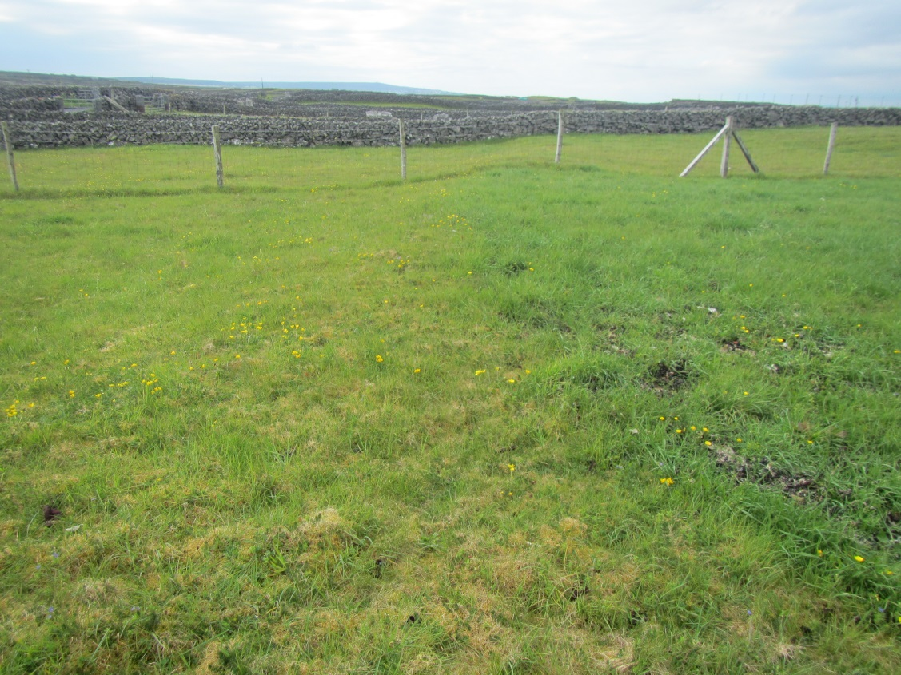

Plot 8 RC1 | Inis Meáin | Short sward of vegetation, rich in mosses. Bare unvegetated patches present (May 2015).
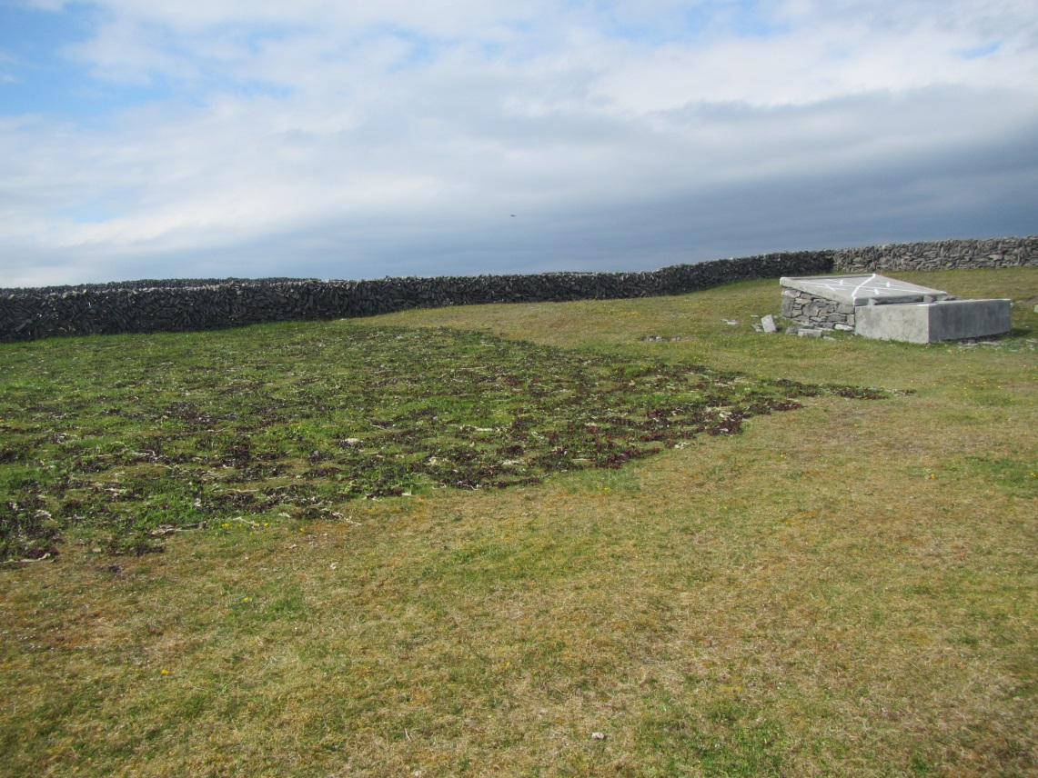

Plot 9 RC2 | Inis Meáin | Low grass cover and sward height and high moss cover (May 2015)
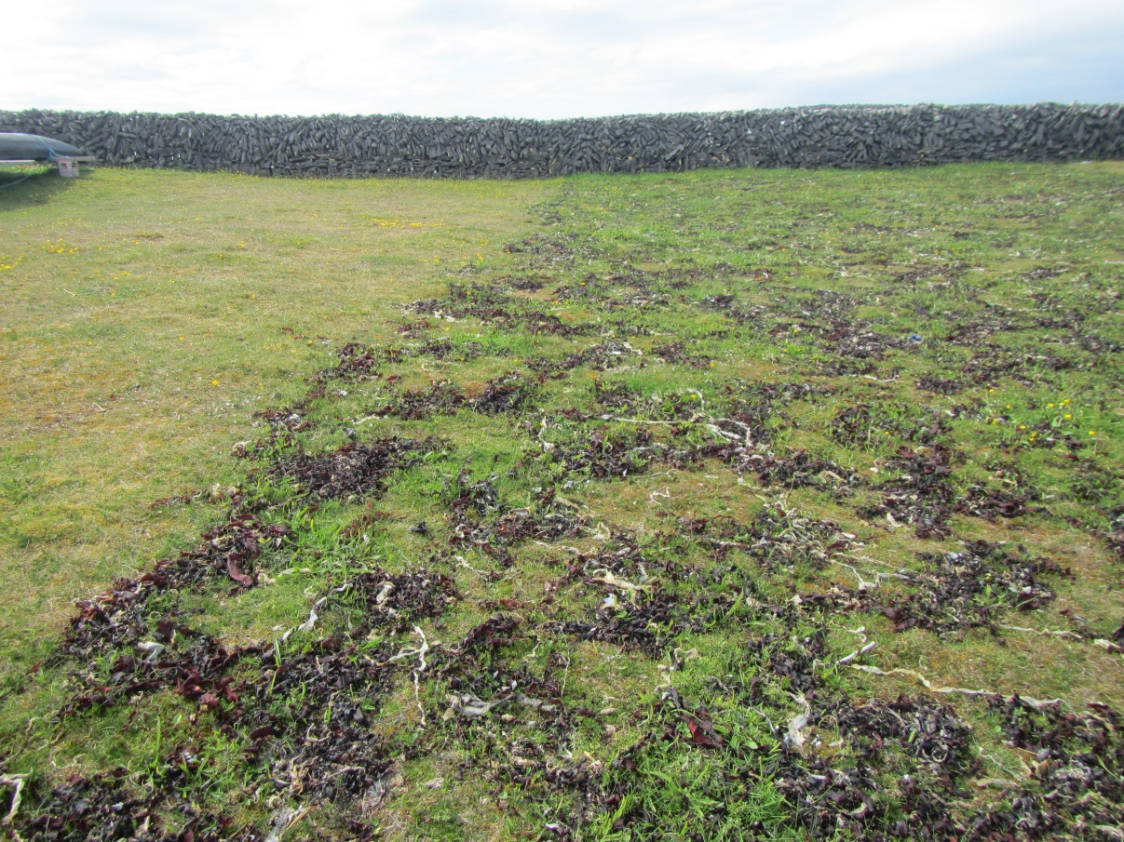

Plot10 RC3 | Inis Meáin | Area disturbed in the past with low sward cover. (May 2015)
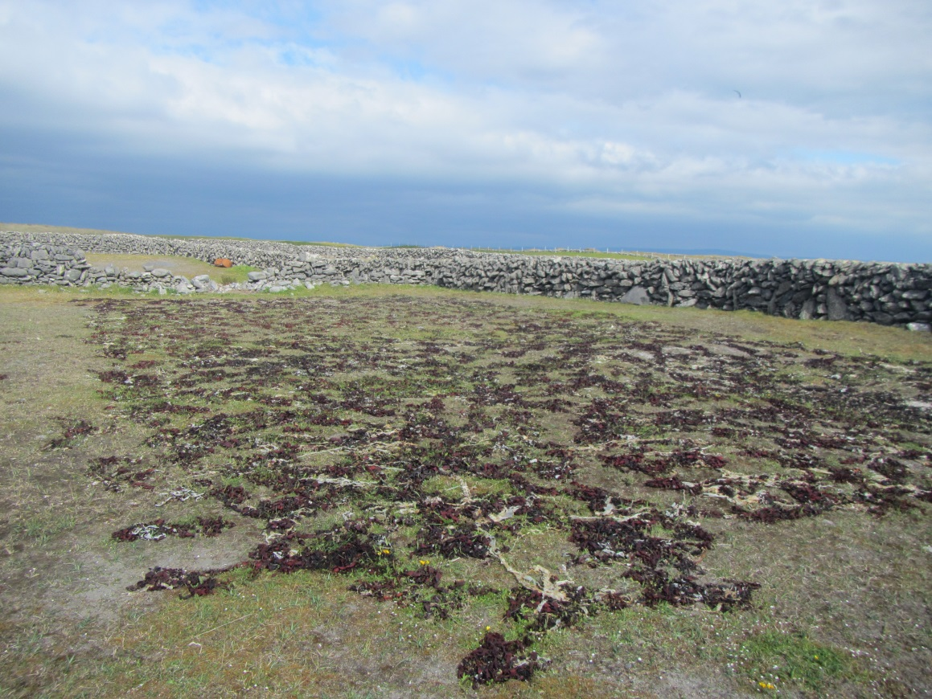

Plot 11 SOD 1 | Inis Meáin | Disturbed area of machair owing to sand removal. Seaweed plot covers entire disturbed area. Vegetation cover is low (May 2015).
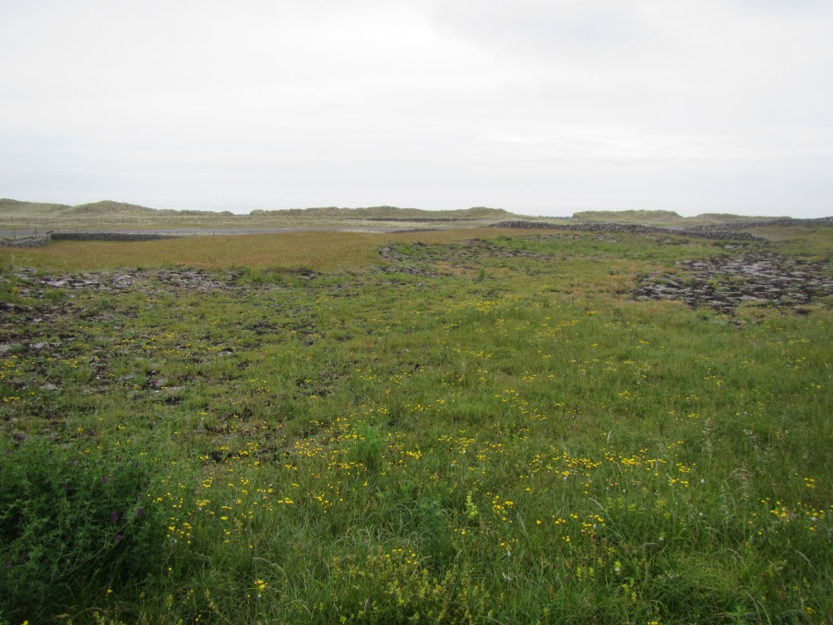

Results

Vegetation
The relevés from both Inis Meáin and Inis Mór are shown in Table 4 and the following trends are apparent:
- There are 13 positive indicator species present in both seaweed treated and untreated areas.
- There are 4 negative indicator species present in both seaweed treated and untreated areas.
- The cover of bryophytes appears to be reduced in most of the seaweed treated plots (Fig. 4), in particular Rhytidiadelphus squarrosus and Scleropodium purum are more abundant in the untreated areas. The exception to this is Plot3 PN2 which was an extremely eroded site has increased its cover of bryophytes within the seaweed treated plot.
- Two bryophyte species (Rhytidiadelphus squarrosus and Scleropodium purum) are also more abundant in the untreated areas (Table 4)
- There is an apparent increase in sedge and grass cover in seaweed treated areas in 50% of the plots (Figs 5 & 6)
- There is an apparent decrease in % broadleaf cover in seaweed treated areas in 60% of the plots (Fig. 7)
- The herbaceous species, Bellis perennis and Stellaria media appear to have a greater affinity with the relevés in seaweed treated plots than in untreated adjacent areas, however Stellaria media only occurs in Inis Meáin machair (Table 6) and Bellis perennis was only recorded on Inis Mór machair (Table 5).
- Rumex acetosa, Leontodon autumnalis, Peltigera canina and Cuscuta epithymum appear to be more abundant in the untreated areas than in the seaweed plots (Table 4).
- The positive indicator species, Rhinanthus minor, appears to be more abundant in the untreated areas (Table 4).

A Bray Curtis ordination was performed on the seaweed and no-seaweed plot relevés (27) along with the other machair relevés that were recorded during the project monitoring programme ) (17 other machair releves, 44 in total) (Fig 2). This ordination was performed to see if there were any outliers and to see if the seaweed/no seaweed relevés varied greatly from the other machair relevés.. The results of this ordination show that both treated and untreated relevés are distributed along both axes of the ordination (Fig 2). There are a few outliers that are from untreated and treated areas aswell as else where within the overall machair habitat.

When relevés are grouped together according to plot there appears to be a trend in that the relevés from the treated plots occur at a higher level on Axis 2 than those from untreated areas (Fig 3.)

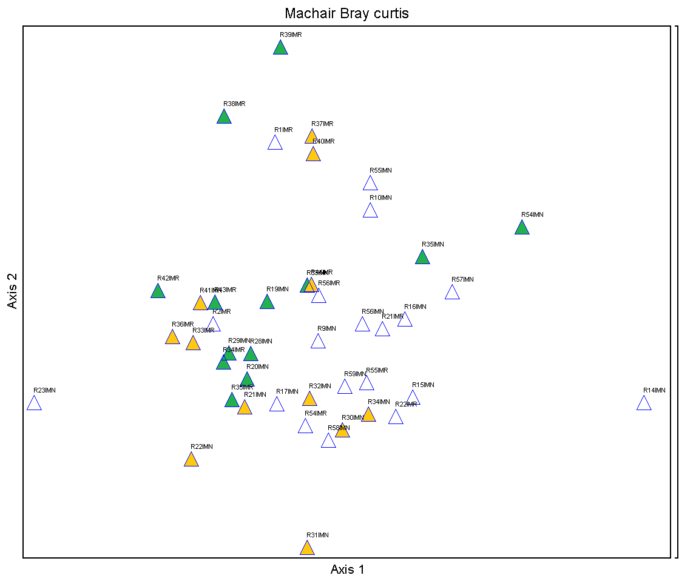
Fig 2. Bray Curtis ordination of seaweed( green triangles) and no seaweed (yellow triangles) relevés plotted alongside other machair relevés (white triangles) on Inis Mór and Inis Meáin.
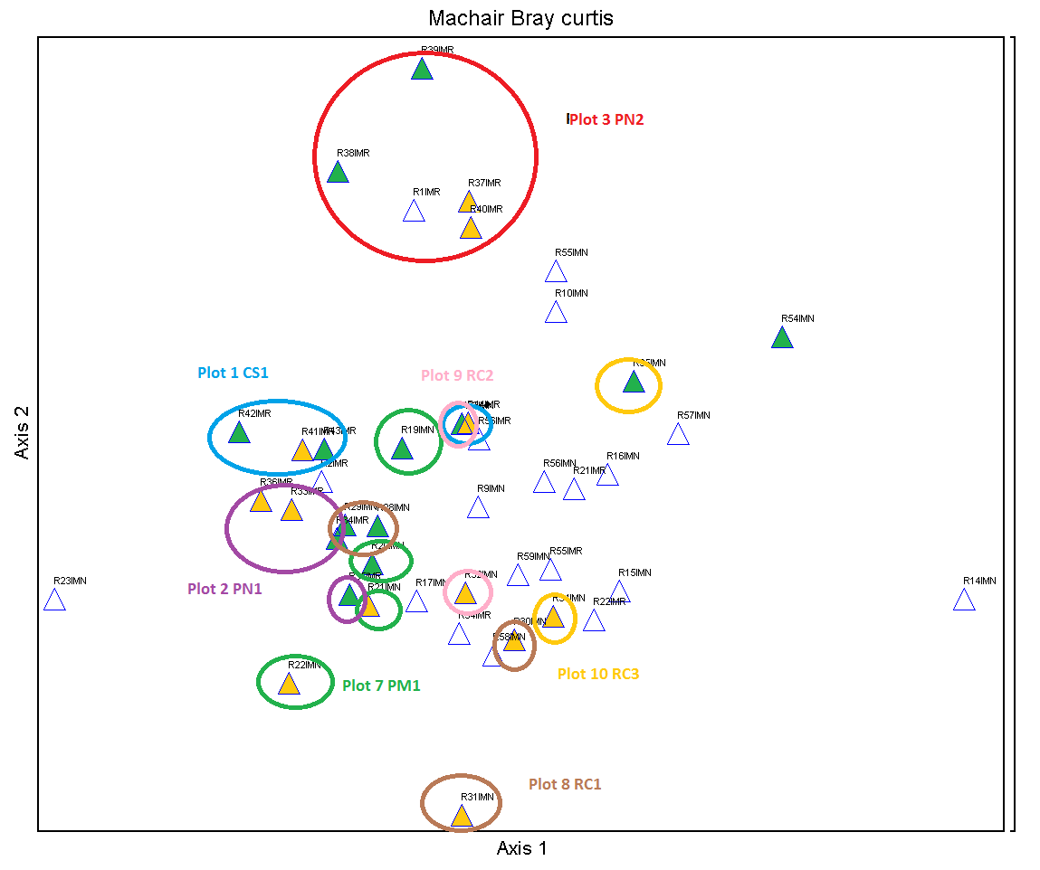
Fig.3. Bray Curtis diagram of the machair releveés. Relevés in seaweed plots (green triangles) and in adjacent untreated areas (yellow triangles) are grouped together in their respective plots.

Fig.4. Average percentage cover of bryophytes in seaweed treatment plots and in adjacent untreated plots
The cover of bryophytes appears to be reduced in most of the seaweed treated plots (Fig. 4). The exception to this is Plot3 PN2 which was an extremely eroded site has increased its cover of bryophytes within the seaweed treated plot.

There is an apparent increase in sedge and grass cover in seaweed treated areas in 50% of the plots (Figs 5 & 6)

Fig.5. Average percentage cover of sedges within seaweed treated (red) and untreated areas (blue)

Fig. 6. Average percentage cover of grass within seaweed treated (red) and untreated areas (blue)

There is an apparent decrease in % broadleaf cover in seaweed treated areas in 60% of the plots (Fig. 7).

Fig. 7. Average percentage cover of broadleaves within seaweed treated (red) and untreated areas (blue)

Table 4. Relevés within seaweed plots (green) and in adjacent untreated plots (yellow). The cover/abundance of species is given in the Domin scale. Dry Matter Yield t/ha for seaweed and untreated plots is also given. % bare ground, %bryophytes, %grass, %sedge and % broadleaved cover per relevé is also presented. Median herb and grass height was recorded for each relevé and is presented below as is the total number of species per relevé.
 | Seaweed |  |  |  |  |  |  |  |  |  |  |  |  |  | No Seaweed
Relevés | R19IMN | R20IMN | R28IMN | R29IMN | R33IMN | R35IMN | R54IMN | R34IMR | R35IMR | R38IMR | R39IMR | R42IMR | R43IMR | R21IMN |  | R22IMN | R32IMN | R34IMN | R30IMN | R31IMN | R14IMN* | R59IMN | R33IMR | R36IMR | R37IMR | R40IMR | R41IMR | R44IMR
Dry Matter Yield (t)/ha | 3.5 | 1.8 | 1.1 | 1.4 | 0.7 | 0.09 | - | 0.8 | 1.4 | 0.6 | 1.5 | 0.3 | 1.3 | 0.9 |  | 2 | 0.5 | 0.4 | 0.9 | 0.9 | - | - | 0.8 | 0.8 | - | - | 1.3 | 0.6
% bare ground | 0 | 0 | 2 | 0 | 1 | 40 | 50 | 0 | 0 | 5 | 15 | 1 | 0 | 0 |  | 0 | 1 | 0 | 0 | 0 | 60 | 0 | 0 | 0 | 50 | 50 | 0 | 0
% grass | 100 | 100 | 30 | 10 | 40 | 15 | 20 | 60 | 60 | 65 | 60 | 50 | 35 | 90 |  | 75 | 15 | 30 | 5 | 15 | 30 | 60 | 50 | 15 | 30 | 30 | 70 | 65
% sedge | 0 | 10 | 70 | 10 | 5 | 35 | 0 | 30 | 30 | 0 | <1 | 10 | 1 | 2 |  | 0 | 15 | 5 | <1 | 0 | 0 | 10 | 15 | 10 | 0 | <1 | 5 | 5
% broadleaves | 50 | 45 | 70 | 50 | 80 | 11 | 12 | 60 | 30 | 30 | 40 | 60 | 35 | 75 |  | 80 | 50 | 40 | 50 | 30 | 3 | 40 | 55 | 50 | 15 | 3 | 50 | 60
% bryophytes | 0 | 25 | 45 | 70 | 60 | 0 | 5 | 70 | 70 | 30 | 10 | 65 | 70 | 80 |  | 70 | 90 | 90 | 90 | 100 | 1 | 60 | 90 | 90 | 5 | 0 | 80 | 75
Median grass height cm | 50 | 50 | 30 | 10 | 10 | 10 | 2 | 20 | 15 | 5 | 4 | 5 | 5 | 30 |  | 25 | 10 | 5 | 15 | 20 | 20 | 20 | 20 | 15 | 5 | 3 | 7 | 4
Median herb height cm | 20 | 20 | 20 | 10 | 15 | 15 | 10 | 5 | 5 | 5 | 2 | 5 | 5 | 15 |  | 10 | 10 | 5 | 10 | 20 | 10 | 20 | 10 | 5 | 2 | 3 | 7 | 5
Soil depth range cm | - | - | - | - | - | - | 25+ | - | - | 11 25+ | 8 20 | 25+ | 25+ | - |  | - | - | - | - | - | - | - | - | - | 11 25+ | 25+ | 25+ | 11 25+
Total species no. | 14 | 21 | 24 | 27 | 23 | 14 | 15 | 17 | 18 | 19 | 19 | 18 | 23 | 25 |  | 18 | 26 | 21 | 26 | 17 | 17 | 30 | 22 | 18 | 14 | 13 | 19 | 23
Stellaria media |  |  | 1 | 1 | 1 | 1 |  |  |  |  |  |  |  |  |  |  | 3
Bellis perennis |  |  |  |  |  |  |  |  |  | 1 |  |  | 3
Rhytidiadelphus squarrosus |  | 4 | 7 | 8 |  |  |  | 8 | 8 |  |  | 8 | 6 | 8 |  | 8 | 5 | 5 | 8 | 8 |  | 5 | 8 | 8 |  |  | 8 | 7
Scleropodium purum |  | 4 |  |  |  |  | 3 | 4 | 4 |  |  |  |  | 7 |  |  | 5 | 4 | 6 | 5 | 3 | 4 | 5 | 5 |  |  | 4 | 5
Rhinanthus minor |  |  | 7 |  |  |  |  |  |  |  |  |  |  | 5 |  | 4 | 5 | 4 | 7 | 6 | 4 | 5
Rumex acetosa |  | 1 |  |  |  |  |  |  |  |  |  |  |  | 3 |  | 4 |  |  |  | 4 | + | 4 | 4 |  |  |  | 1 | 1
Peltigera canina |  |  |  |  |  |  |  |  |  |  |  |  |  |  |  |  |  |  | 1 |  |  |  |  | 1 | + |  | 1
Leontodon autumnalis |  |  |  |  |  |  |  |  |  |  |  |  |  |  |  |  |  | 1 |  |  |  | 1
Cuscuta epithymum |  |  |  |  |  |  |  |  | 4 |  |  | 4 |  |  |  |  |  |  |  |  |  |  | 4 | 4 |  |  | 6 | 6
Festuca rubra | 7 | 7 | 5 | 4 | 7 | 4 |  | 8 | 7 | 8 | 7 | 7 | 6 | 8 |  |  | 5 | 6 | 4 | 4 | 4 | 8 | 7 | 5 | 6 | 6 | 8 | 8
Asperula cynanchica | 3 | 4 | 4 | 7 | 8 | 4 | 3 | 6 | 5 | 5 | 4 | 4 | 4 | 4 |  | 5 | 7 | 6 | 7 |  |  |  | 5 | 5 | 5 | 3 | 4 | 6
Galium verum | 6 | 6 | 5 | 5 | 6 |  |  | 5 | 4 | 4 |  | 6 | 6 | 7 |  | 7 | 5 | 4 | 4 | 8 |  | 5 | 5 | 5 | 4 | 3 | 6 | 4
Trifolium repens | 4 | 3 | 5 | 4 |  |  | 1 | 7 | 4 | 3 | 1 | 5 | 1 | 5 |  | 6 | 4 |  | 3 | 4 | + | 4 | 4 | 4 |  | 1 | 3
Lotus corniculatus | 5 | 4 | 4 | 4 | 1 |  |  |  |  | 3 | 5 | 5 | 4 | 4 |  | 6 | 1 | 1 | 3 |  |  | 4 | 6 | 4 | 4 | 1 | 4 | 4
Plantago lanceolata | 3 | 4 | 3 | 3 | 1 | 3 | 3 | 3 | 1 |  |  | 1 | 1 | 1 |  | 4 | 1 | 4 | 3 | 4 | 3 | 4 | 3 |  |  |  |  | 3
Cerastium fontanum | 3 | 1 | 4 | 4 | 3 |  |  | 3 | 1 | 4 | 4 | 3 | 1 | 4 |  | 3 |  | 1 |  | 1 |  |  | 4 | 4 |  | 1 | 3 | 4
Luzula campestris |  |  | 5 | 4 | 4 | 4 |  | 4 | 6 |  |  | 4 | 4 |  |  | 1 | 4 | 4 | 4 | 3 |  | 4 | 4 | 4 |  |  | 3 | 4
Hypochaeris radicata |  |  | 4 | 4 | 1 | 4 | 4 | 1 | 1 | 1 | 1 |  |  |  |  |  | 4 | 3 |  |  |  |  | 1 | 3 | 1
Trifolium dubium |  |  | 3 | 3 | 3 |  | 3 |  |  |  | 1 |  |  | 5 |  |  | 4 | 1 | 4 | 3 | 3 |  |  |  | 3 | 1 |  | 3
Carex arenaria |  | 4 |  |  |  |  |  | 6 | 6 |  | 1 | 3 | 3 | 3 |  |  | 4 |  |  |  |  |  | 4 | 4 |  | 1 | 1
Calliergonella cuspidatum |  |  |  |  | 4 |  |  | 4 | 4 | 1 | 3 | 1 | 4 | 4 |  |  |  |  |  | 4 |  | 4 | 4 |  |  |  |  | 4
Senecio jacobaea | 3 | 1 |  |  |  |  | 1 |  |  |  | 1 |  | 1 | 1 |  | 3 |  |  | 4 |  | 3 | 1 |  |  |  |  |  | 3
Homalaothesium lutescens |  |  | 4 | 4 |  |  | 3 |  |  | 5 | 5 | 4 |  |  |  |  |  |  | 4 |  |  | 4 |  |  | 1 |  | 4 | 5
Agrostis stolonifera |  |  |  |  |  | 5 |  | 4 |  | 4 | 4 |  |  |  |  |  |  |  |  |  |  |  | 5 | 3 | 1 | 3 | 4 | 4
Dactylis glomerata | 4 | 4 |  |  | 1 | 4 | 3 |  |  |  |  |  |  | 4 |  | 4 |  |  | 1 |  | 3 |  |  |  | +
Anagallis arvensis |  |  |  |  |  |  | 3 |  |  | 1 | 1 | 1 | 1 |  |  |  |  |  |  |  | + |  | 1 | 1 |  | 1
Arrhenatherum elatius | 8 | 8 | 4 |  |  |  |  |  |  |  |  |  |  | 7 |  | 8 |  |  | 1 | 4 |  |  |  | 1
Carex flacca |  |  |  | 4 | 4 | 6 |  |  |  |  |  | 4 |  |  |  |  | 4 |  |  |  |  | 4 | 4 |  |  |  | 4
Poa pratensis |  | 1 |  |  | 1 |  |  |  | 5 |  |  | 1 | 1 | 3 |  |  |  |  |  |  |  | 4 |  |  |  |  |  | 1
Ranunculus bulbosus | 1 |  |  |  |  |  |  | 3 | 1 |  |  | 1 | 1 |  |  |  |  |  |  |  |  | 1 | 3 |  |  |  |  | 1
Veronica chamaedrys |  | 1 |  | 1 |  |  |  |  | 1 |  |  |  |  | 7 |  | 4 |  |  | 1 | 1 |  | 4
Viola tricolor |  |  |  |  |  |  |  |  |  | 3 | 1 | 1 | 1 |  |  |  |  |  |  |  |  |  |  | + | 1 | 1 |  | 1
Campanula rotundifolia |  | 1 |  | 3 |  | 4 |  |  | 1 |  |  |  |  |  |  |  | 1 | 1 |  |  |  | 5
Euphrasia officinalis agg. |  |  | 6 |  |  |  |  |  |  |  |  |  | 1 | 4 |  | 5 |  |  |  |  |  | 5 |  |  |  |  | 4 | 5
Ranunculus repens |  |  |  | 1 | 1 | 1 |  |  |  |  |  |  |  |  |  | 1 |  | 1 | 1 | 1
Anthylis vulneraria |  |  | 5 | 4 | 4 | 3 |  |  |  |  |  |  |  |  |  | 5 |  |  | 5
Cerastium glomeratum |  |  | 4 | 1 | 3 |  |  |  | 1 |  |  |  |  |  |  |  | 1 |  | 1
Pillosella officinarum |  |  | 3 | 3 |  |  |  |  |  |  |  |  |  |  |  |  | 1 | 4 | 3 |  | +
Sedum acre |  |  |  |  |  |  |  |  |  | 1 | 4 |  | 1 |  |  |  |  |  |  |  |  |  |  |  | 3 | 1 |  | 1
Syntrichia ruralis |  |  | 3 |  | 5 |  | 3 |  |  | 1 | 3 |  |  |  |  |  | 6 |  |  |  |  |  |  |  | 5
Blackstonia perfoliata |  |  |  | 1 | 4 |  |  |  |  |  |  |  |  |  |  |  | 1 | 1 |  |  |  | 3
Daucus carota | 3 | 1 |  | 1 |  |  |  |  |  |  |  |  |  | 1 |  |  |  |  |  |  |  | 3
Leontodon taraxacoides |  |  | 1 |  |  |  |  |  |  | 3 | 1 |  |  |  |  |  | 1 |  |  |  |  |  |  |  |  | 1
Sagina nodosa |  |  |  | 1 |  | 3 |  |  |  |  |  |  |  |  |  |  | 4 | 1 | 3
Dicranum scoparium |  |  | 3 | 4 | 4 |  |  |  |  |  |  |  |  |  |  |  | 5 | 4
Centaurium erythraea |  |  |  |  | 3 | 1 |  |  |  |  |  |  |  |  |  |  | 1 | 1
Linum catharticum |  |  |  |  | 1 |  |  |  |  | 1 |  |  |  |  |  |  |  |  |  |  |  | 4 |  |  |  |  |  | 3
Agrostis capillaris |  | 1 |  |  |  |  |  |  |  |  |  |  | 1 |  |  |  |  |  |  |  |  |  |  |  |  |  | 4
Aira praecox |  |  |  |  |  |  |  |  |  | 1 | 1 |  |  |  |  |  |  |  |  |  |  |  |  |  | 1
Carex spp |  |  |  | 3 |  |  |  | 4 |  |  |  |  |  |  |  |  |  |  | 3
Lolium perenne |  |  |  |  |  |  | 5 |  |  |  |  |  |  |  |  |  |  |  |  |  | 5 | 4
Phleum pratensis |  |  |  |  |  |  |  | 4 |  |  |  |  |  |  |  |  | 1 |  |  |  |  |  |  | 3
Crepis capillaris |  |  |  |  |  |  | 3 |  |  |  |  |  |  |  |  | 1 |  |  |  |  | +
Viol sp. |  |  |  | 3 |  |  |  |  |  |  |  |  |  |  |  |  | 1 |  |  |  |  | 1
Holcus lanatus |  |  |  |  |  |  |  |  |  |  |  |  |  | 5 |  |  |  |  |  |  |  |  | 4
Poa annua |  |  |  |  |  |  |  |  |  |  | 4 |  |  |  |  |  |  |  |  |  |  | 4
Geranium molle |  |  |  |  |  |  |  |  |  | 1 |  |  | 1
Taraxacum officinale |  |  |  |  |  |  | 3 |  |  |  |  |  |  |  |  |  |  |  |  |  | +
Homalothesium sericeum |  |  |  |  |  |  |  |  |  |  |  |  | 5 |  |  |  |  |  |  |  |  |  |  |  |  |  | 4
Hylocomium splendens |  |  |  |  |  |  |  | 4 |  |  |  |  |  |  |  |  |  |  |  |  |  |  | 3
Rhytidiadelphus triquetrus |  |  |  |  | 5 |  |  |  |  |  |  |  |  |  |  |  |  |  |  |  |  | 4

Species that were only recorded in one relevé: Chenopodium album, Geranium sanguineum (R19IMN), Galium saxatile, Galium spp (R20IMN); Agrostis spp, Thymus polytrichus (R28IMN); Cladonia spp. (R29IMN); Atriplex prostrata (R54IMN); Tortella tortuosa (R43IMR); Centaurea nigra, Elytrigia repens, Ranunculus acris (R21IMN); Ctenidium molluscum (R34IMN); Achillea millefolium, Bromus hordeaceus, Anacamptis pyramidalis (R30IMN); Leucanthemum vulgare (R31IMN); Leontodon hispidus, Medicago sativa, Sanguisorba minor (R214IMN*); Primula spp., Trifolium pratense, Platanthera bifolia (R59IMN); Carex distans (R33IMR); Prunella vulgare (R44IMR).

Table 5. Relevés in seaweed plots (green) and in adjacent untreated (yellow) plots in Inis Mór. Positive indicator species are highlighted in bold and negative indicator species are underlined
 | Seaweed |  |  |  |  |  | No seaweed
Relevés | R34IMR | R35IMR | R38IMR | R39IMR | R42IMR | R43IMR |  | R33IMR | R36IMR | R37IMR | R40IMR | R41IMR | R44IMR
Dmyield(t) per ha | 0.8 | 1.3 | 0.6 | 1.5 | 0.3 | 1.3 |  | 2.1 | 0.8 |  |  | 1.3 | 0.6
% Bare ground | 0 | 0 | 5 | 15 | 1 | 0 |  | 0 | 0 | 50 | 50 | 0 | 0
% Grass | 60 | 60 | 65 | 60 | 50 | 35 |  | 50 | 15 | 30 | 30 | 70 | 65
% Sedge | 30 | 30 | 0 | <1 | 10 | 1 |  | 5 | 10 | 0 | <1 | 5 | 0
% Broadleaves | 60 | 30 | 30 | 40 | 60 | 35 |  | 55 | 50 | 15 | 3 | 50 | 60
% Bryophytes | 70 | 70 | 30 | 10 | 65 | 70 |  | 90 | 90 | 15 | 0 | 80 | 75
Total species no. | 17 | 18 | 19 | 19 | 18 | 23 |  | 22 | 18 | 14 | 13 | 19 | 23
Calliergonella cuspidata | 4 | 4 | 1 | 3 | 1 | 4 |  | 4 |  |  |  |  | 4
Bellis perennis |  |  | 1 |  |  | 3
Poa pratensis |  | 5 |  |  | 1 | 1 |  |  |  |  |  |  | 1
Geranium molle |  |  | 1 |  |  | 1
Scleropodium purum | 4 | 4 |  |  |  |  |  | 5 | 5 |  |  | 4 | 5
Trifolium dubium |  |  |  | 1 |  |  |  |  |  | 3 | 1 |  | 3
Rumex acetosa |  |  |  |  |  |  |  | 4 |  |  |  | 1 | 1
Peltigera canina |  |  |  |  |  |  |  |  | 1 | + |  | 1
Festuca rubra | 8 | 7 | 8 | 7 | 7 | 6 |  | 7 | 5 | 6 | 6 | 8 | 8
Asperula cynanchica | 6 | 5 | 5 | 4 | 4 | 4 |  | 5 | 5 | 5 | 3 | 4 | 6
Cerastium fontanum | 3 | 1 | 4 | 4 | 3 | 1 |  | 4 | 4 |  | 1 | 3 | 4
Galium verum | 5 | 4 | 4 |  | 6 | 6 |  | 5 | 5 | 4 | 3 | 6 | 4
Trifolium repens | 7 | 4 | 3 | 1 | 5 | 1 |  | 4 | 4 |  | 1 | 3
Lotus corniculatus |  |  | 3 | 5 | 5 | 4 |  | 6 | 4 | 4 | 1 | 4 | 4
Carex arenaria | 6 | 6 |  | 1 | 3 | 3 |  | 4 | 4 |  | 1 | 1
Agrostis stolonifera | 4 |  | 4 | 4 |  |  |  | 5 | 3 | 1 | 3 | 4 | 4
Rhytidiadelphus squarrosus | 8 | 8 |  |  | 8 | 6 |  | 8 | 8 |  |  | 8 | 7
Luzula campestris | 4 | 6 |  |  | 4 | 4 |  | 4 | 4 |  |  | 3 | 4
Viola tricolor |  |  | 3 | 1 | 1 | 1 |  |  | + | 1 | 1 |  | 1
Hypochaeris radicata | 1 | 1 | 1 | 1 |  |  |  | 1 | 3 | 1
Anagallis arvensis |  |  | 1 | 1 | 1 | 1 |  | 1 | 1 |  | 1
Plantago lanceolata | 3 | 1 |  |  | 1 | 1 |  | 3 |  |  |  |  | 3
Homalothecium lutescens |  |  | 5 | 5 | 4 |  |  |  |  | 1 |  | 4 | 5
Ranunculus bulbosus | 3 | 1 |  |  | 1 | 1 |  | 3 |  |  |  |  | 1
Cuscuta epithymum |  | 4 |  |  | 4 |  |  | 4 | 4 |  |  | 6 | 6
Sedum acre |  |  | 1 | 4 |  | 1 |  |  |  | 3 | 1 |  | 1
Senecio jacobaea |  |  |  | 1 |  | 1 |  |  |  |  |  |  | 3
Carex flacca |  |  |  |  | 4 |  |  | 4 |  |  |  | 4
Euphrasia officinalis agg. |  |  |  |  |  | 1 |  |  |  |  |  | 4 | 5
Syntrichia ruraralis |  |  | 1 | 3 |  |  |  |  |  | 5
Leontodon taraxacoides |  |  | 3 | 1 |  |  |  |  |  |  | 1
Aira praecox |  |  | 1 | 1 |  |  |  |  |  | 1
Linum catharticum |  |  | 1 |  |  |  |  |  |  |  |  |  | 3
Agrostis capillaris |  |  |  |  |  | 1 |  |  |  |  |  | 4
Phleum pratensis | 4 |  |  |  |  |  |  |  | 3
Homalothecium sericeum |  |  |  |  |  | 5 |  |  |  |  |  | 4
Hylocomium splendens | 4 |  |  |  |  |  |  | 3
Species that occur in just one relevé: Carex spp (R34IMR); Veronica chamaedrys, Campanula rotundifolia, Cerastium glomeratum (R35IMR); Poa annua (R39IMR); Tortella tortuosa (R43IMR); Carex distans, Holcus lanatus (R33IMR); Arrhenatherum elatius (R36IMR); Dactylis glomerata (R37IMR); Prunella vulgaris (R44IMR).

Table 6. Relevés in seaweed plots (green) and in adjacent untreated (yellow) plots in Inis Meáin. Positive indicator species are highlighted in bold and negative indicator species are underlined.
 | Seaweed |  |  |  |  |  |  | No Seaweed
Relevés | R19IMN | R20IMN | R28IMN | R29IMN | R33IMN | R35IMN | R54IMN | R21IMN | R22IMN | R32IMN | R34IMN | R30IMN | R31IMN | R59IMN | R14IMN*
DM yield(t) per ha | 3.6 | 1.8 | 1.1 | 1.4 | 0.8 | 0.1 |  | 1.0 | 2.0 | 0.5 | 0.8 | 0.9 | 0.9
% Bare ground | 0 | 0 | 2 | 0 | 1 | 40 | 50 | 0 | 0 | 1 | 0 | 0 | 0 | 0 | 60
% Grass | 100 | 100 | 30 | 10 | 40 | 15 | 20 | 90 | 75 | 15 | 30 | 5 | 15 | 60 | 30
% Sedge | 0 | 10 | 70 | 10 | 5 | 35 | 0 | 2 | 0 | 15 | 5 | <1 | 0 | 10 | 0
% Broadleaves | 50 | 45 | 70 | 50 | 80 | 11 | 12 | 75 | 80 | 50 | 40 | 50 | 30 | 40 | 3
% Bryophytes | 0 | 25 | 45 | 70 | 60 | 0 | 5 | 80 | 70 | 90 | 90 | 90 | 100 | 60 | 1
Total species no. | 14 | 21 | 24 | 27 | 23 | 14 | 15 | 25 | 18 | 26 | 21 | 26 | 17 | 30 | 17
Stellaria media |  |  | 1 | 1 | 1 | 1 |  |  |  | 3
Hypochaeris radicata |  |  | 4 | 4 | 1 | 4 | 4 |  |  | 4 | 3
Anthylis vulneraria |  |  | 5 | 4 | 4 | 3 |  |  | 5 |  |  | 5
Syntrichia ruralis |  |  | 3 |  | 5 |  | 3 |  |  | 6
Rhytidiadelphs squarrosus |  | 4 | 7 | 8 |  |  |  | 8 | 8 | 5 | 5 | 8 | 8 | 5
Scleropodium purum |  | 4 |  |  |  |  | 3 | 7 |  | 5 | 4 | 6 | 5 | 4 | 3
Rhinanthus minor |  |  | 7 |  |  |  |  | 5 | 4 | 5 | 4 | 7 | 6 | 5 | 4
Rumex acetosa |  | 1 |  |  |  |  |  | 3 | 4 |  |  |  | 4 | 4 | +
Euphrasia officinalis agg. |  |  | 6 |  |  |  |  | 4 | 5 |  |  |  |  | 5
Peltigera canina |  |  |  |  |  |  |  |  |  |  |  | 1
Leontodon autumnalis |  |  |  |  |  |  |  |  |  |  | 1 |  |  | 1
Plantago lanceolata | 3 | 4 | 3 | 3 | 1 | 3 | 3 | 1 | 4 | 1 | 4 | 3 | 4 | 4 | 3
Festuca rubra | 7 | 7 | 5 | 4 | 7 | 4 |  | 8 |  | 5 | 6 | 4 | 4 | 8 | 4
Asperula cynanchica | 3 | 4 | 4 | 7 | 8 | 4 | 3 | 4 | 5 | 7 | 6 | 7
Galium verum | 6 | 6 | 5 | 5 | 6 |  |  | 7 | 7 | 5 | 4 | 4 | 8 | 5
Trifolium repens | 4 | 3 | 5 | 4 |  |  | 1 | 5 | 6 | 4 |  | 3 | 4 | 4 | +
Lotus corniculatus | 5 | 4 | 4 | 4 | 1 |  |  | 4 | 6 | 1 | 1 | 3 |  | 4
Luzula campestris |  |  | 5 | 4 | 4 | 4 |  |  | 1 | 4 | 4 | 4 | 3 | 4
Trifolium dubium |  |  | 3 | 3 | 3 |  | 3 | 5 |  | 4 | 1 | 4 | 3 |  | 3
Cerastium fontanum | 3 | 1 | 4 | 4 | 3 |  |  | 4 | 3 |  | 1 |  | 1
Dactylis glomerata | 4 | 4 |  |  | 1 | 4 | 3 | 4 | 4 |  |  | 1 |  |  | 3
Senecio jacobaea | 3 | 1 |  |  |  |  | 1 | 1 | 3 |  |  | 4 |  | 1 | 3
Arrhenatherum elatius | 8 | 8 | 4 |  |  |  |  | 7 | 8 |  |  | 1 | 4
Veronica chamaedrys |  | 1 |  | 1 |  |  |  | 7 | 4 |  |  | 1 | 1 | 4
Campanula rotundifolia |  | 1 |  | 3 |  | 4 |  |  |  | 1 | 1 |  |  | 5
Ranunculus repens |  |  |  | 1 | 1 | 1 |  |  | 1 |  | 1 | 1 | 1
Pillosella officinarum |  |  | 3 | 3 |  |  |  |  |  | 1 | 4 | 3 |  |  | +
Homalothecium lutescens |  |  | 4 | 4 |  |  | 3 |  |  |  |  | 4 |  | 4
Carex flacca |  |  |  | 4 | 4 | 6 |  |  |  | 4 |  |  |  | 4
Cerastium glomeratum |  |  | 4 | 1 | 3 |  |  |  |  | 1 |  | 1
Blackstonia perfoliata |  |  |  | 1 | 4 |  |  |  |  | 1 | 1 |  |  | 3
Daucus carota | 3 | 1 |  | 1 |  |  |  | 1 |  |  |  |  |  | 3
Sagina nodosa |  |  |  | 1 |  | 3 |  |  |  | 4 | 1 | 3
Dicranum scoparium |  |  | 3 | 4 | 4 |  |  |  |  | 5 | 4
Calliergonella cuspidatum |  |  |  |  | 4 |  |  | 4 |  |  |  |  | 4 | 4
Poa pratensis |  | 1 |  |  | 1 |  |  | 3 |  |  |  |  |  | 4
Centaurium erythraea |  |  |  |  | 3 | 1 |  |  |  | 1 | 1
Carex arenaria |  | 4 |  |  |  |  |  | 3 |  | 4
Lolium perenne |  |  |  |  |  |  | 5 |  |  |  |  |  |  | 4 | 5
Crepis capillaris |  |  |  |  |  |  | 3 |  | 1 |  |  |  |  |  | +
Viola sp. |  |  |  | 3 |  |  |  |  |  | 1 |  |  |  | 1
Anagallis arvensis |  |  |  |  |  |  | 3 |  |  |  |  |  |  |  | +
Ranunculus bulbosus | 1 |  |  |  |  |  |  |  |  |  |  |  |  | 1
Leontodon taraxacoides |  |  | 1 |  |  |  |  |  |  | 1
Linum catharticum |  |  |  |  | 1 |  |  |  |  |  |  |  |  | 4
Carex spp |  |  |  | 3 |  |  |  |  |  |  |  | 3
Taraxacum officinale |  |  |  |  |  |  | 3 |  |  |  |  |  |  |  | +
Rhytidiadelphus triquetrus |  |  |  |  | 5 |  |  |  |  |  |  |  |  | 4

Species that occur in only one relevé: Chenopodium album, Geranium sanguineum (R19IMN); Agrostis capillaris, Galium saxatile, Galium spp. (R20IMN); Agrostis spp., Thymus polytrichus (R28IMN); Cladonia spp. (R29IMN); Agrostis stolonifera (R35IMN); Atriplex prostrata (R54IMN); Holcus lanatus, Elytrigia repens, Centaurea nigra, Ranunculus acris (R21IMN); Phleum pratense (R32IMN); Ctenidium molluscum (R34IMN); Achillea millefolium, Bromus hordeaceus, Anacamptis pyramidalis (R30IMN); Leucanthemum vulgare (R31IMN); Primula spp., Poa annua, Trifolium pratense, Platanthera bifolia (R59IMN); Medicago sativa, Leontodon hispidus, Sanguisorba minor (R14IMN*).

Machair vegetation is highly variable owing to the dynamic nature of the habitat and this is shown in the variation between machair habitat between Inis Mór and Inis Meáin (Tables 5 & 6)

Species that were only recorded machair on Inis Mór (positive indicator species in bold and negative indicator species underlined):
Viola tricolor, Cuscuta epithymum, Sedum acre, Aira praecox, Geranium molle, Homalothecium sericeum, Hylocomium splendens, Carex distans, Prunella vulgare, Tortella tortuosa, Bellis perennis

Species that were only recorded on machair on Inis Meáin (positive indicator species in bold and negative indicator species underlined):
Ranunculus repens, Anthyllis vulneraria, Pillosella officinarum, Blackstonia perfoliata, Daucus carota, Sagina nodosa, Dicranum scoparium, Centaurea erythraea, Lolium perenne, Crepis capillaris, Taraxacum officinale, Rhytidiadelphus triquetrus, Agrostis spp., Bromus hordeaceus, Elytrigia repens, Achillea millefolium, Atriplex prostrata, Centaurea nigra, Chenopodium album, Galium saxatile, Galium spp, Geranium sanguineum, Leontodon hispidus, Leucanthemum vulgare, Medicago sativa, Primula spp, Ranunculus acris, Sanguisorba minor, Trifolium pratense, Anacamptis pyramidalis, Platanthera bifolia, Ctenidium molluscum, Cladonia spp., Thymus polytrichum, Leontodon autumnalis, Rhinanthus minor, Stellaria media.

Dry matter yields in machair plots
Forage samples were collected throughout the plots and in adjacent control areas and the dry matter yields of the vegetation were calculated (Fig. 7).
The dry matter yield is greater in the seaweed plots than in the corresponding untreated areas: Plot2 PN1, Plot 8 RC1, Plot 9 RC2 (Fig. 7).
In Plot 3 PN2, the adjacent untreated area is badly eroded and lacks vegetation cover and a forage sample was not possible, this was also the case for Plot 11SOD 1. Forage sample was not collected from the untreated area of Plot 11 SOD1 (Fig. 7).

In Plot 10, the area treated with seaweed had particularly sparse vegetation cover, whereas adjacent areas had more vegetation cover, and hence greater dry matter yield (Fig 7).

The Inis Mór plots at Trá Mór (Plots 1, 2 and 3) are subject to considerable grazing pressure from rabbits which are impacting on the dry matter yields in both treated and untreated areas. Rabbits are also becoming more frequent on the Inis Meáin machair (Plots 7 to 11).

Fig. 7. Dry matter yields in seaweed plots (green columns) and adjacent control areas (yellow columns)

Soils
Machair soils within seaweed plots and in adjacent non-seaweed areas were analysed for Phosphorus, Potassium and Magnesium (Table 7). Morgan’s method is the conventional method for analysing mineral soils, however, uncharacteristically high levels of Phosphourus were recorded using Morgans method in these soils as this method is unsuitable for soils with high pH such as occurs in machair soils. Subsequent samples analysed using Olsen’s method yielded more realistic results.
Table 7. The following table shows the results of soil analyses both inside the seaweed plots (green) and in adjacent areas (yellow). The values in the brackets are indices.
Plot | Seaweed Y/N | pH | P (ppm) | K (ppm) | Mg (ppm)
Plot1 CS1 | Y | 8 | 4(0) | 126(2-) | 207(4)
Plot1 CS1 | N | 7.8 | 1(0) | 82(1) | 178(4)
Plot 2 PN1 | Y | 7.8 | 4(0) | 219(2+) | 161(3)
Plot 2 PN1 | N | 8.1 | 2(0) | 83(1) | 147(3)
Plot3 PN2 | Y | 7.5 | 8(0) | 76(1) | 180(4)
Plot 3 PN2 | N | 8 | 6(0) | 35(0) | 169(3)
Plot 7 PM1 | Y | 7.8 | 13(1) | 507(4) | 180(4)
Plot 7 PM1 | N | 7.6 | 4(0) | 94(1) | 122 (3)
Plot 8 RC1 | Y | 8.1 | 5(0) | 76(1) | 127(3)
Plot 8 RC1 | N | 7.8 | 3(0) | 77(1) | 120(3)
Plot 9 RC2 | Y | 8.1 | 3(0) | 87(1) | 116(3)
Plot 9 RC2 | N | 8 | 3(0) | 44(0) | 109(3)
Plot 10 RC3 | Y | 8 | 5(0) | 71(1) | 116(3)
Plot 10 RC3 | N | 8 | 2(0) | 31(0) | 109(3)
Plot11 SOD1 | Y | 8.1 | 11(1) | 36(0) | 130(3)
Plot11 SOD1 | N | 7.7 | 3(0) | 54(0) | 129(3)

Using the Teagasc soil index system (Table 8) (http://www.teagasc.ie/soil/analysis/index_system.asp)
Table 8: The Soil Index System
Soil Index | Index Description | Response to Fertilisers
1 | Very Low | Definite
2 | Low | Likely
3 | Medium | Unlikely/Tenuous
4 | Sufficient/Excess | None

The machair soils have a high pH, and are very low in Phosphorous. Low potash is also a feature of these soils as are high magnesium levels (Table 7 & 8).

Conclusions
After the first year and phase 1 of the seaweed treatment trial of machair on Inis Meáin and Inis Mór, it is apparent that the application of seaweed is having a positive effect of increasing vegetation cover in areas that are bare and exposed. Machair soils have poor water retention capabilities and hence are prone to leaching nutrients. The application of seaweed improves the water retention of the soil and adds organic matter which facilitates the colonising of bare sand areas and the development of vegetation cover.
From the results presented here it is unclear as yet, the effects of seaweed on areas with complete vegetation cover, in some plots there appears to be some reduction in Rhytidiadelphus squarrosus, however, the cover of bryophytes in all of the vegetated plots is still high both in the seaweed treated and untreated areas. Positive indicator species are frequent in both untreated and treated sites and negative indicator species are not abundant at any of the plots.
Phase 2 of the trials will involve the reapplication of seaweed in existing plots, the selection of new plots as well as the monitoring of seaweed application on plots at Kilmurvey, Inis Mór which took place in October 2015. Following on from the mollusc study of proposed plots at Kilmurvey and the other the other plot sites it is evident that existing habitat is as yet unsuitable for Vertigo angustior (Browne 2016) (Appendix 4), the effects of seaweed application on the mollusc communities of the Inis Meáin and Inis Mór will be continued to be monitored over the course of the project.

References
Browne, N. (2016) First monitoring survey for Vertigo angustior and other molluscs at sites chosen for seaweed application trials, AranLIFE project – 2015 survey.

Delaney, A. Devaney, F.M., Martin, J.M. and Barron, S.J. (2013). Monitoring survey of AnnexI sand dune habitats in Ireland. Irish Wildlife Manuals, N0.75. National Parks and Wildlife Service, Department of the Arts, Heritage and the Gaeltacht, Dublin Ireland.

Ferguson, A. (2012). A report on the effect of cutting date on crop quality/yield and the effect of seaweed application on soil nutritive values. A report prepared by SAC consulting on behalf of Machair LIFE.

Moorkens, E.A. & Killeen, I.J. (2011) Monitoring and Condition Assessment of Populations of Vertigo geyeri, Vertigo angustior and Vertigo moulinsiana in Ireland. Irish Wildlife Manuals, No. 55. National Parks and Wildlife Service, Department of Arts, Heritage and Gaeltacht, Dublin, Ireland.

Moorkens, E.A. and Gaynor, K. (2003). “Studies on Vertigo angustior at a coastal site in western Ireland (Gastropoda, Pulmonata: Vertiginidae)” Heldia 5 (7): 125-134.

Ryle, T., Murray, A., Connolly, K. and Swann, M. (2009). Coastal Monitoring Project 2004-2006. A report submitted to the National Parks and Wildlife Service, Dublin

Appendix 1. Inis Mór Seaweed treatment plots
Plot 1 CS1
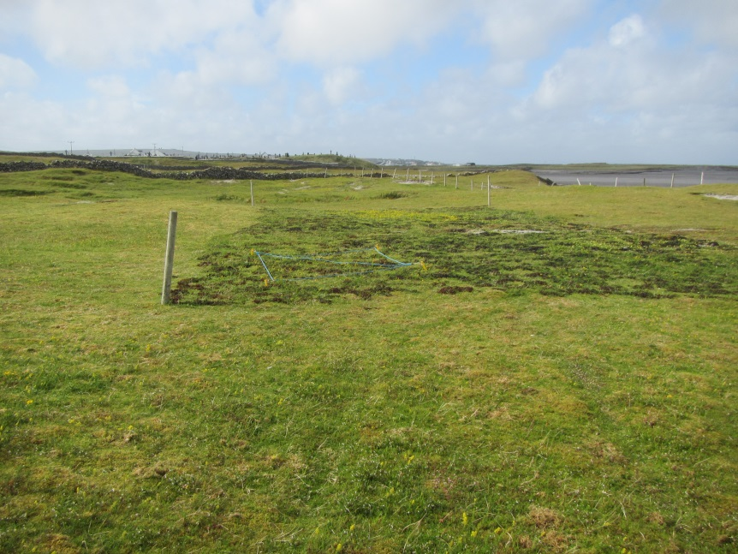

R41IMR no seaweed 04/08/15  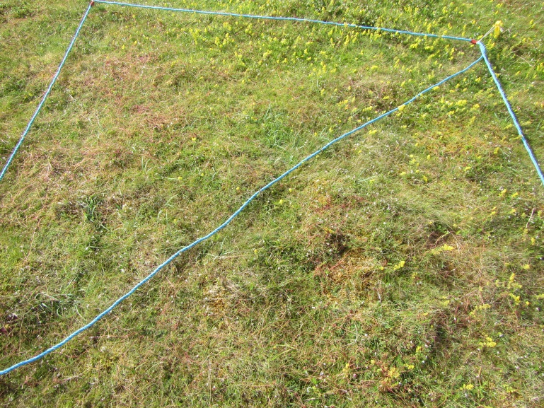 |  |  |  | R42IMR seaweed 04/08/15  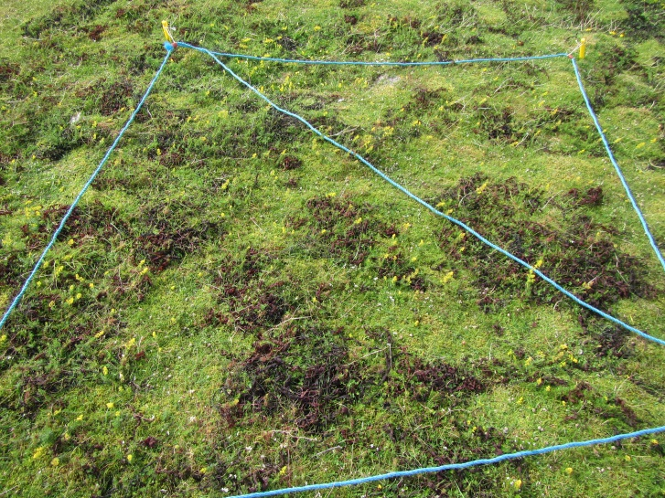
R43IMR seaweed04/08/15  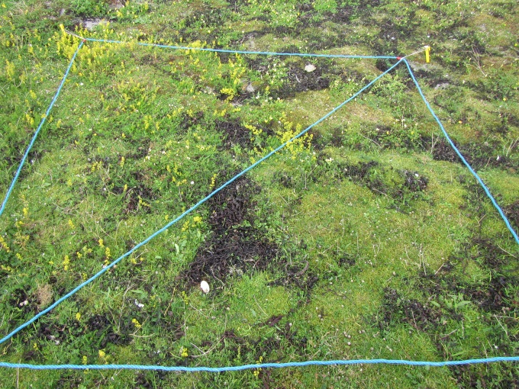 |  |  |  | R44IMR no seaweed 04/08/15  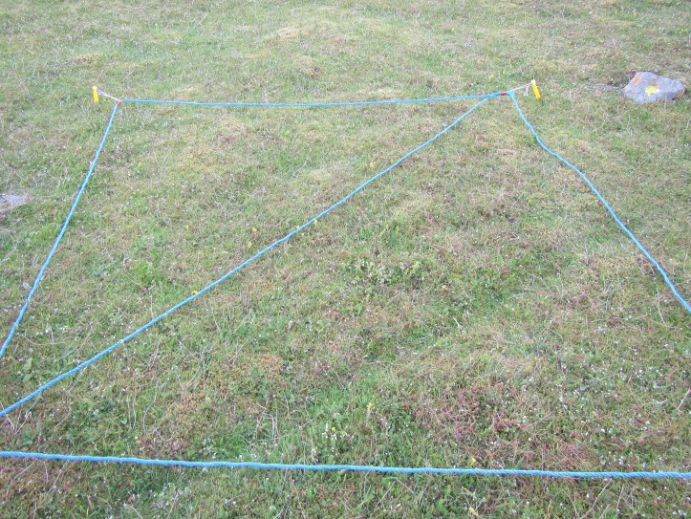
 | Plot 1 CS1 | Seaweed |  |  | No Seaweed
 | Relevés | R42IMR | R43IMR |  | R41IMR | R44IMR
 | Dmyield(t) per ha | 0.3264 | 1.3204 |  | 1.3028 | 0.6016
 | % Bare ground | 1 | 0 |  | 0 | 0
 | % Grass | 50 | 35 |  | 70 | 65
 | % Sedge | 10 | 1 |  | 5 | 0
 | % Broadleaves | 60 | 35 |  | 50 | 60
 | % Bryophytes | 65 | 70 |  | 80 | 75
 | Total species no. | 18 | 23 |  | 19 | 23
 | Anagallis arvensis | 1 | 1
 | Scleropodium purum |  |  |  | 4 | 5
 | Rumex acetosa |  |  |  | 1 | 1
 | Agrostis stolonifera |  |  |  | 4 | 4
 | Festuca rubra | 7 | 6 |  | 8 | 8
 | Asperula cynanchica | 4 | 4 |  | 4 | 6
 | Cerastium fontanum | 3 | 1 |  | 3 | 4
 | Galium verum | 6 | 6 |  | 6 | 4
 | Lotus corniculatus | 5 | 4 |  | 4 | 4
 | Rhytidiadelphus squarrosus | 8 | 6 |  | 8 | 7
 | Luzula campestris | 4 | 4 |  | 3 | 4
 | Trifolium repens | 5 | 1 |  | 3
 | Carex arenaria | 3 | 3 |  | 1
 | Viola tricolor | 1 | 1 |  |  | 1
 | Plantago lanceolata | 1 | 1 |  |  | 3
 | Calliergonella cuspidata | 1 | 4 |  |  | 4
 | Poa pratensis | 1 | 1 |  |  | 1
 | Homalothecium lutescens | 4 |  |  | 4 | 5
 | Ranunculus bulbosus | 1 | 1 |  |  | 1
 | Cuscuta epithymum | 4 |  |  | 6 | 6
 | Euphrasia officinalis agg. |  | 1 |  | 4 | 5
 | Sedum acre |  | 1 |  |  | 1
 | Senecio jacobaea |  | 1 |  |  | 3
 | Carex flacca | 4 |  |  | 4
 | Agrostis capillaris |  | 1 |  | 4
 | Homalothecium sericeum |  | 5 |  | 4
 | Bellis perennis |  | 3
 | Geranium molle |  | 1
 | Tortella tortuosa |  | 5
 | Peltigera canina |  |  |  | 1
 | Prunella vulgaris |  |  |  |  | 1
 | Linum catharticum |  |  |  |  | 3
 | Trifolium dubium |  |  |  |  | 3

Features
There are 11 positive indicator species in both the seaweed and no seaweed plots.
One positive indicator species (Agrostis stolonifera) is confined to the no seaweed plot.
Negative indicator species are absent.
The % cover of bryophytes is high in both seaweed and no seaweed treatments.

Plot 2 PN1
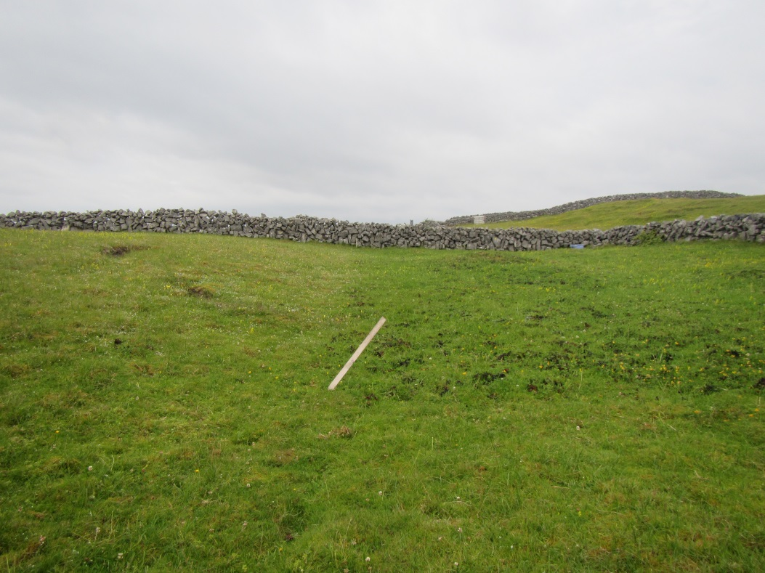
R33 IMR ( no seaweed) 16/7/15  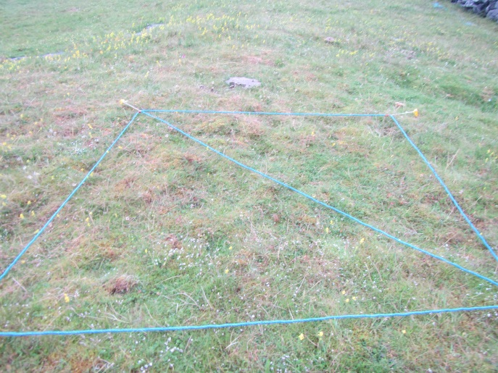 | R34 IMR (seaweed) 16/7/15  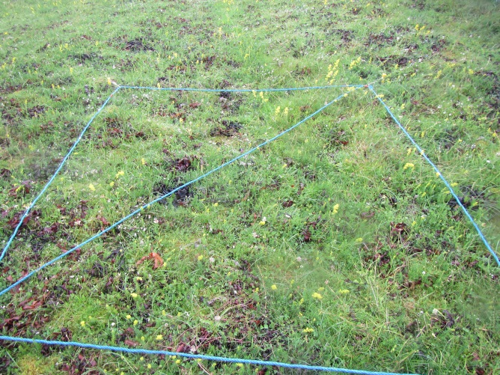
R35IMR (seaweed) 16/7/15  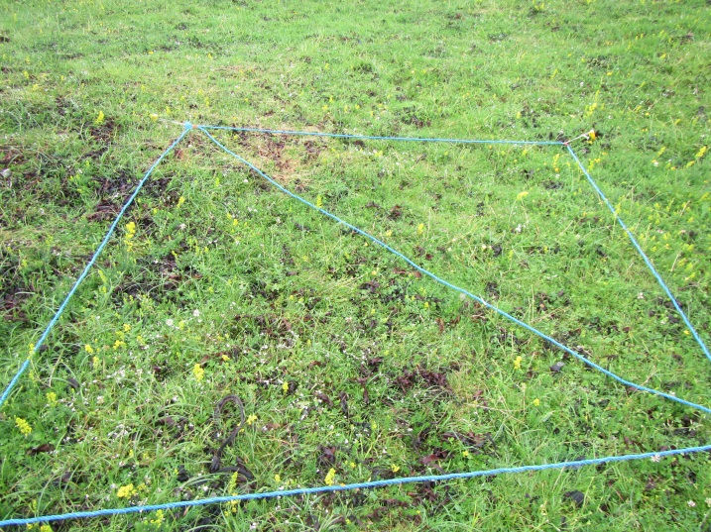 | R36 IMR (no seaweed) 16/7/15  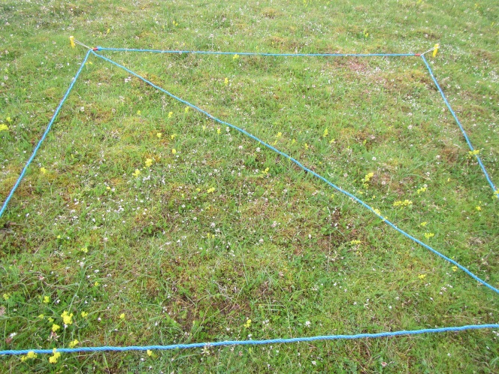

Features
There are five positive indicator species present in both the seaweed treated and untreated areas.
One negative indicator species, Arrehenatherum elatius occurs in the untreated area
The cover of bryophytes is higher in the untreated areas plot, though both treated and untreated areas have a high bryophyte cover.
There is a higher cover of sedges in the seaweed plot.
Two species are absent from the seaweed plot but are present elsewhere: Anagallis arvensis and Lotus corniculatus (a positive indicator species).
Plot2 PN1 | seaweed |  | no seaweed
Relevés | R34IMR | R35IMR | R33IMR | R36IMR
Dmyield(t) per ha | 0.8092 | 1.3496 | 2.0592 | 0.7888
% Bare ground | 0 | 0 | 0 | 0
% Grass | 60 | 60 | 50 | 15
% Sedge | 30 | 30 | 5 | 10
% Broadleaves | 60 | 30 | 55 | 50
% Bryophytes | 70 | 70 | 90 | 90
Total species no. | 17 | 18 | 22 | 18
Lotus corniculatus |  |  | 6 | 4
Anagallis arvensis |  |  | 1 | 1
Scleropodium purum | 4 | 4 | 5 | 5
Festuca rubra | 8 | 7 | 7 | 5
Asperula cynanchica | 6 | 5 | 5 | 5
Cerastium fontanum | 3 | 1 | 4 | 4
Galium verum | 5 | 4 | 5 | 5
Trifolium repens | 7 | 4 | 4 | 4
Carex arenaria | 6 | 6 | 4 | 4
Agrostis stolonifera | 4 |  | 5 | 3
Rhytidiadelphus squarrosus | 8 | 8 | 8 | 8
Luzula campestris | 4 | 6 | 4 | 4
Hypochaeris radicata | 1 | 1 | 1 | 3
Calliergonella cuspidata | 4 | 4 | 4
Plantago lanceolata | 3 | 1 | 3
Ranunculus bulbosus | 3 | 1 | 3
Cuscuta epithymum |  | 4 | 4 | 4
Phleum pratensis | 4 |  |  | 3
Hylocomium splendens | 4 |  | 3
Carex spp | 4
Poa pratensis |  | 5
Veronica chamaedrys |  | 1
Campanula rotundifolia |  | 1
Cerastium glomeratum |  | 1
Carex flacca |  |  | 4
Rumex acetosa |  |  | 4
Carex distans |  |  | 3
Holcus lanatus |  |  | 4
Peltigera canina |  |  |  | 1
Viola tricolor |  |  |  | +
Arrhenatherum elatius |  |  |  | 1

Plot3 PN2
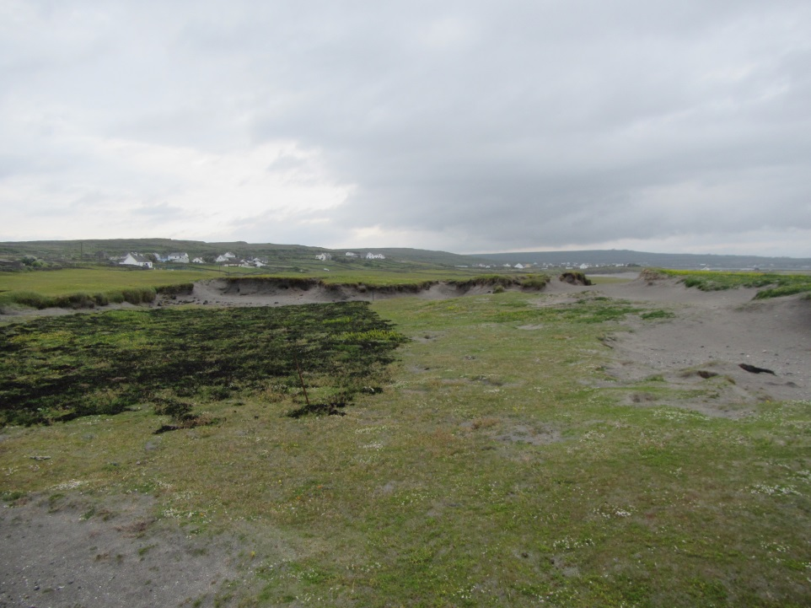
R37IMR No seaweed 4/8/15  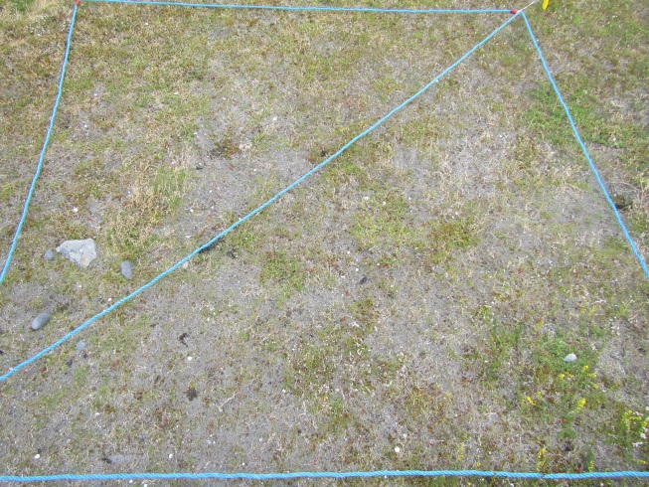 | R38IMR Seaweed 4/8/15  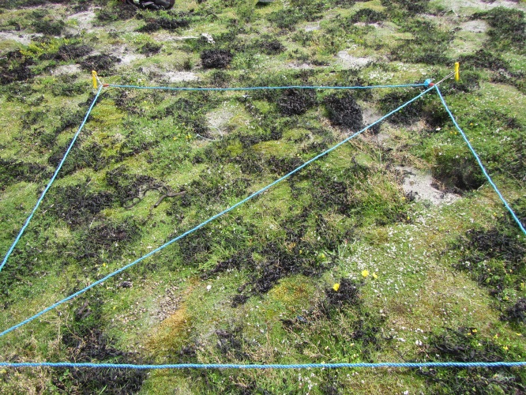
R39IMR Seaweed plot 4/8/15  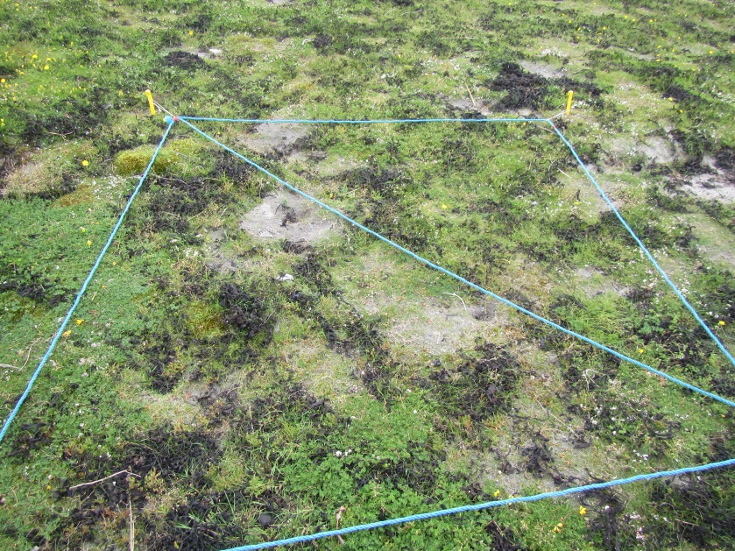 | R40IMR no seaweed 4/8/15  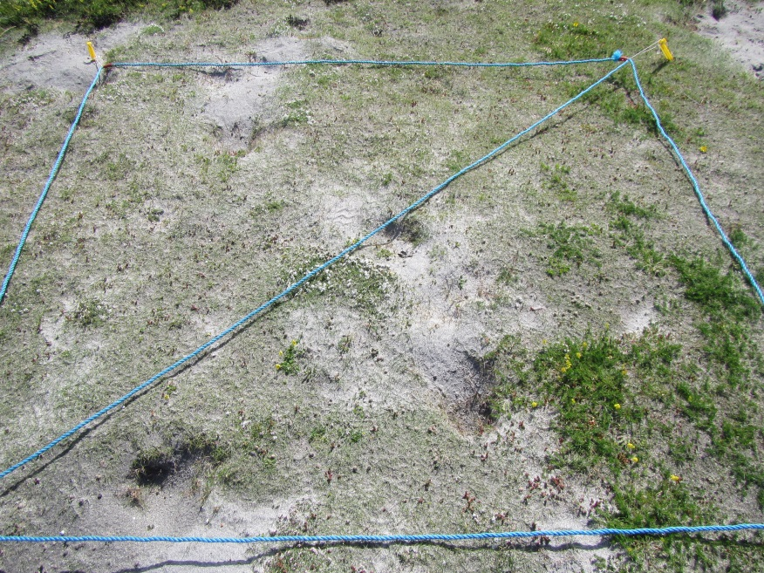

Features
The % bare ground is lower in the seaweed treated area and this corresponds with a higher %cover of grass and broadleaves in the seaweed treated plot.
The % cover bryophytes is higher in the seaweed treated plot as is the total no. of species per relevé.
One species (Calliergonella cuspidata) is only present in both relevés in the seaweed treated plot but absent from releves elsewhere.
Nine positive indicator species occur in both the seaweed treated area and elsewhere.
One negative indicator species occurs in one relevé within the seaweed plot, Senecio jacobaea.
Plot3 PN2
Relevés | R38IMR | R39IMR | R37IMR | R40IMR
Dmyield(t) per ha | 0.6508 | 1.4812
% Bare ground | 5 | 15 | 50 | 50
% Grass | 65 | 60 | 30 | 30
% Sedge | 0 | <1 | 0 | <1
% Broadleaves | 30 | 40 | 15 | 3
% Bryophytes | 30 | 10 | 15 | 0
Total species no. | 19 | 19 | 14 | 13
Calliergonella cuspidata | 1 | 3
Festuca rubra | 8 | 7 | 6 | 6
Lotus corniculatus | 3 | 5 | 4 | 1
Agrostis stolonifera | 4 | 4 | 1 | 3
Viola tricolor | 3 | 1 | 1 | 1
Sedum acre | 1 | 4 | 3 | 1
Asperula cynanchica | 5 | 4 | 5 | 3
Hypochaeris radicata | 1 | 1 | 1
Homalothecium lutescens | 5 | 5 | 1
Syntrichia ruraralis | 1 | 3 | 5
Aira praecox | 1 | 1 | 1
Trifolium dubium |  | 1 | 3 | 1
Galium verum | 4 |  | 4 | 3
Carex arenaria |  | 1 |  | 1
Anagallis arvensis | 1 | 1 |  | 1
Leontodon taraxacoides | 3 | 1 |  | 1
Trifolium repens | 3 | 1 |  | 1
Cerastium fontanum | 4 | 4 |  | 1
Bellis perennis | 1
Linum catharticum | 1
Geranium molle | 1
Poa annu |  | 4
Senecio jacobaea |  | 1
Dactylis glomerata |  |  | +
Peltigera canina |  |  | +

Appendix 2: Seaweed Plots Inis Meáin
Plot 7 PM1
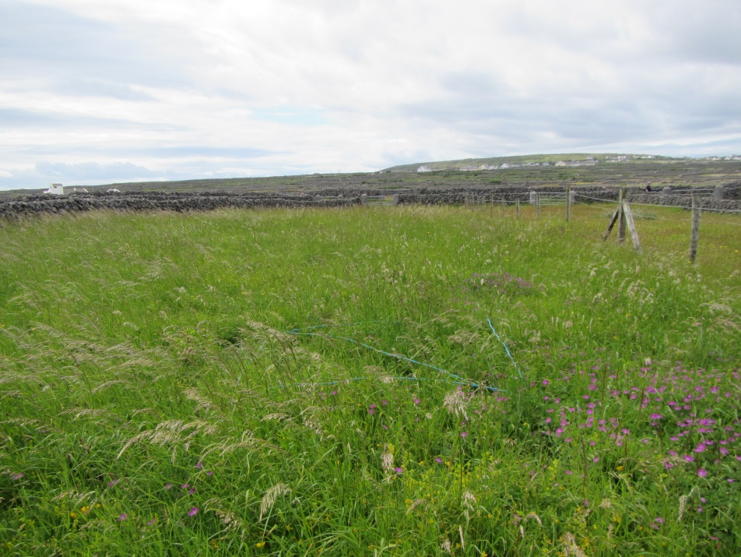
R19IMN (seaweed)  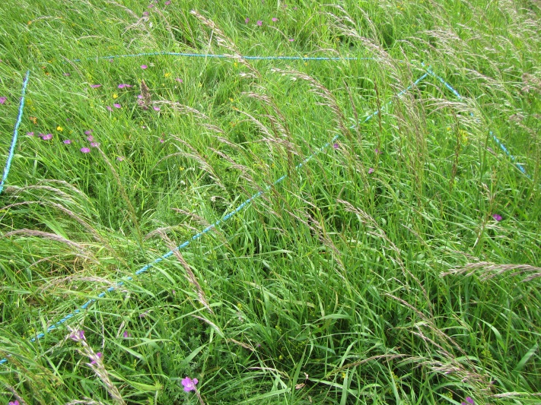 | R21IMN (no seaweed)  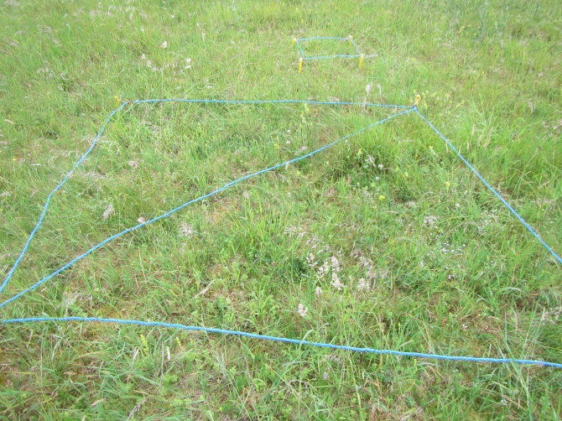
R20IMN (seaweed)  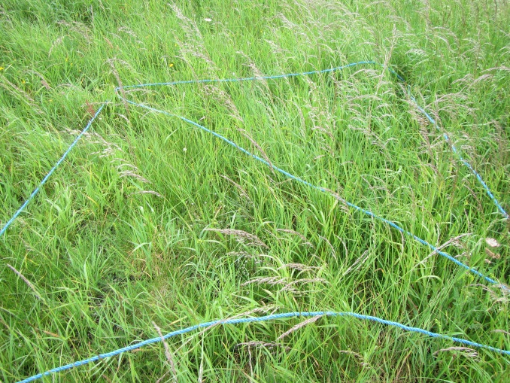 | R22IMN (no seaweed)  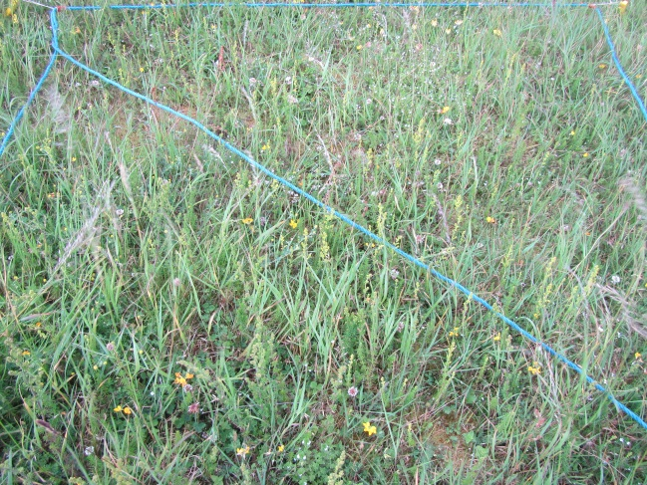

Features
Average Dry Matter yield is higher in the seaweed plot (2.7) than outside (1.5)
There appears to be lower %cover of broadleaves within the seaweed plot than in adjacent areas and a corresponding increase in %grass cover.
Average total species number per releve is higher outside the seaweed plot than inside
Rhinanthus minor and Euphrasia officinalis agg (positive indicator species) only occur in both relevés outside the seaweed plot.
No suite of species occur only in both seaweed plot releves
Rhytidiadelphus squarrosus cover is reduced within the seaweed plot.
Seven positive indicator species occur in relevés outside of seaweed plot.
Four positive indicator species occur within the seaweed plot.
Two negative indicator species occur both within and outside seaweed plot.

Plot 7_PM1 | Seaweed |  | No Seaweed
Relevé | R19IMN | R20IMN | R21IMN | R22IMN
% Bare ground | 0 | 0 | 0 | 0
% Grass | 100 | 100 | 90 | 75
% Sedges | 0 | 10 | 2 | 0
% Broadleaves | 60 | 45 | 75 | 80
% Bryophytes | 0 | 25 | 80 | 70
DM yield(t) per ha | 3.5548 | 1.812 | 0.978 | 1.9916
Total species no. | 14 | 21 | 25 | 18
Rhinanthus minor |  |  | 5 | 4
Euphrasia officinalis agg. |  |  | 4 | 5
Plantago lanceolata | 3 | 4 | 1 | 4
Asperula cynanchica | 3 | 4 | 4 | 5
Galium verum | 6 | 6 | 7 | 7
Trifolium repens | 4 | 3 | 5 | 6
Lotus corniculatus | 5 | 4 | 4 | 6
Cerastium fontanum | 3 | 1 | 4 | 3
Dactylis glomerata | 4 | 4 | 4 | 4
Senecio jacobaea | 3 | 1 | 1 | 3
Arrhenatherum elatius | 8 | 8 | 7 | 8
Veronica chamaedrys |  | 1 | 7 | 4
Rhytidiadelphs squarrosus |  | 4 | 8 | 8
Rumex acetosa |  | 1 | 3 | 4
Daucus carota | 3 | 1 | 1
Festuca ovina/rubra | 7 | 7 | 8
Scleropodium purum |  | 4 | 7
Poa pratensis |  | 1 | 3
Carex arenaria |  | 4 | 3
Ranunculus bulbosus | 1
Chenopodium album | 1
Geraanium sanguineum | 5
Agrostis capillaris |  | 1
Galium saxatile |  | 1
Galium spp |  | 1
Campanula rotundifolia |  | 1
Holcus lanatus |  |  | 5
Calliergonella cuspidatum |  |  | 4
Elytrigia repens |  |  | 3
Centaurea nigra |  |  | 1
Ranunculus acris |  |  | 4
Trifolium dubium |  |  | 5
Anthylis vulneraria |  |  |  | 5
Crepis capillaris |  |  |  | 1
Luzula campestris |  |  |  | 1
Ranunculus repens |  |  |  | 1

Plot 8 RC1
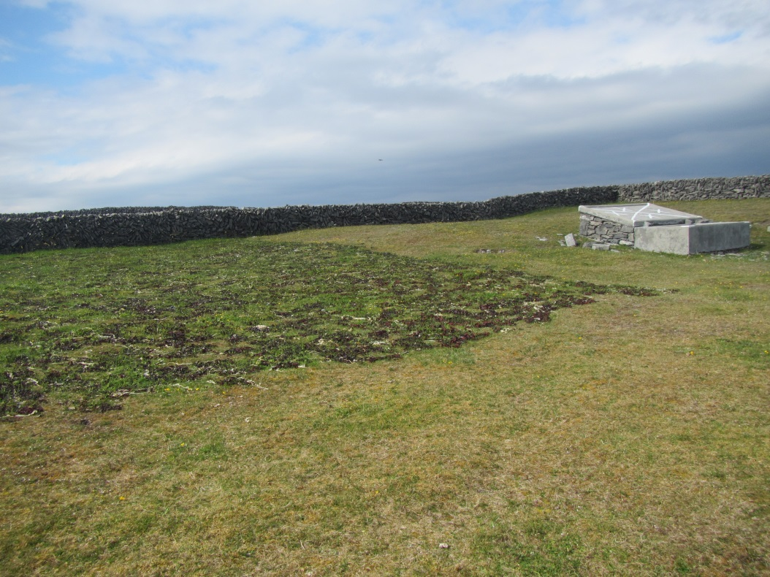
R28IMN (seaweed) 02/07/15  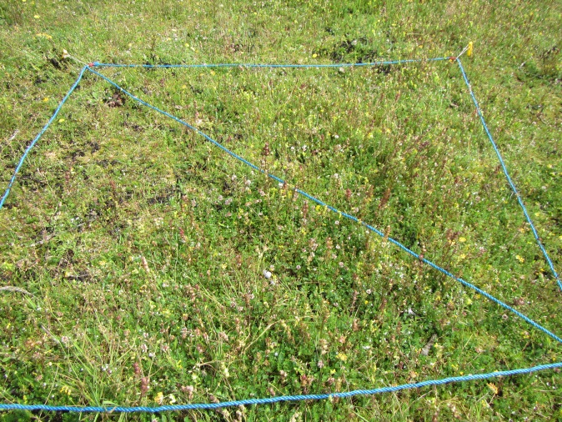 | R29IMN (seaweed) 02/07/15  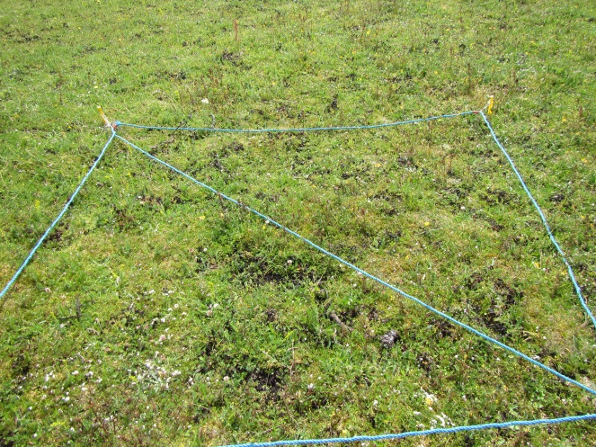
R30IMN (no seaweed) 02/07/15  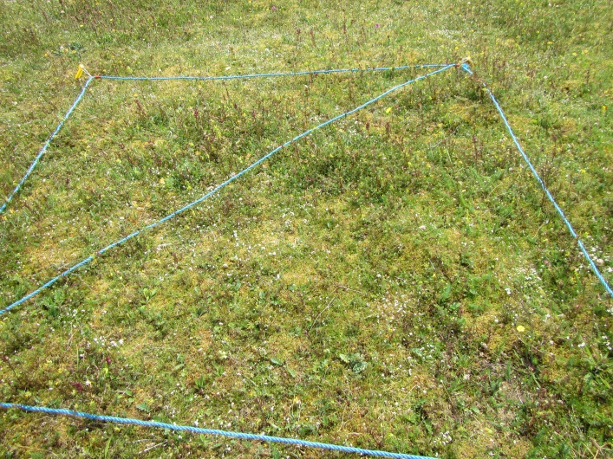 | R31IMN (no seaweed) 02/07/15  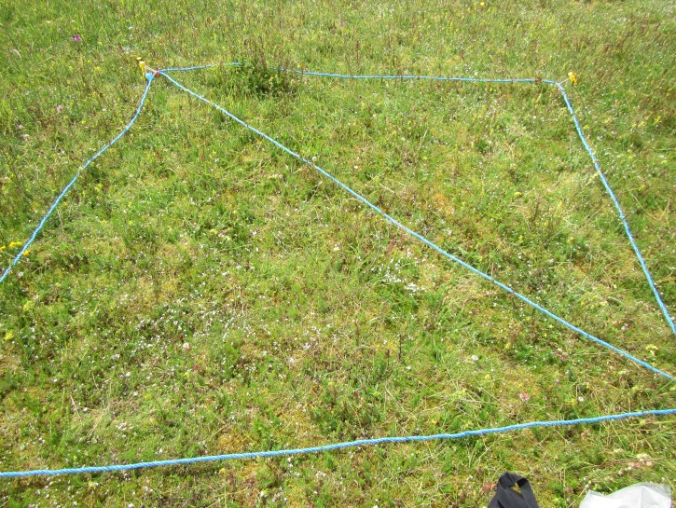

Features
There is a slight increase in species number in the seaweed plots (Average sp. no. with seaweed=25.5; without seaweed = 21.5)
There is a slight increase in Dry Matter yield in the seaweed plot (Average DM yield with seaweed=1.2156; without seaweed = 0.8856)
The % cover of grass and broadleaves increases within the seaweed plot, while the % cover bryophytes decreases
Species that do not occur in seaweed: Scleropodium purum
Species that only occur within the seaweed plot: Stellaria media, Hypochaeris radicata, Dicranum scoparium.
Fifteen positive indicator species and one negative indicator species were recorded in the seaweed plot.
Nine positive indicator and two negative indicator species were recorded outside the seaweed plot

Plot8_RC1 | Seaweed |  | no Seaweed
Relevé no. | R28IMN | R29IMN | R30IMN | R31IMN
DM yield(t) per ha | 1.066 | 1.3652 | 0.8552 | 0.916
% bare ground | 2 | 0 | 0 | 0
% grass | 30 | 10 | 5 | 15
% sedge | 0 | 7 | <1 | 0
% broadleaves | 70 | 50 | 50 | 30
% bryophytes | 45 | 70 | 90 | 100
Total species no. | 24 | 27 | 26 | 17
Stellaria media | 1 | 1
Hypochaeris radicata | 4 | 4
Dicranum scoparium | 3 | 4
Scleropodium purum |  |  | 6 | 5
Rhytidiadelphs squarrosus | 7 | 8 | 8 | 8
Plantago lanceolata | 3 | 3 | 3 | 4
Festuca rubra | 5 | 4 | 4 | 4
Luzula campestris | 5 | 4 | 4 | 3
Trifolium dubium | 3 | 3 | 4 | 3
Galium verum | 5 | 5 | 4 | 8
Trifolium repens | 5 | 4 | 3 | 4
Rhinanthus minor | 7 |  | 7 | 6
Asperula cynanchica | 4 | 7 | 7
Lotus corniculatus | 4 | 4 | 3
Anthylis vulneraria | 5 | 4 | 5
Cerastium fontanum | 4 | 4 |  | 1
Arrhenatherum elatius | 4 |  | 1 | 4
Veronica chamaedrys |  | 1 | 1 | 1
Ranunculus repens |  | 1 | 1 | 1
Pillosella officinarum | 3 | 3 | 3
Homalothecium lutescens | 4 | 4 | 4
Cerastium glomeratum | 4 | 1 | 1
Sagina nodosa |  | 1 | 3
Carex sp. |  | 3 | 3
Euphrasia officinalis agg. | 6
Syntrichium ruralis | 3
Leontodon taraxacoides | 1
Agrostis sp | 1
Thymus polytrichum | 1
Blackstonia perfoliata |  | 1
Carex flacca |  | 4
Daucus carota |  | 1
Cladonia sp. |  | 4
Viola sp. |  | 3
Campanula rotundifolia |  | 3
Peltigera canina |  |  | 1
Achillea millefolium |  |  | 3
Bromus hordeaceus |  |  | 1
Dactylis glomerata |  |  | 1
Senecio jacobaea |  |  | 4
Anacamptis pyramidalis |  |  | +
Calliergonella cuspidatum |  |  |  | 4
Rumex acetosa |  |  |  | 4
Leucanthemum vulgare |  |  |  | 1

Plot 9_RC2
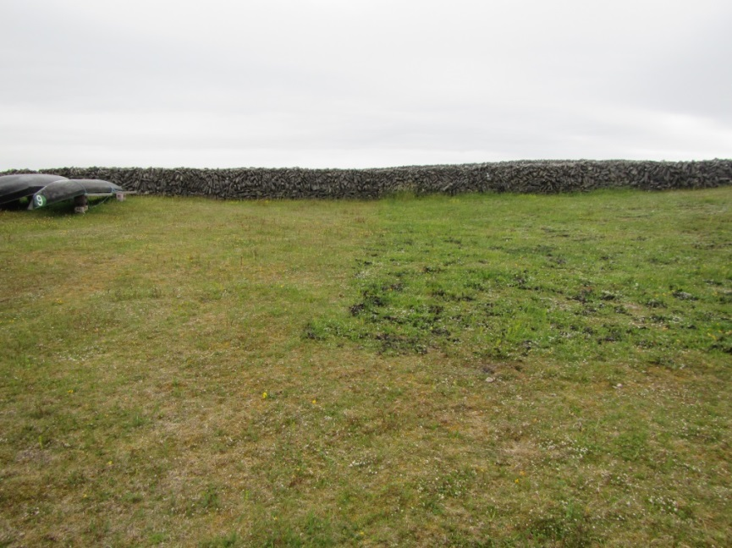
R33IMN 02/07/2015 seaweed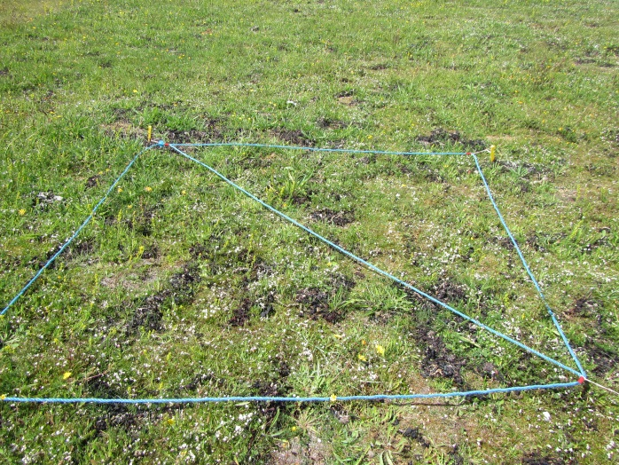 | R32IMN 02/07/2015 no seaweed  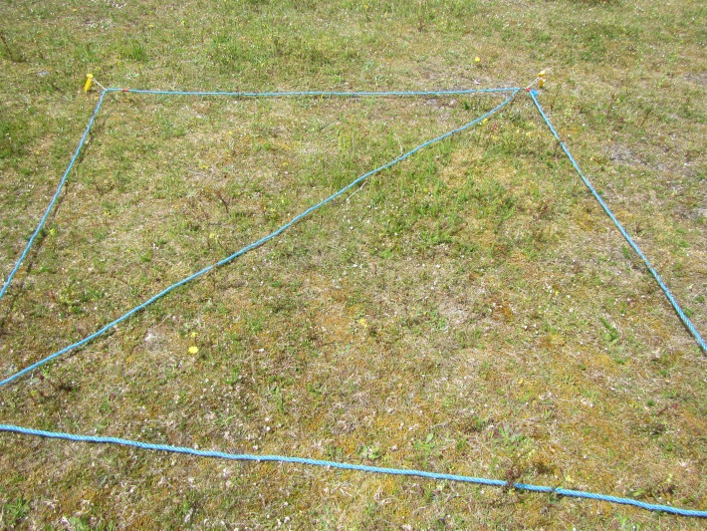

Features
There is a slight increase in Dry Matter yield within the seaweed plot though there is also a decrease in the number of species.
There %cover of broadleaves and grasses is greater within the seaweed plot than outside while the %cover of sedges and bryophytes is less within the seaweed plot than outside.
Species which increase in cover/abundance with seaweed: Festuca rubra, Asperula cynanchica, Galium verum, Centaurium erythraea, Cerastium glomeratum and Blackstonia perfoliata.
Species which decrease in cover/abundance with seaweed: Syntrichia ruralis, Stellaria sp, Hypochaeris radicata, Trifolium dubium and Dicranum scoparium.
A range of species only occur within the seaweed plot and a range only occur outside seaweed plot.

Plot9_RC2 | Seaweed | No Seaweed
Relevé no. | R33IMN | R32IMN
DM yield(t) per ha | 0.772 | 0.5398
% bare ground | 1 | 1
% grass | 40 | 15
% sedge | 5 | 10
% broadleaves | 80 | 50
% bryophytes | 60 | 90
Total species no. | 23 | 26
Festuca rubra | 7 | 5
Asperula cynanchica | 8 | 7
Galium verum | 6 | 5
Centaurium erythraea | 3 | 1
Cerastium glomeratum | 3 | 1
Blackstonia perfoliata | 4 | 1
Syntrichium ruralis | 5 | 6
Stellaria media | 1 | 3
Hypochaeris radicata | 1 | 4
Trifolium dubium | 3 | 4
Dicranum scoparium | 4 | 5
Carex flacca | 4 | 4
Luzula campestris | 4 | 4
Plantago lanceolata | 1 | 1
Lotus corniculatus | 1 | 1
Anthylis vulneraria | 4
Cerastium fontanum | 3
Dactylis glomerata | 1
Ranunculus repens | 1
Calliergonella cuspidatum | 4
Poa pratensis | 1
Linum catharticum | 1
Rhytidiadelphus triquetrus | 5
Rhytidiadelphs squarrosus |  | 5
Scleropodium purum |  | 5
Rhinanthus minor |  | 5
Trifolium repens |  | 4
Campanula rotundifolia |  | 1
Pillosella officinarum |  | 1
Sagina nodosa |  | 4
Carex arenaria |  | 4
Viola sp. |  | 1
Leontodon taraxacoides |  | 1
Phleum pratense |  | 1

Plot 10_RC3
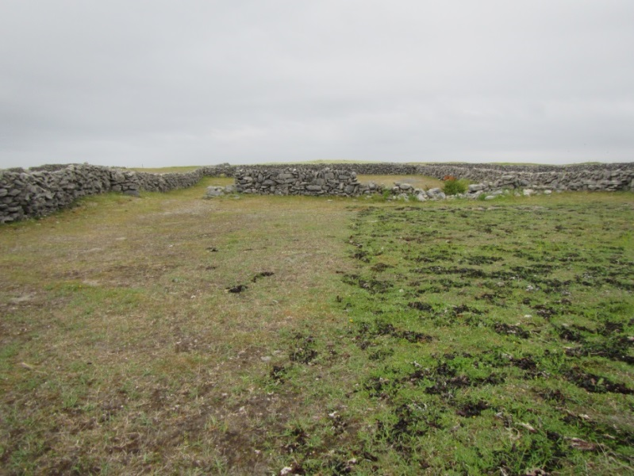
R35IMN Seaweed 02/07/2015  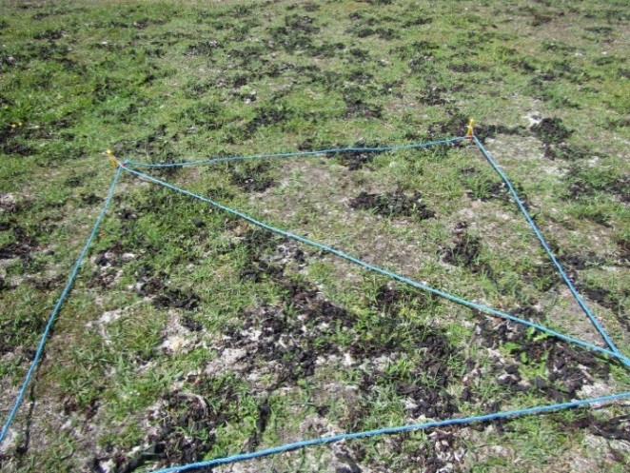 | R34IMN No Seaweed 02/07/2015  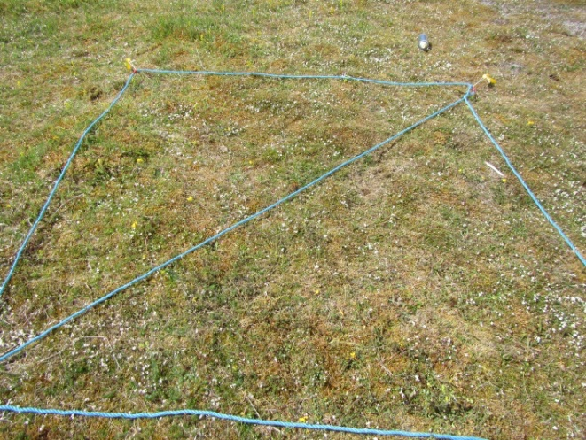

Features
Low Dry Matter yield and species number occur within the seaweed plot, however, this tallies with the high %bare ground and lower %cover of grasses, broadleaves and bryophytes within the seaweed plot.
Sedge cover is greater within the seaweed plot.
There are 8 positive indicator species within releve located outside the seaweed plot. There are 4 positive indicator species within the seaweed plot. Negative indicator species are absent from releveés both within and outside the seaweed plot.
Species that increase in cover/abundance in seaweed plot: Hypochaeris radicata, Campanula rotundifolia and Sagina nodosa.
Species that decreased in cover in the seaweed plot are Festuca rubra and Asperula cynanchica.
Rhytidiadelphus squarrosus is absent from the seaweed plot along with other bryophytes, Ctenidium moluscum, Scleropodium purum.

Plot10_RC3 | Seaweed | No Seaweed
Relevés | R35IMN | R34IMN
DM yield(t) per ha | 0.0884 | 0.8092
% bare ground | 40 | 0
% grass | 15 | 30
% sedge | 30 | 0
% broadleaves | 11 | 40
% bryophytes | 0 | 90
Total species no. | 14 | 21
Hypochaeris radicata | 4 | 3
Campanula rotundifolia | 4 | 1
Sagina nodosa | 3 | 1
Plantago lanceolata | 3 | 4
Festuca rubra | 4 | 6
Asperula cynanchica | 4 | 6
Luzula campestris | 4 | 4
Ranunculus repens | 1 | 1
Centaurium erythraea | 1 | 1
Carex flacca | 6
Agrostis stolonifera | 5
Dactylis glomerata | 4
Stellaria sp | 1
Anthylis vulneraria | 3
Ctenidium molluscum |  | 8
Rhytidiadelphs squarrosus |  | 5
Scleropodium purum |  | 4
Rhinanthus minor |  | 4
Leontodon autumnalis |  | 1
Galium verum |  | 4
Lotus corniculatus |  | 1
Trifolium dubium |  | 1
Cerastium fontanum |  | 1
Blackstonia perfoliata |  | 1
Pillosella officinarum |  | 4
Dicranum scoparium |  | 4

Plot 11 SOD1
R14IMN 08/09/14 (before seaweed)  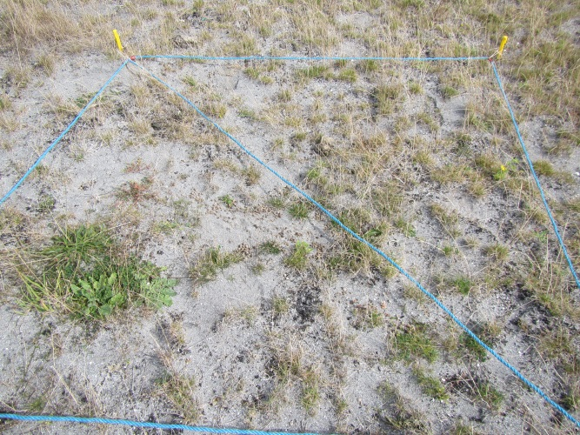 | R59IMN 02/09/15 (after seaweed)  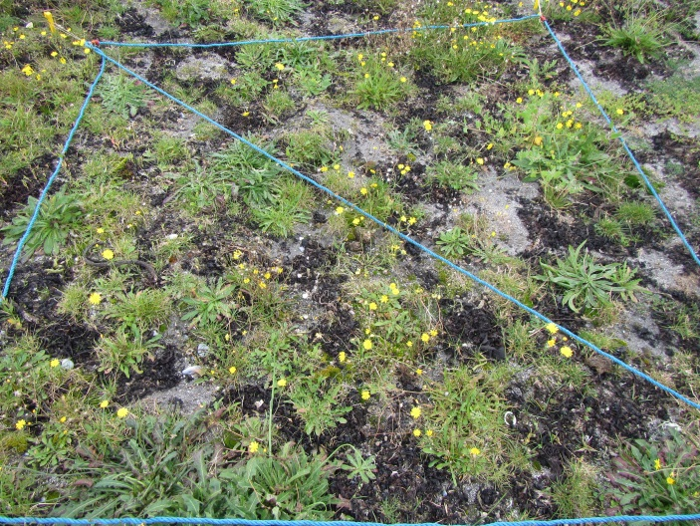
R59IMN 20/08/15 (no seaweed)
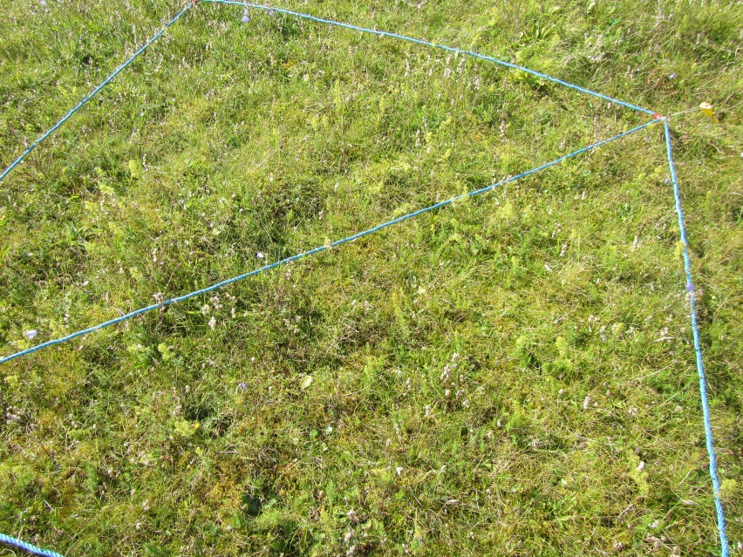

Features
Plot area previously damaged by sand removal. R14IMN recorded before seaweed was applied. R54IMN was recorded in location of R14IMN after seaweed had been applied. R59IMN was taken in adjacent are of field where damage and sand removal had not taken place.
Rhinanthus minor is absent from seaweed plot.
% Broadleaves and %Bryophytes has increased within the seaweed area with a corresponding decrease in bare earth.
Before seaweed application R14IMN had four positive indicator species. After seaweed application this relevé supported five positive indicators species.
Two negative indicator species, Senecio jacobaea and Lolium perenne occur in all three relevés, however their cover/abundance is greatest in the relevé before seaweed application.
R59IMN located in the undisturbed area adjacent to seaweed plot supports the most positive indicator species (14).

Plot 11 SOD1
Relevés | R14IMN* | R54IMN | R59IMN
Total species no. | 17 | 15 | 30
Bare earth % | 60 | 50 | 0
Grass % | 30 | 20 | 60
Sedge % | 0 | 0 | 10
Broadleaves% | 3 | 12 | 40
Bryophytes% | 1 | 5 | 60
Rhinanthus minor | 4 |  | 5
Rumex acetosa | + |  | 4
Scleropodium purum | 3 | 3 | 4
Plantago lanceolata | 3 | 3 | 4
Senecio jacobaea | 3 | 1 | 1
Trifolium repens | + | 1 | 4
Lolium perenne | 5 | 5 | 4
Festuca ovina/rubra | 4 |  | 8
Trifolium dubium | 3 | 3
Dactylis glomerata | 3 | 3
Anagallis arvensis | + | 3
Crepis capillaris | + | 3
Taraxacum officinale | + | 3
Homalothecium lutescens |  | 3 | 4
Pillosella officinarum | +
Medicago sativa | +
Leontodon hispidus | +
Sanguisorba minor | 3
Asperula cynanchica |  | 3
Atriplex prostrata |  | 3
Hypochaeris radicata |  | 4
Syntrichium ruralis |  | 3
Galium verum |  |  | 5
Lotus corniculatus |  |  | 4
Luzula campestris |  |  | 4
Veronica chamaedrys |  |  | 4
Campanula rotundifolia |  |  | 5
Carex flacca |  |  | 4
Blackstonia perfoliata |  |  | 3
Daucus carota |  |  | 3
Calliergonella cuspidatum |  |  | 4
Poa pratensis |  |  | 4
Euphrasia officinalis agg. |  |  | 5
Leontodon autumnalis |  |  | 1
Rhytidiadelphs squarrosus |  |  | 5
Viola sp. |  |  | 1
Ranunculus bulbosus |  |  | 1
Linum catharticum |  |  | 4
Rhytidiadelphus triquetrus |  |  | 4
Primula spp |  |  | 4
Poa annu |  |  | 4
Trifolium pratense |  |  | 4
Platanthera bifolia |  |  | 1

Appendix 3. National Monitoring Methods for assessing *21A0 Machairs
The following tables show the criteria used to assess the conservation status at a monitoring stop and site level (Delaney et al. 2013) (Table 3). A monitoring stop or relevé must support greater than 6 positive indicator species, a low percentage cover of negative indicator species and more than 1% cover of bryophytes to pass and have favourable conservation status.
Table 3. Criteria to pass/fail monitoring stops in the assessment of conservation status
1a. Positive species indicators: At least six must be present in more than 20% stops to pass
Agrostis stolonifera
Aira praecox
Bellis perennis
Carex arenaria
Carex flacca
Carex nigra
Cerastium fontanum
Crepis capillaris
Euphrasia officinalis agg.
Festuca rubra
Galium verum
Hydrocotyle vulgaris
Linum catharticum
Lotus corniculatus
Orchid spp.
Plantago lanceolata
Potentilla anserina
Prunella vulgaris
Rhinanthus minor
Sedum acre
Thymus polytrichus
Trifolium repens
Viola canina
Viola riviniana
Viola tricolor
1b. Lowest number of positive indicator species in a monitoring stop: At least three species present in each stop

2. Cover of bryophytes: Always over 1%
3. Negative Indicator species: No species present in more than 40% of stops. L. perenne and P. pratense not present in more than 20% of the stops. Combined cover of negative indicators 5% or less
Arrenatherum elatius
Cirsium arvense
Cirsium vulgare
Senecio jacobaea
Urtica dioica
Lolium perenne
Phleum pratense
Pteridium aquilinum
4. Non-Native species: no species present in more than 20% of the stops
5. Flowering and fruiting of positive indicator species: present in more than 40% of stops
6. Sward Height: mean height <20cm

Appendix 4. Vertigo angustior survey of seaweed trial plot sites

FIRST MONITORING SURVEY FOR VERTIGO ANGUSTIOR AND OTHER MOLLUSCS AT SITES CHOSEN FOR SEAWEED APPLICATION TRIALS, ARANLIFE PROJECT – 2015 SURVEY

January 2016

Neil Browne

Contact Address:
9 Cois na ce
Cappa,
Kilrush,
Co.Clare.

Tel: 087 8106200

e-mail: browneneil@hotmail.com

Citation: Browne, N. (2016) First monitoring survey for Vertigo angustior and other molluscs at sites chosen for seaweed application trials, AranLIFE project – 2015 survey.

Author: Neil Browne
Reviewed by: Dr Evelyn Moorkens

1.0 Introduction
The Annex II snail species Vertigo angustior is a qualifying interest species of Inis Mór SAC (Moorkens & Killeen, 2011). It lives in the decaying grass understorey in machair habitat and is sensitive to drying out, requiring appropriate habitat for a successful long term population (Moorkens & Gaynor, 2003).

Machair is a qualifying Interest of both Inis Mór and Inis Méain SACs. The condition of some areas of machair is degraded, and the AranLIFE project has proposed to bring 29 hectares of machair habitat into favourable conservation status.

The improvement of machair habitat conditions should improve the density and spread of molluscan species, including Vertigo angustior.

The AranLIFE project proposes to trial the application of seaweed to machair sites to address issues such as over-dominance of bryophytes and reduction in species-diversity. Seaweed will be applied to plots in the traditional way, by hand ensuring even coverage throughout the plot.

It is important to understand how the application of seaweed would positively or negatively affect V. angustior. This species was never recorded on Inis Meáin, but is known from some machair habitat on Inis Mór, where it is a qualifying interest of the SAC. There are areas of good V. angustior habitat at Eararna, close to the airport, and at Kilmurvey (Moorkens & Killeen, 2011).

The objective of the study is to assess the changes to the molluscan fauna before and after the affects of the seaweed application. The methods are designed to assess the distribution of V. angustior (via hand sampling along walking transects) and changes to the molluscan composition and abundance, through semi-quantitative sampling comparisons between equivalent seaweed applied and control quadrats at each application site.

One round of molluscan sampling was undertaken in September 2015, just after seaweed application but before any effects would be evident, and repeat sampling is proposed at the end of the trial to assess change in both the trial sites and the control sites where seaweed will not be applied.

2.0 Methodology
2.1 The seaweed study

The molluscan studies are based on the areas chosen by AranLIFE as their seaweed experimental plots. Each seaweed plot measures 20mx10m. Participating farmers have spread seaweed evenly by hand on the selected plots. This is a traditional application rate that relates to approximately one layer of seaweed frond deep.

Permanent monitoring quadrats (4m²) have been set up within the 20mx10m plots by the AranLIFE team. These quadrats will be surveyed for their floristic composition prior to seaweed application and monitored annually over the duration of the project and any changes in vegetation noted.

It is anticipated that seaweed will be applied within the plots annually until 2017.

2.2 The mollusc study

Two studies were undertaken. The first was a distribution study to assess the general differences in mollusc distribution across each plot, and to ensure that the quantitative quadrats assessed were representative of the plot. The second study was the quantitative study to assess change over time in both species number (biodiversity) and number of individuals (biomass) and relate to the vegetation monitoring quadrats.

- Walking transects – Distribution study
At each 20mx10m plot a diagonal line was walked and at six evenly distributed points along the line (approximately every 4m) a sample of litter was shaken into a plastic tray and checked for the presence of V. angustior and other species with a hand lens.

- Quadrat sampling - Quantitative study
Within each 20mx10m plot 2 monitoring quadrats were sampled by removing the litter layer from the base of a 20cmX20cm quadrat adjoining a 4m² botanical relevé area. An equivalent sample was removed from the same number of control quadrats with no seaweed treatment. Each sample was taken back to the laboratory, dried and sieved and the snails in each sample were identified and counted under a binocular microscope with a 4X to 40X magnification.

3.0 Results
The locations of the 11 20x10m plots, and the study and control relevees are shown in Figures 3.1 to 3.4.
A description with photographs at the study sites are provided in Table 3.1.

The results of the 66 field assessments (six per plot along the transect) are presented in Table 3.2. None of the field samples were positive for Vertigo angustior.

The results of the quantitative study are presented in Table 3.3, with a summary in Table 3.4. A total of 206 individuals of 6 species were found, with a further species (Discus rotundatus) found in the walking transects but not in the quantitative quadrats.

Table 3.1 Locations and descriptions of the 11 plots and their control areas, September 2015.

Quadrat / location | Description In September 2015 | Photograph in September 2015
Plot 1 IMR  N53 05 59  W9 39 01 | The Plot is in open exposed commonage in Tramor with disturbed ground from burrowing animals. The ground was very dry with little or no understorey thatch layer. Transect points from 0m to 20m were taken at 4m intervals diagonally in a NW to SE direction. No Vertigo angustior found visually from transect hand sampling. | 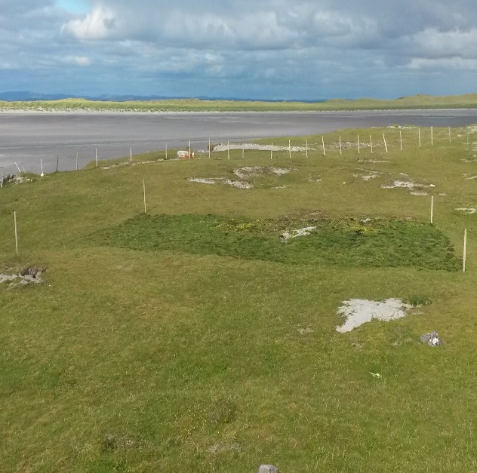
Plot 2 IMR.  N53 05 49  W09 38 36 | The plot had a dense vegetative cover from the seaweed application with good underlying thatch. Transect points from 0m to 20m were taken at 4m intervals diagonally in a SW to NE direction. No Vertigo angustior found visually from transect hand sampling. | 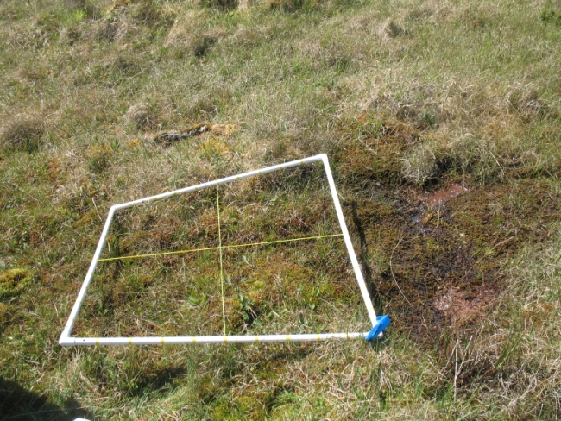
Plot 3 IMR.  N53 05 59  W09 39 01 | The Plot in Tramor commonage had bare exposed sand and colonizing vegetation. No control samples were collected as the area outside the plot consisted of bare open sand with little vegetation or thatch layer. Transect points from 0m to 20m were taken at 4m intervals diagonally in a SE to NW direction. No Vertigo angustior found visually from transect hand sampling. | 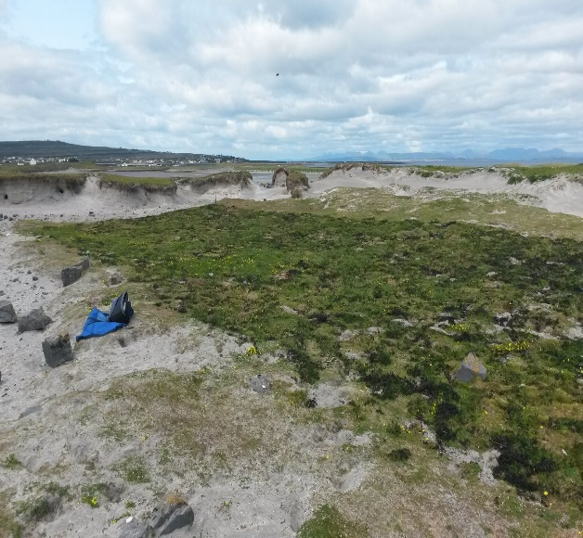
Plot 4 IMR. | Plot consisted of exposed bare sand with little vegetation. No samples were collected. Transect points from 0m to 20m were taken at 4m intervals diagonally in a SE to NW direction. No Vertigo angustior found visually from transect hand sampling. | 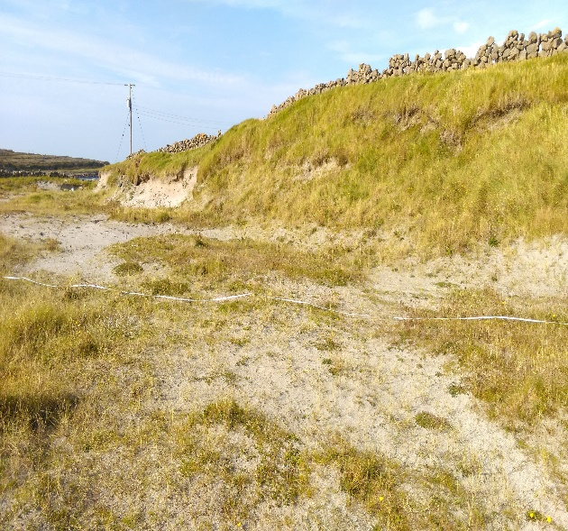
Plot 5 IMR. | The plot consisted of dense low vegetation in a field that had been grazed recently by cattle, There was also a good depth of damp thatch. Transect points from 0m to 20m were taken at 4m intervals diagonally in a SE to NW direction. No Vertigo angustior found visually from transect hand sampling. | 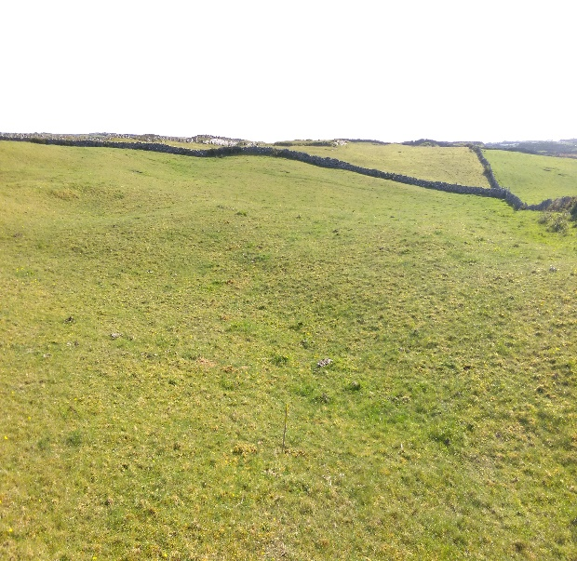
Plot 6 IMR. | Within the same field as Plot 5 but at a higher elevation with the plot sloping from East to West. Good dense vegetative coverage and damp thatch layer were found. Transect points from 0m to 20m were taken at 4m intervals diagonally in a SE to NW direction. No Vertigo angustior found visually from transect hand sampling. | 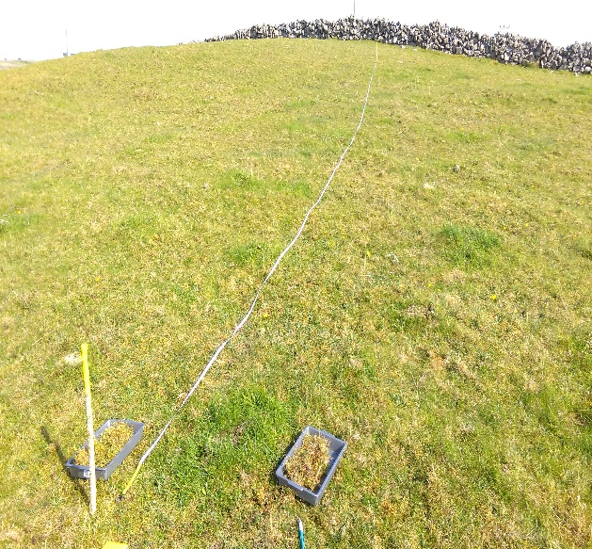
Plot 7 INM.  N53 05 51 W09 34 25 | Plot was within a field that had a dense vegetative cover with a good damp understorey of thatch. Transect points from 0m to 20m were taken at 4m intervals diagonally in a SW to NE direction. No Vertigo angustior found visually from transect hand sampling. | 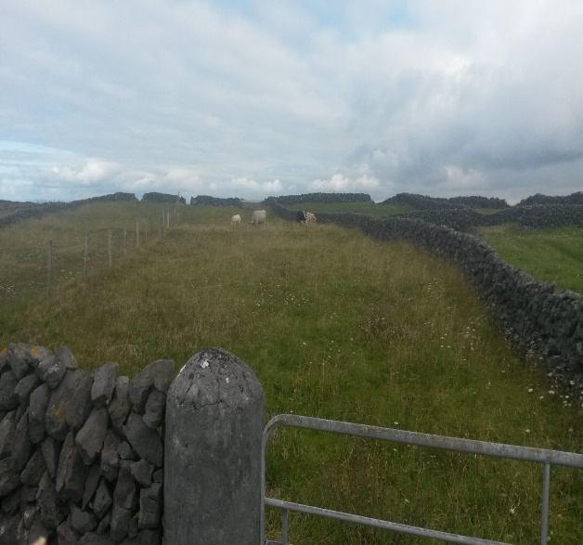
Plot 8 INM.  N53 05 50  W09 34 17 | Good low vegetative coverage found but the understorey consisted of dry sand with little thatch. Transect points from 0m to 20m were taken at 4m intervals diagonally in a SE to NW direction. No Vertigo angustior found visually from transect hand sampling. | 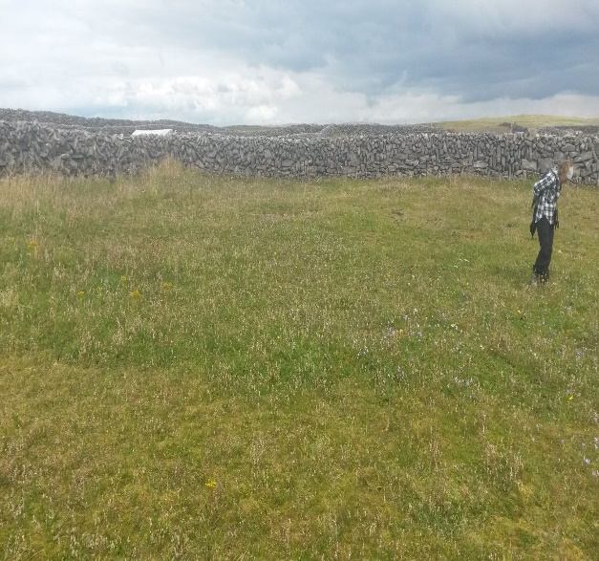
Plot 9 INM.  N53 05 51  W09 34 16 | Very dry plot with sparse vegetation and little or no thatch in places. Transect points from 0m to 20m were taken at 4m intervals diagonally in a SE to NW direction. No Vertigo angustior found visually from transect hand sampling. | 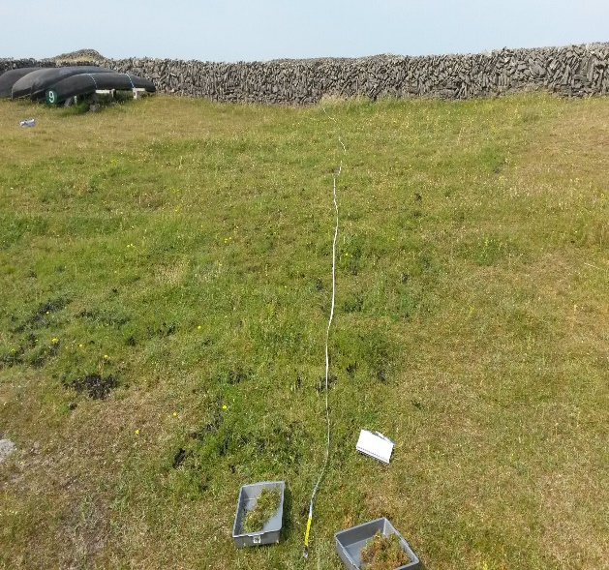
Plot 10 INM.  N53 05 51  W09 34 12 | A very dry sandy plot with sparse vegetation and no understorey of thatch. Transect points from 0m to 20m were taken at 4m intervals diagonally in a NW to SE direction. No Vertigo angustior found visually from transect hand sampling. | 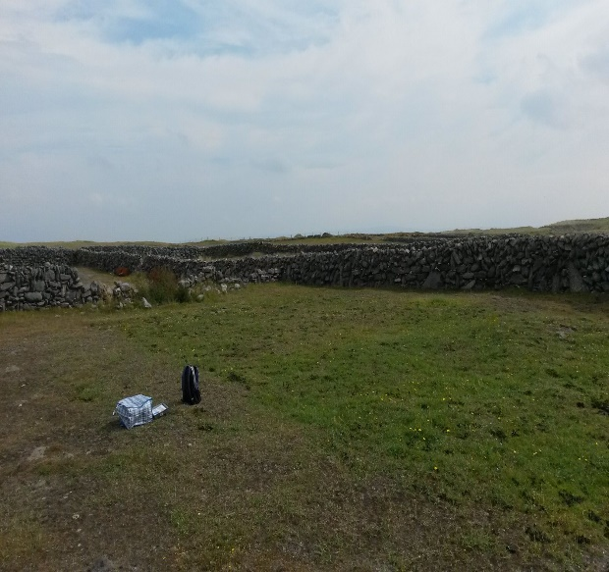
Plot 11 INM.  N53 05 28  W09 34 07 | Dry open sand area but improvement seen visually with colonizing vegetation after recent seaweed application. There was little or no understorey of thatch. Transect points from 0m to 20m were taken at 4m intervals diagonally in a SE to NW direction. No Vertigo angustior found visually from transect hand sampling. | 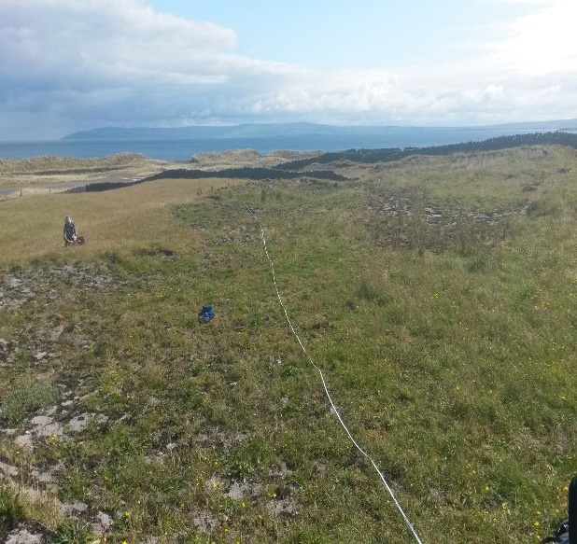

Table 3.2 Results of the field sampling across the diagonal transects in the 11 plots. Species follow the nomenclature of Anderson (2005).

Plot | 1 IMR |  |  |  |  |  | 2 IMR
Species | 0m | 4m | 8m | 12m | 16m | 20m | 0m | 4m | 8m | 12m | 16m | 20m
Helicella itala |  | 1 |  |  | 2 |  |  |  | 3
Candidula intersecta |  |  |  |  |  |  |  |  | 1
Discus rotundatus |  |  |  |  |  |  | 1 | 1 | 1
Total individuals |  | 1 |  |  | 2 |  | 1 | 1 | 5
Total species |  | 1 |  |  | 1 |  | 1 | 1 | 3

Plot | 3 IMR |  |  |  |  |  | 4 IMR
Species | 0m | 4m | 8m | 12m | 16m | 20m | 0m | 4m | 8m | 12m | 16m | 20m
Candidula intersecta |  | 2 | 1 | 1 | 1
Cernuella virgata |  |  |  |  | 1 | 1
Total individuals |  | 2 | 1 | 1 | 1 | 1
Total species |  | 1 | 1 | 1 | 2 | 1

Plot | 5 IMR |  |  |  |  |  | 6 IMR
Species | 0m | 4m | 8m | 12m | 16m | 20m | 0m | 4m | 8m | 12m | 16m | 20m
Cochlicopa lubricella | 1 |  |  |  | 1 |  | 1 | 3 | 3 | 4 | 1 | 2
Helicella itala |  | 2 | 3 | 3
Total individuals | 1 | 2 | 3 | 3 | 1 |  | 1 | 3 | 3 | 4 | 1 | 2
Total species | 1 | 1 | 1 | 1 | 1 |  | 1 | 1 | 1 | 1 | 1 | 1

Plot | 7 IMN |  |  |  |  |  | 8 IMN
Species | 0m | 4m | 8m | 12m | 16m | 20m | 0m | 4m | 8m | 12m | 16m | 20m
Helicella itala | 1 |  |  |  |  |  |  | 1 |  |  | 3
Total individuals | 1 |  |  |  |  |  |  | 1 |  |  | 3
Total species | 1 |  |  |  |  |  |  | 1 |  |  | 1

Plot | 9 IMN |  |  |  |  |  | 10 IMN
Species | 0m | 4m | 8m | 12m | 16m | 20m | 0m | 4m | 8m | 12m | 16m | 20m
Helicella itala |  |  | 1 | 1 |  |  | 2
Total individuals |  |  | 1 | 1 |  |  | 2
Total species |  |  | 1 | 1 |  |  | 1

Plot | 11 IMN
Species | 0m | 4m | 8m | 12m | 16m | 20m
Helicella itala | 1
Total individuals | 1
Total species | 1

Table 3.3 Results of the quantitative study in the 11 plots. Species follow the nomenclature of Anderson (2005).

SPECIES | PLOT 1  R41 IMR  Control | R42 IMR  Within plot | R43 IMR  Within plot | R44 IMR  Control | PLOT 2  R33 IMR  Control | R34 IMR  Within plot | R35 IMR  Within plot | R36 IMR  Control
Cochlicopa lubricella |  |  | 1 |  |  | 1
Vallonia excentrica |  |  | 2
Helicella itala | 2 | 2 |  | 5 | 6 |  | 3 | 3
Candidula intersecta |  |  | 1
Total individuals | 2 | 2 | 4 | 5 | 6 | 1 | 3 | 3
Total no. species | 1 | 1 | 3 | 1 | 1 | 1 | 1 | 1

SPECIES | PLOT 3  R37 IMR  Control | R38 IMR  Within plot | R39 IMR  Within plot | R40 IMR  Control | PLOT 4  R41 IMR  Control | R43 IMR  Within plot | R44 IMR  Within plot | R42 IMR  Control
Helicella itala |  | 1
Total individuals | 0 | 1 | 0 | 0 | 0 | 0 | 0 | 0
Total no. species | 0 | 1 | 0 | 0 | 0 | 0 | 0 | 0

SPECIES | PLOT 5  R51 IMR  Control | 0 M  Within plot | 4 M  Within plot | 8 M  Within plot | 12 M  Within plot | 16 M  Within plot | 20 M  Within plot | R52 IMR  Control
Cochlicopa lubricella | 2 | 5 | 2 |  |  | 3 | 3 | 3
Vitrea contracta |  | 2 | 1 |  | 1 | 2
Helicella itala |  |  |  | 1 |  |  | 1 | 1
Total individuals | 2 | 7 | 3 | 2 | 1 | 5 | 4 | 4
Total no. species | 1 | 2 | 2 | 2 | 1 | 2 | 2 | 2

SPECIES | PLOT 6  R61 IMR  Control | 0 M  Within plot | 4 M  Within plot | 8 M  Control | 12 M  Control | 16 M  Within plot | 20 M  Within plot | R62 IMR  Control
Cochlicopa lubricella | 1 | 3 | 19 | 18 | 26 | 22 | 14 | 3
Helicella itala | 1 |  |  |  |  | 1 |  | 3
Total individuals | 2 | 3 | 19 | 18 | 26 | 23 | 14 | 6
Total no. species | 2 | 1 | 1 | 1 | 1 | 2 | 1 | 2

SPECIES | PLOT 7  R19 IMN  Within plot | R20 IMN  Within plot | R21 IMN  Control | R22 IMN  Control | R23 IMN  Control
Cochlicopa lubricella |  |  |  |  | 2
Vitrea contracta |  |  |  |  | 1
Helicella itala |  |  | 1
Total individuals | 0 | 0 | 1 | 0 | 3
Total no. species | 0 | 0 | 1 | 0 | 2

SPECIES | PLOT 8  R28 IMN  Within plot | R29 IMN  Within plot | R30 IMN  Control | R31 IMN  Control | PLOT 9  R32 IMN  Control | R32(b) IMN  Control | R33 IMN  Within plot | R33(b) IMN  Within plot
Helicella itala | 1 | 3 | 2 | 5 |  | 4 | 2 | 3
Total individuals | 1 | 3 | 2 | 5 | 0 | 4 | 2 | 3
Total no. species | 1 | 1 | 1 | 1 | 0 | 1 | 1 | 1

SPECIES | PLOT 10  R34 IMN  Control | R34(b) IMN  Control | R35 IMN  Within plot | R35(b) IMN  Within plot | PLOT 11  R14 IMN  Control | R14/R54 IMN  Within plot
Helicella itala | 4 | 2 | 1 | 3 | 3 | 2
Trochulus hispidus |  |  |  |  | 3
Total individuals | 4 | 2 | 1 | 3 | 6 | 2
Total no. species | 1 | 1 | 1 | 1 | 2 | 1

Table 3.4 Summary of molluscan species found in 2015 study.
SPECIES | Inis Mór,  Trá mór (3 Sites) |  | Inis Mór,  Kilmurvey (3 Sites) |  | Inis Meain (5 Sites)
 | No. Individuals | No. sites | No. Individuals | No. sites | No. Individuals | No. sites
Cochlicopa lubricella | 1 | 1 | 124 | 2 | 2 | 1
Vallonia excentrica | 2 | 1
Vitrea contracta |  |  | 6 | 1 | 1 | 1
Helicella itala | 22 | 3 | 8 | 2 | 36 | 5
Trochulus hispidus |  |  |  |  | 3 | 1
Candidula intersecta | 1 | 1
Total individuals | 26 |  | 138 |  | 42
Total no. species | 4 |  | 3 |  | 4

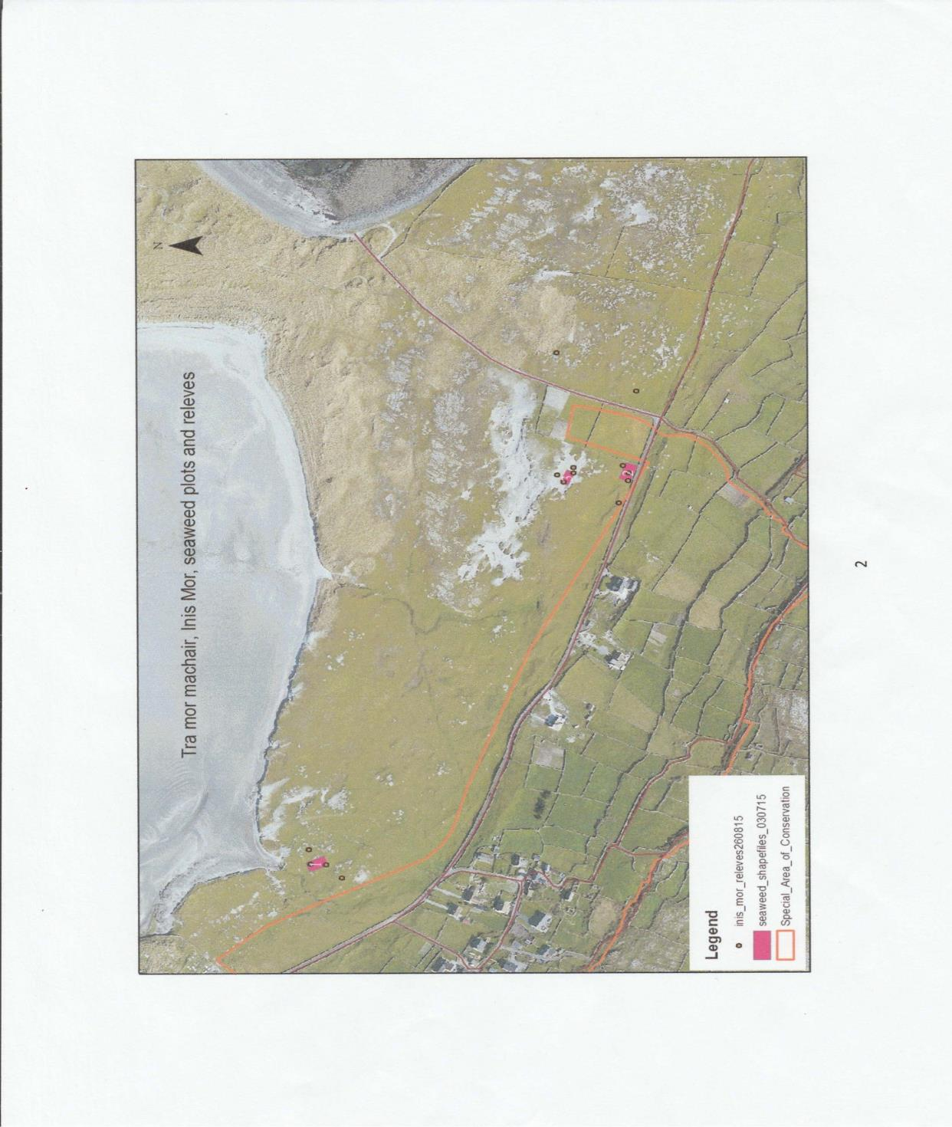
Figures 3.1 to 3.4 Map of Seaweed Plots
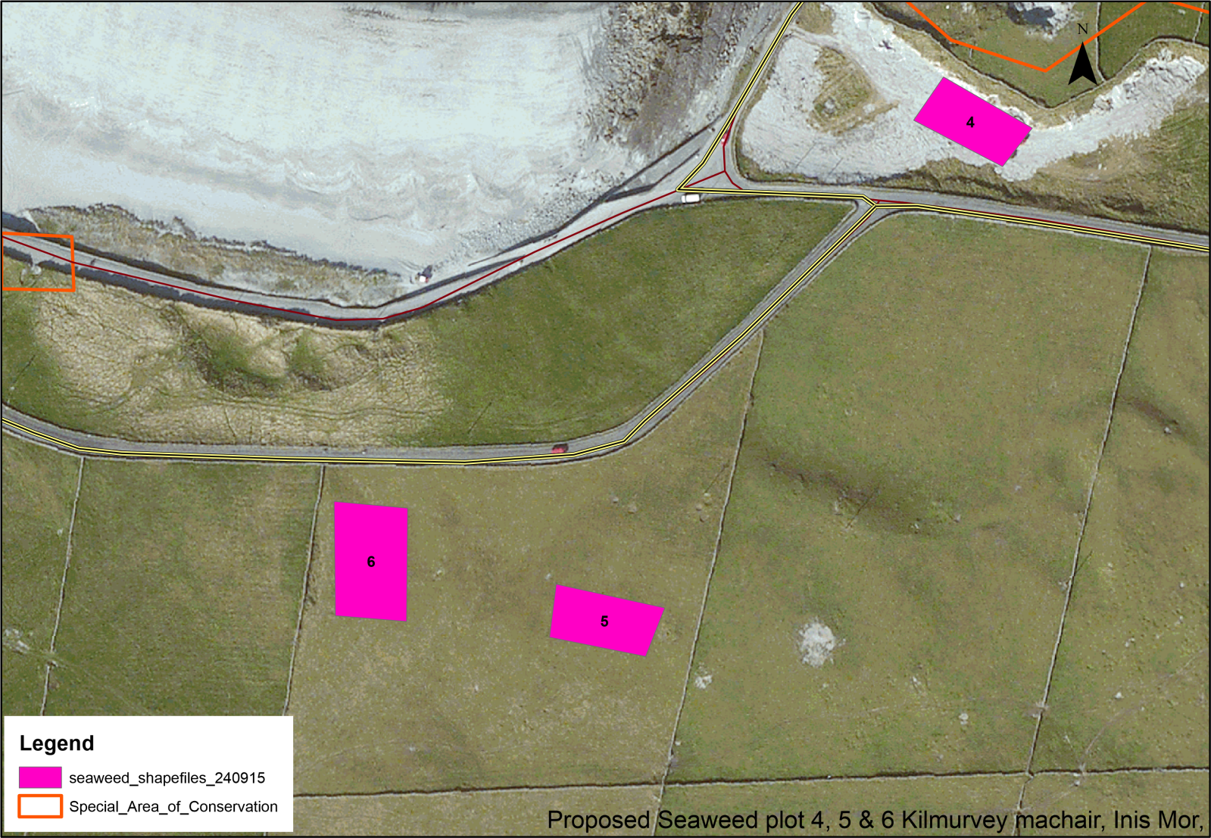

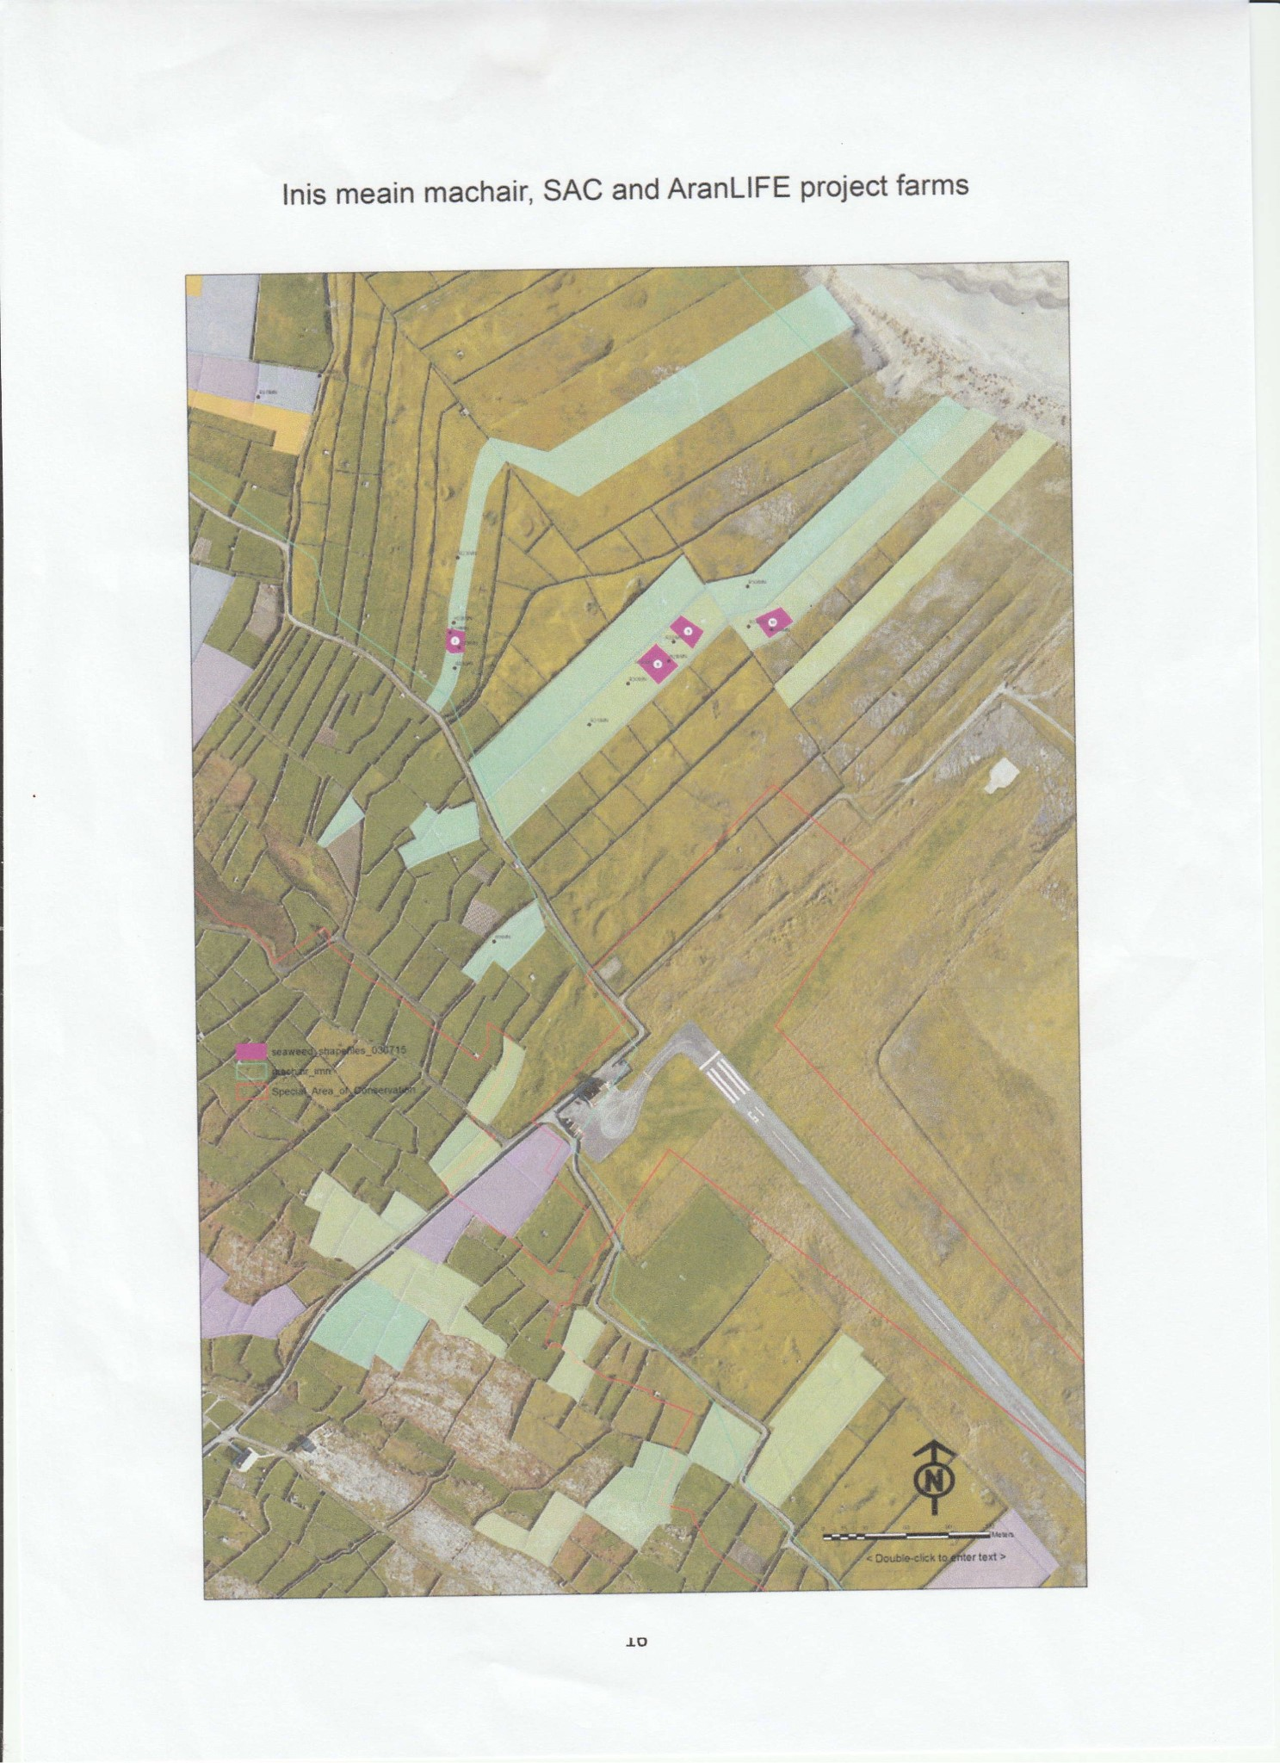
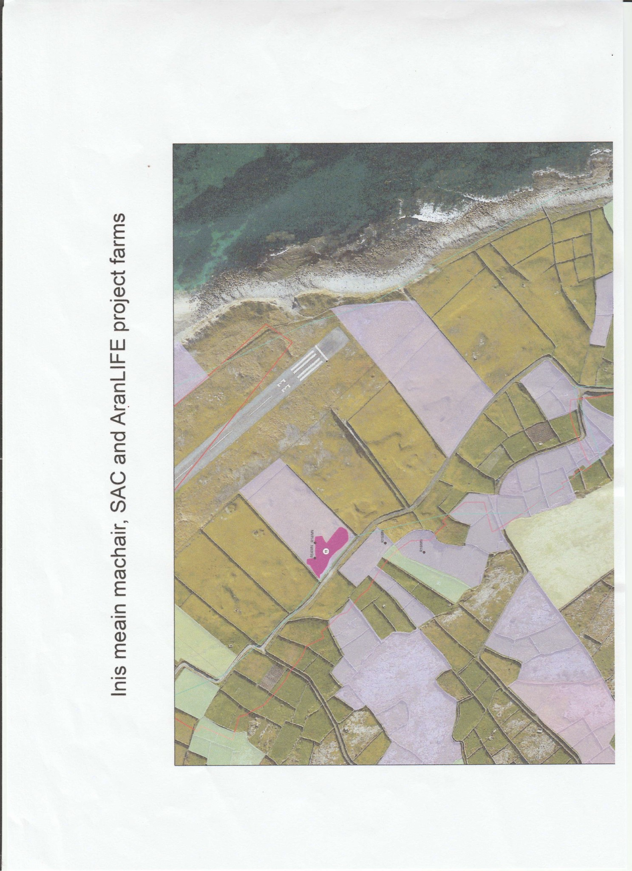

4.0 Discussion
The results of the 2015 molluscan study demonstrated that molluscs were sparse, both in terms of species richness and in biomass of individuals. This result was in keeping with the habitats present in the plots, which were barely colonized by vegetation cover and in some places had extensive bare sand. It is to be expected that lands that are poor for grazing due to lack of vegetation, land that farmers consider would benefit from improvement in fertility and vegetation growth response through seaweed application, would also not have the thatch and litter build up that most snail species require for food and shelter.

The snail species found were few, but most sites had some individuals of Helicella itala where even sparse vegetation was present. This species is adapted to sparse vegetation, it is a xerophilous species found in all kinds of dry, open habitats such as calcareous grassland and dunes. It is more likely to be lost from areas of dense vegetation cover, and the species can disappear rapidly from a site with abandonment and the cessation of grazing (Byrne et al. 2009). It is common and widespread across both islands, so an improvement in some areas of vegetation will not affect its conservation status. Similarly the so-called “wrinkled dune snail” Candidula intersecta could be expected to be present in sites with bare to sparse vegetation cover as it can tolerate bare soil and often takes refuge under rocks and stones rather than seeking out deep litter.

The other species found included the pillar snail Cochlicopa lubricella. This is one of two species of common pillar snails in dune habitats, the other being Cochlicopa lubrica. The species found in large numbers in Kilmurvey Sites 5 and 6 is C. lubricella, and this demonstrates that the habitat in these two sites had a more vegetated, thatched base than the other sites, but the habitat was not deep and damp enough to support the less tolerant C. lubrica or other damp dune grass species such as Vertigo angustior. Similarly Vallonia excentrica is one of three vallonids found in dune grasslands, and the one with the most tolerance of dry conditions. Vitrea contracta has a similar tolerance range for dry conditions. One control site in Trá Mór had 3 individuals of Trochulus hispidus, a species that is normally associated with damper conditions.

All sites treated with seaweed can therefore be considered, at this baseline stage, to be unsuitable for Vertigo angustior, and also not supportive of the range of dune molluscs that require stable damp conditions with a well developed understorey of thatch. Table 4.1 lists the species found in this baseline study along with the species found in the Kilmurvey and airport area SAC sites that include well developed V. angustior habitat (data from Moorkens & Killeen, 2011). Interestingly, 5 of the 7 species found in the current study were not found in the two SAC area sampling studies, most likely due to the fact that the SAC surveys were biased towards examination of the habitats that were most likely to contain Vertigo angustior. As the seaweed trial continues, it will be of interest to see which, if any, molluscan species can spread into the plot areas. While molluscs are known to be slow in nature, and some are very small in size, they are actually highly mobile, with smaller species being easily transported by larger invertebrates and mammals, so if habitat conditions change the mollusc fauna is normally quick to respond.

Table 4.1 species found in field sampling in Kilmurvey and Airport area components of Inishmore SAC (Moorkens & Killeen, 2011) compared with baseline species found in the seaweed trial plots.
Table 2: Molluscan composition of samples (X = present)
 | Kilmurvey  SAC | Airport  SAC | Seaweed plots
Species
Carychium tridentatum | X
Cochlicopa lubrica | X | X
Cochlicopa lubricella |  |  | X
Vertigo pygmaea | X | X
Vertigo angustior | X | X
Pupilla muscorum | X | X
Lauria cylindracea | X | X
Acanthinula aculeata | X
Vallonia costata | X
Vallonia excentrica |  |  | X
Arion intermedius | X
Punctum pygmaeum | X | X
Discus rotundatus |  |  | X
Vitrina pellucida | X
Vitrea contracta | X |  | X
Deroceras reticulatum | X
Helicella itala | X | X | X
Candidula intersecta |  |  | X
Trochulus hispidus |  |  | X
Cepaea nemoralis | X | X
Cornu aspersum |  | X
Total No. of Species | 15 | 9 | 7

6.0 References
Anderson R. (2005). An Annotated List of the Non-Marine Mollusca of Britain and Ireland Journal of Conchology 38 No 6: 607-637.
Byrne, A., Moorkens, E.A., Anderson, R., Killeen, I.J. & Regan, E.C. (2009) Ireland Red List No. 2 – Non-Marine Molluscs. National Parks and Wildlife Service, Department of the Environment, Heritage andLocal Government, Dublin, Ireland.
Moorkens, E.A. and Gaynor, K. (2003). “Studies on Vertigo angustior at a coastal site in western Ireland (Gastropoda, Pulmonata: Vertiginidae)” Heldia 5 (7): 125-134.
Moorkens, E.A. & Killeen, I.J. (2011). Monitoring and Condition Assessment of Populations of Vertigo geyeri, Vertigo angustior and Vertigo moulinsiana in Ireland. Irish Wildlife Manuals, No. 55. National Parks and Wildlife Service, Department of Arts, Heritage and Gaeltacht, Dublin, Ireland.

