 | 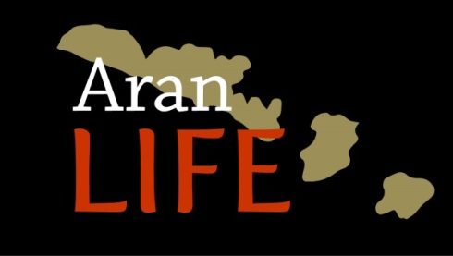 | 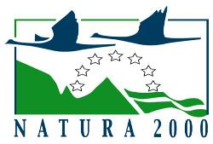

7.2.3 Suitable mineral supplements to maintain health of grazing animals on the Aran Islands.

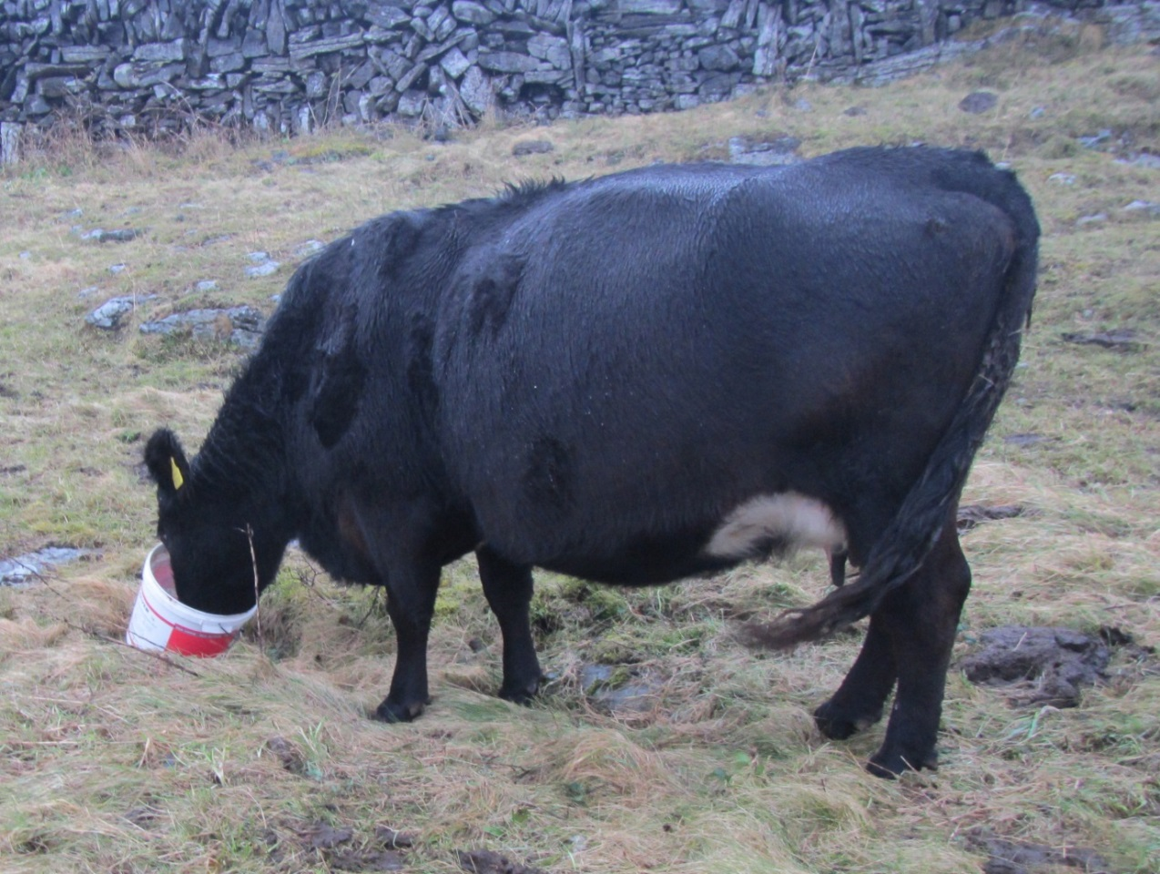

December 2018

Mineral deficiencies in Aran Island grasslands
The national Irish data for forage analysis indicate that optimal mineral nutrition of cattle and sheep on forage-based diets involves some degree of routine supplementation to ensure balanced inputs of the essential major and trace elements. The Aran Islands’ farming system, with free draining soils and winter grazing of grass with a high percentage of dead material, would indicate that mineral deficiencies are more likely. This was reflected in forage analyses taken over a two year period from 2015. Table 1 outlines the results from an analysis of forage samples taken on the Aran Islands along with levels recommended for optimal animal performance.
Table 1. Mineral analysis from Aran Forage against recommended levels.
Mineral | Aran Islands | Recommended levels for livestock
Phosphorus (%) | 0.17 | 0.3
Copper (mg kg-1) | 5.96 | 10
Selenium (mg kg-1) | 0.11 | 0.1
Cobalt (mg kg-1) | 0.03 | 0.1

Forage analysis alone cannot be used to determine deficiencies, as mineral deficiency falls into two categories. Primary deficiency, where there is insufficient levels in the forage; and secondary deficiency, where the mineral is sufficient in the forage but another mineral interferes with its absorption. Therefore, blood samples and liver biopsies can also be used to in conjunction with forage analysis to assess the mineral status of a cow. Liver samples are a more accurate indicator of mineral status but are expensive and were above the needs of the AranLIFE project.
AranLIFE project worked with the local veterinary surgeon on the islands to blood test a sample of 96 cattle to investigate the mineral status of the livestock and see if the deficiencies identified in the forage were reflected in the livestock. The original proposal was to blood test for Ca, Mg, P, Cu, Co, Se, I and Fe. However, based on forage samples and local expert knowledge, it appeared that there were adequate I and Fe levels in the forage and deficiencies were unknown. Whilst for Co, normal levels in the blood of Co/B12 are low, requiring very sensitive testing to detecting suitably. Liver tissue is the preferred option and so Co was not included in the blood sampling, but deficiency symptoms are observed in livestock on the islands. Table 2 outlines the results from the cattle tested. The samples were analysed by the DAFM Regional Veterinary Laboratories. For Se, the enzyme glutathione peroxidase (GSH-Px) is measured as it verifies true functional selenium status. P, GSH-Px, Ca and Mg were measured using colormetric methods whilst Cu was measured by Atomic Absorption Spectroscopy.
Table 2. Mineral concentrations in blood samples from livestock on the islands (samples taken August/September).
 | Phosphorous(P)  mmol/l | Selenium(GSH-Px)(Se) units/ml | Copper (Cu)  µmol/l | Calcium(Ca)  mmol/l | Magnesium(Mg)  mmol/l
No. tested | 96 | 73 | 95 | 18 | 18
Average | 2.47 | 34.7 | 10.6 | 2.39 | 1.05
Range | 1.03-3.79 | 3-136 | 6.7-19.6 | 2.06-2.57 | 0.79-1.3
Recommended* | 1.4-2.5 | 18.46-500 | 9.4-24 | 2.1-3.1 | 0.65-1.2
*https://www.agriculture.gov.ie/media/migration/animalhealthwelfare/labservice/cvrl/pathology/ClinChemRefRanges.pdf
Calcium and Magnesium were deemed to in adequate quantities. Magnesium may be required during tetany risk periods; tetany is caused by a sudden drop in magnesium blood levels of magnesium but is rarely seen on the islands. It usually occurs in high-yielding dairy cows/lactating animals in spring and autumn and is associated with decreased availability of magnesium from the diet. Stress factors, such as wet weather conditions, are contributing factors. Levels of Copper and Selenium indicated a deficiency problem within the overall livestock herd. The average value for Copper was 10.6 umol/l with a recommended range of 9.4-24umol/l. However 23 percent of 94 animals tested were below the normal range and therefore deficient in Copper. The average value of the 73 cattle tested for Selenium (GSH-Px) was 34.7 with a recommended range of 18.46-500units/ml PCV. However 43% of animals tested were below the recommended range and therefore deficient in Selenium. There were some animals deficient in phosphorus, 6 percent of the 95 animals tested were below the recommended range of 1.4-2.4mmol/l. However the overall average was 2.47mmol/l with 48% of the livestock having higher than the recommended range for Phosphorous. Phosphorous status is difficult to measure in animal tissues. Accurate sampling requires serum to be separated from the red/white blood cell clot within one to two hours of collection. Logistically, this is difficult to achieve on the islands. Whilst serum phosphorous concentrations can aid in diagnosing deficiency, with mobilization of bone phosphorous to maintain serum concentration, significant drops in serum may take weeks to develop. Longer-term phosphorous deficiency can be diagnosed post-mortem by measuring bone or bone ash phosphorous concentrations. Therefore animal blood samples may show adequate phosphate only because phosphate has moved from storage in the bones to the blood, while there is actually an underlying nutritional deficiency. Therefore with low levels of phosphorous in forage, no additional phosphorous entering the farming system, and clinical symptoms of phosphate deficiency, some form of supplementation is necessary.
From the results of the forage and blood sampling, the main mineral deficiencies likely on the islands are P, Co, Cu and Se. These results are broadly in-line with previous Irish studies; where Cu deficiency is the most common deficiency to affect beef cattle, with Co and Se deficiency being less common. However there appears to be higher levels of P, Se and Co deficiencies on Aran Islands compared to the mainland. Nationally, pastures are likely to suffer from I deficiencies, but the high I concentrations found in Aran forages are likely due to maritime influences. Based on the blood and forage results, some degree of mineral supplementation to ensure balanced inputs of the essential major and trace elements is required on the islands.
Providing required minerals through supplementation
The main methods of mineral supplementation for livestock include slow-release intraruminal boluses, feed supplementation, mineral lick, fertilisation, and additions to water supplies.
Slow release intra ruminal boluses
Intraruminal boluses are self-contained devices designed to be administered orally and remain in the reticulorumen until fully dissolved. They contain one or more trace elements and are manufactured in sizes to match the type of animal. There are existing slow release trace element boluses on the market containing I, Cu, Se and Co. These are administered orally by means of a balling gun. They are a widely used method of correcting mineral deficiencies in livestock and suitable on the islands. Whilst boluses containing phosphorous are commercially available they are not slow releasing and designed for rapidly dissolving and supplying phosphate over a short period, often immediately post calving.
Feed supplementation
Adding trace elements to feed supplements is standard practice where rations are fed indoors. Feed supplements such as purchased concentrate feeds are used on the islands but contribute a small percentage of the animals’ annual energy intake. The traditional farming system on the islands relies on building a bank of grass during the summer and grazing this grass in the winter. This removal of vegetation is important in maintaining the ecological integrity of the grassland. Therefore, supplementation should be at a level that doesn’t reduce forage intake. From the forage analysis it is evident that daily intake levels and forage energy content within an average winterage pasture is insufficient to meet the daily energy requirements of suckler cows during late pregnancy. Therefore feed supplement has a role here and should include minerals, particularly P, Co, Se and Cu. This will not meet the livestock requirements all year but offers a way of additional minerals entering the overall system. The level of feeding should reflect the condition of the cow.
Mineral licks
Molasses licks containing trace elements are a simple method of providing supplementation and are ideally suited in feeding to grazing livestock. They are not completely satisfactory because many behavioural factors influence interest and craving, and therefore not all animals will receive adequate intake. However for the islands they appear to be the best practical approach particularly for the minor trace elements. They are more problematic for major elements as the levels required are in grammes per day rather than milligrammes. Mineral blocks with a high percentage of phosphate appeared less palatable for livestock and farmers comment that the blocks remain untouched. Cows with phosphorous deficiency that are displaying pica, or depraved/abnormal appetite, may still use them so they can be beneficial. Mineral licks that include phosphorous, usually between 4-9%, have proved to be an efficient way of supplying some of the requirements of the herd..
Fertilisers
General fertilisation of grasslands for increased grass production is an efficient way of inputting phosphorous into the system which improves grass growth and meets the mineral requirements of the grazing animal. As a result in Ireland, P deficiency in cows is rare, due to routine use of phosphate fertiliser. Fertilisation of grasslands is rare on the islands and a notifiable action within the Special Areas of Conservation. However grasslands with a low level of soil P are associated with the most species-rich and valuable plant community assemblages (Critchley et al. 2002), with levels of phosphate in the soil below 5mg/100g necessary to give highest levels of plant diversity Janssens et al. (1998). Therefore where the intention of work is to maintain and enhance species rich grasslands, applying fertiliser to the swards would be detrimental and unadvisable.
Water supply
Soluble Liquid Phosphorous solution for administration via the animals’ drinking water is commercially available and can be added directly to drinking troughs daily. Water for livestock on the islands comes from rain harvesting (with spillage of the excess water collected in the troughs) and therefore it is impossible to regulate the supply of water and phosphorous, limiting the effectiveness of this method.
Conclusion
Mineral deficiency is an issue for animal health in grazing livestock of the Aran Islands. This is due to the low status of some minerals in the vegetation and the lack of additional inputs to the system. The trace element deficiencies for Co, Cu and Se, can be rectified with similar approaches taken elsewhere in Ireland, i.e. slow release intra ruminal boluses, mineral licks or feed supplementation. Supplying additional phosphate is more problematic due to the high levels required compared to the trace elements, and the detrimental effect of fertilising pasture with phosphorous The simplest approach is to ensure any supplementation contains some level of phosphorous, only mineral licks with a minimum 5% phosphate should be used as per the manufactures instructions. Further work is required to find a suitable delivery mechanism and should form part of the work following AranLIFE.
Footnote
Mineral supplements containing the deficient nutrients were feed to livestock over a two year period. 25 cattle fed the supplements were blood tested to see if any improvement in mineral status was visible. The average Selenium level rose from 34.7(GSH-Px)(Se) units/ml with 43% of cattle deficient to 55.4 with only 12% of cattle deficient whilst copper levels rose from 10.6 umol/l with 23% cattle deficient to 11.6 with 7% cattle still deficient. Whilst the numbers retested were lower, the results are positive indicating the supplementation was successful and the use mineral supplementation is continuing due to positive outcomes.

References
Aitken, P. (2015). Trace mineral testing in cattle: where and what to look for. https://www.vettimes.co.uk/app/uploads/wp-post-to-pdf-enhanced-cache/1/trace-mineral-testing-in-cattle-where-and-what-to-look-for.pdf
Critchley, C.N.R., Chambers, B.J., Fowbert, J.A., Sanderson, R.A., Bhogal, A., Rose, S.C. (2002) Association between lowland grassland plant communities and soil properties. Biol Conserv 105:199–215
Grace, N.D., Knowles S. (2012) Trace Element Supplementation of Livestock in New Zealand: Meeting the Challenges of Free-Range Grazing Systems Published online 2012 Dec 20. Vet Med Int. 2012
Herdt T. H., and Hoff B. (2011). The use of blood analysis to evaluate trace mineral status in ruminant livestock, Vet Clin North Am: Food Anim Pract 27(2): 255-283.
Janssens, F., Peeters, A., Tallowin, J.R.B., Bakker, J.P., Bekker, R.M., Fillat, F. & Oomes, M.J.M. (1998). Relationship between soil chemical factors and grassland biodiversity. Plant and Soil, 202, 69-78.

