7.2.2 Report for AranLIFE on the mineral deficiencies affecting performance from grazing livestock.

(Forage quality of semi natural grasslands of the Aran Islands.)
  - Louise Duignan, James Moran, John Finn, Daire Ó hUallacháin

May 2018

Report on the mineral deficiencies affecting performance from grazing livestock.
The mineral concentrations in Aran Islands’forages
Seventy six forage samples were collected between March 2015 and January 2017 and analysed for dietary minerals, i.e. P, Mn, Ca, Na, K, Cl, Mg, Cu, Zn, Se, Co, I (Inductively Coupled Plasma – Mass Spectrometry), during May 2015 and January 2016. The analytical results are detailed in Table 1. Two samples were excluded due to soil contamination. Full analysis details are listed in Appendix 1.
Table 1. Average mineral concentrations found Aran Islands’ forages.
 |  | Total | Summer grazing | Winter grazing
Macrominerals | Phosphorus (%) | 0.17 | 0.28 | 0.12
 | Magnesium (%) | 0.26 | 0.24 | 0.27
 | Calcium (%) | 0.77 | 0.76 | 0.78
 | Sodium (%) | 0.46 | 0.55 | 0.42
 | Potassium (%) | 0.96 | 1.24 | 0.83
 | Chloride (%) | 0.76 | 1.06 | 0.63
 | CAB (mEq kg-1) | 300.86 | 278.61 | 310.90
Microminerals | Manganese (mg kg-1) | 72.87 | 34.90 | 90
 | Copper (mg kg-1) | 5.96 | 7.39 | 5.31
 | Zinc (mg kg-1) | 27.41 | 30.16 | 26.17
 | Selenium (mg kg-1) | 0.11 | 0.08 | 0.12
 | Cobalt (mg kg-1) | 0.03 | 0.02 | 0.03
 | Iodine (mg kg-1) | 2.69 | 3.05 | 2.52
Antagonists | Iron (mg kg-1) | 84.35 | 92.83 | 80.53
 | Aluminium (mg kg-1) | 37.11 | 35.83 | 37.69
 | Molybdenum (mg kg-1) | 0.97 | 1.07 | 0.92
 | Sulphur (%) | 0.22 | 0.24 | 0.21
 | Lead (mg kg-1) | 0.20 | 0.17 | 0.22

The mineral analyses data indicate that the forages are seasonally deficient throughout the year in P, Cu, Se, Co and Zn (e.g. see selected mineral concentrations in Figure 1). Overall there were moderate to high levels of Ca, Mg, K, Mn and I. Very high levels of Na and Cl were recorded in the forages. There were many imbalances of major- and trace elements (e.g. Ca:P, Zn:Cu, Cu:Mo, Fe:Zn).

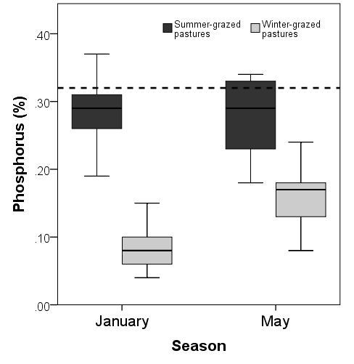 | 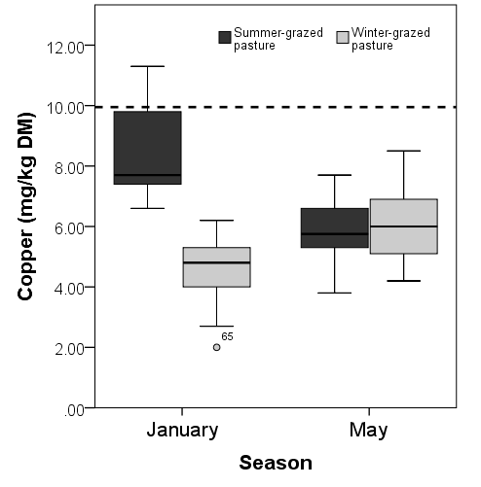
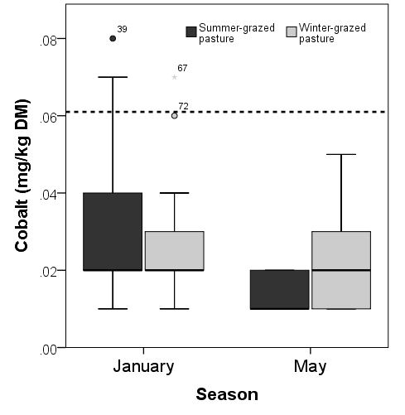 | 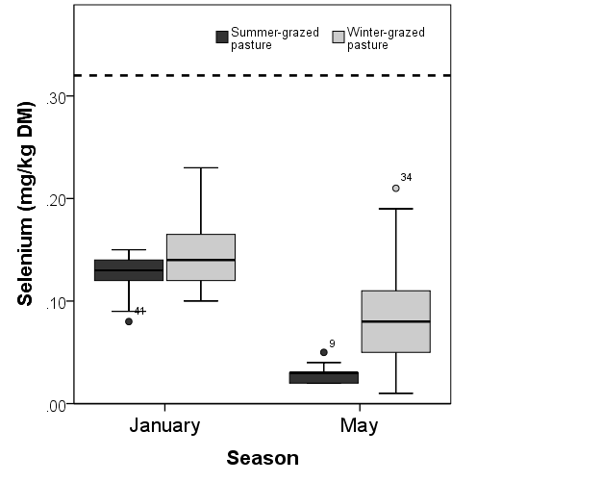
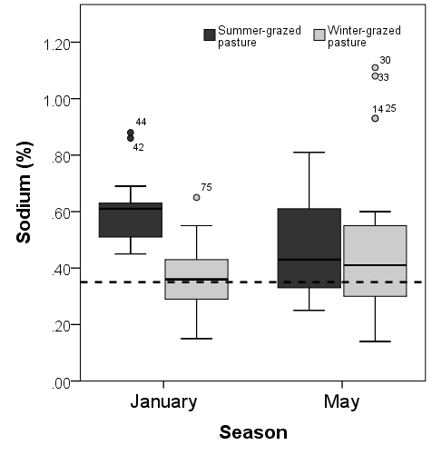 | 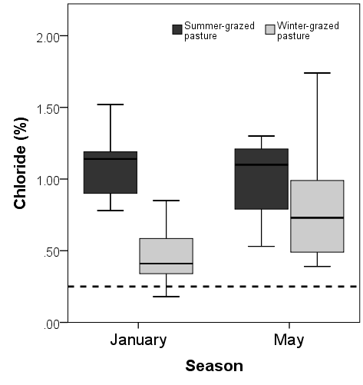
Figure 1: Seasonal (January versus May) comparison of mineral concentrations in SGP and WGP forages. The dashed horizontal lines denote required dietary mineral concentrations for livestock nutrition.

Mineral requirements for grazing livestock
Beef cattle require at least 17 important minerals (NRC, 2000) for optimal growth, disease resistance and reproduction. Minerals essential to cattle nutrition are classified as either macrominerals (>100 ppm) or microminerals (<100 ppm). The major elements include calcium (Ca), phosphorus (P), magnesium (Mg) and sodium (Na). Potassium (K) and sulphur (S) can act as antagonists to other minerals and interrupt their bioavailability. The trace elements include cobalt (Co), copper (Cu), iodine (I), manganese (Mn), selenium (Se) and zinc (Zn). Molybdenum (Mo) and iron (Fe) are powerful Cu-antagonists.
The results of the mineral analysis of the forage samples for the islands are compared to the recommended mineral requirements in beef diets (Table 2; NRC, 2000).
Table 1. Mineral requirements and maximum tolerable concentrations.
 |  | Growing and Finishing Cattle | Cow |  |  | Maximum Tolerable Concen-tration
 |  |  | Gestating | Early Lactation | Dry
Macrominerals | Phosphorus (%) | 0.3 | 0.19 | 0.21-0.22 | 0.16 | —
 | Magnesium (%) | 0.1 | 0.12 | 0.2 | 0.12 | 0.4
 | Calcium (%) | 0.45 | 0.31 | 0.31-0.34 | 0.18 | —
 | Sodium (%) | 0.06-0.08 | 0.06-0.08 | 0.1 | 0.06-0.08 | —
 | Potassium (%) | 0.6 | 0.6 | 0.7 | 0.6 | 3
Microminerals | Manganese (mg kg⁻¹) | 20 | 40 | 40 | 40 | 1000
 | Copper (mg kg⁻¹) | 10 | 10 | 10 | 10 | 100
 | Zinc (mg kg⁻¹) | 30 | 30 | 30 | 30 | 500
 | Selenium (mg kg⁻¹) | 0.1 | 0.1 | 0.1 | 0.1 | 2
 | Cobalt (mg kg⁻¹) | 0.1 | 0.1 | 0.1 | 0.1 | 10
 | Iodine (mg kg⁻¹) | 0.5 | 0.5 | 0.5 | 0.5 | 50
Antag-onists | Iron (mg kg⁻¹) | 50 | 50 | 50 | 50 | 1000
 | Aluminium (mg kg⁻¹) | — | — | — | — | 1000
Source: Adapted from Table 5.1 and 5.2 and Chapter 9 (P and Ca) in ‘Nutrient Requirements of Beef Cattle’. Seventh Revised Edition: Update 2000. Washington, D.C.: National Academy of Sciences
Phosphorus: The Island’s pasturelands are seasonally deficient in P (mean of 0.16% ± S.E. 0.01). Grasslands with a low level of soil P are associated with the most species-rich and valuable plant community assemblages (Critchley et al. 2002); the P mineral status of forages recorded on the islands likely reflect a low soil nutrient status. Phosphorus concentrations in forages are also depleted with increased stage of maturity of the vegetation community, soil low-moisture conditions, and winter-time grazing. Livestock diets containing less than 0.25% P may not be sufficient for optimal rumen microbe activity (Satter et al. 2005).
Calcium and Magnesium: Levels of Ca in the forages were high (Average 0.76% DM ± S.E. 0.03). High forage Ca content very likely reflect Ca-rich calcareous soils. In general, high concentrations of dietary calcium are tolerated well by cattle and levels are not so high as to interrupt Mn, Zn and P absorption. However, Ca concentrations > 0.4% DM may lead to Ca imbalances pre-partum. Ca imbalances pre-partum may be compounded if Magnesium levels are not adequate and post-parturient hypocalcemia may occur. Magnesium levels on the islands were found in low to (mainly) marginal concentrations (Average 0.26% DM ± S.E. 0.01). Regular dietary supplementation with Mg may be required if the herd has a history of milk fever.
Calcium Phosphorus ratio: In addition to the amount of Ca and P in the diet, Ca and P ratios are also important. Calcareous grasslands a very high ratio of Calcium to Phosphate may be detrimental to proper utilization.
Given the low P concentrations and high Ca:P ratios in winter-grazed pastures recorded in Winter (Table 3), a dietary P supplement should be considered.

Table 3. Distribution of forage sample results across different Ca:P ratios in each of May and January, and for both summer- (SGP) and winter-grazed (WGP) pastures.
 | SGP % |  | WGP %
Ca:P | May` | January | May | January
1.17:1 |  | 4
1.4:1 to 2:1 |  | 28
2:1 to 8:1 | 44 | 24 | 45 | 31
>8:1 |  |  | 2 | 22
Ideal: 1.75:1; Acceptable range 1.1:1 to 8:1

Potassium, Calcium and Magnesium ratio: Low K/(Ca+Mg) ratios (<2.2; Table 4) across all forage samples suggest minimal tetany risk at time of sampling (however, sampling did not occur during the first flush of fast-growing spring growth).

Table 4. Distribution of forage sample results across different K/(Ca+Mg) ratios in each of May and January, and for both summer- (SGP) and winter-grazed (WGP) pastures.
 | SGP % |  | WGP %
K/(Ca+Mg) | May` | January | May | January
0.29:1 to 2.17:1 | 44 | 56 | 35 | 65
Target ratio for animal nutrition is <2.2:1

Iodine: Forage I concentrations were found in high levels (Average 2.52 mg kg⁻¹ ± S.E 0.16), but not so high as to cause toxicity (>50 mg kg⁻¹). National pastures are likely suffer from I deficiencies; the high concentrations found in the forages are likely due to maritime influences.
Sodium: Usually an issue for mineral nutrition for grazing cattle on the mainland, Na is not deficient in the forages (Average 0.45% ± S.E 0.02). Additional Na should be minimized in any supplementary feeding programme, especially were water availability may be limited.

Zinc, Molybdenum and Copper: Zinc (Zn) and molybdenum (Mo) are powerful copper(Cu)-antagonists.

Zn:Cu ratio: High Zn inhibits Cu absorption, the forages have low concentrations of Zn (Average 27.4 mg kg⁻¹ DM ± S.E. 0.68), however Zn:Cu ratios are high in the majority of samples further compounding existing Cu deficiencies (Table 5).

Table 5. Distribution of forage sample results across different Zn:Cu ratios in each of May and January, and for both summer- (SGP) and winter-grazed (WGP) pastures.
 | SGP % |  | WGP %
Zn:Cu | May` | January | May | January
2:1 to 3:1 | 4 | 8
3:1 to 4:1 | 8 | 16 | 8 | 2
>4:1 | 32 | 32 | 39 | 51
Target ratio for animal nutrition is from 2:1 to 3:1

Copper and Molybdenum ratio: The ratio of Cu to Mo in the diet should be at least 3:1 to prevent Cu deficiency or Mo toxicity. Ideally between 4:1 and 10:1 to minimize risk. 17% of samples had Cu:Mo ratios below 4:1 (Table 6), and are therefore considered suspect to induce Cu deficiency due to Mo antagonism. Only 4% of samples had Sulphur levels > 0.25% DM in conjunction with high Cu:Mo ratios - Mo-induced Cu deficiency is likely in these samples
Table 6. Distribution of forage sample results across different Cu:Mo ratios in each of May and January, and for both summer- (SGP) and winter-grazed (WGP) pastures.
 | SGP % |  | WGP %
Cu:Mo | May` | January | May | January
>3:1 | 4 | 0 | 2 | 6
3:1 to 4:1 | 8 | 4 | 4 | 8
4:1 to 10:1 | 28 | 32 | 29 | 37
>10:1 | 4 | 20 | 12 | 2
Minimum ratio 3:1; Ideal range 4:1 to 10:1

It should be observed that some breeds of cattle may have higher Copper requirements than others. Large framed breeds (Simmental and Charolais) cows and their calves had lower plasma copper concentrations than intermediate-framed breeds (Angus) cattle when fed the same diets (Ward et al., 1995).
Iron and Zinc ratio: High levels of Fe can decrease Zn absorption. Absorption of Zn decreases once the ratio of Fe to Zn exceeds 2:1. Of the islands’ forages sampled in this study, 69% had high Fe:Zn ratios (Table 7).
Table 7. Distribution of forage sample results across different Fe:Zn ratios in each of May and January, and for both summer- (SGP) and winter-grazed (WGP) pastures.
 | SGP % |  | WGP %
Fe:Zn | May` | January | May | January
<2:1 | 42 | 8 | 12 | 10
2:1 to 4:1 | 0 | 25 | 32 | 32
>4:1 | 4 | 21 | 4 | 10
Target ratio for animal nutrition is <= 2:1

References
Critchley CNR, Chambers BJ, Fowbert JA, Sanderson RA, Bhogal A, Rose SC (2002) Association between lowland grassland plant communities and soil properties. Biol Conserv 105:199–215
National Research Council (2000). Nutrient Requirements of Beef Cattle: Seventh Revised Edition: Update 2000. Washington, DC: The National Academies Press.
Satter, L. D., Klopfenstein, T. J., Erickson, G. E., & Powell, J. M. (2005). Phosphorus and dairy/beef nutrition. Faculty Papers and Publications in Animal Science, 549.
Ward, J. D., Spears, J. W., & Gengelbach, G. P. (1995). Differences in copper status and copper metabolism among Angus, Simmental, and Charolais cattle. Journal of animal science, 73(2), 571-577.

Appendix 1. Mineral analysis Mean ± (s.e.m), range of mineral concentrations for Aran Islands’ forages.
 |  | All sites |  |  | Summer |  |  | Winter
 |  | Average | SEM | Range | Average | SEM | Range | Average | SEM | Range
Macrominerals | Phosphorus (%) | 0.17 | 0.01 | 0.04 - 0.37 | 0.28 | 0.01 | 0.18 - 0.37 | 0.12 | 0.01 | 0.04 - 0.24
 | Magnesium (%) | 0.26 | 0.01 | 0.17 - 0.46 | 0.24 | 0.01 | 0.17 - 0.40 | 0.27 | 0.01 | 0.18 - 0.46
 | Calcium (%) | 0.77 | 0.04 | 0.35 - 1.65 | 0.76 | 0.06 | 0.42 - 1.55 | 0.78 | 0.04 | 0.35 - 1.65
 | Sodium (%) | 0.46 | 0.02 | 0.14 - 1.11 | 0.55 | 0.03 | 0.25 - 0.88 | 0.42 | 0.03 | 0.14 - 1.11
 | Potassium (%) | 0.96 | 0.05 | 0.26 - 2.19 | 1.24 | 0.08 | 0.74 - 2.19 | 0.83 | 0.06 | 0.26 - 1.63
 | Chloride (%) | 0.76 | 0.04 | 0.18 - 1.74 | 1.06 | 0.05 | 0.53 - 1.52 | 0.63 | 0.05 | 0.18 - 1.74
 | CAB (mEq kg⁻¹) | 300 | 12.9 | 142 - 619 | 278.6 | 22.48 | 142-502 | 310.9 | 15.81 | 152-619
Microminerals | Manganese (mg kg⁻¹) | 72.87 | 6.47 | 13.6 - 308.2 | 34.90 | 3.02 | 13.6 - 72.7 | 90.00 | 8.25 | 24.6 - 308.2
 | Copper (mg kg⁻¹) | 5.96 | 0.21 | 2.00 - 11.30 | 7.39 | 0.40 | 3.80 - 11.30 | 5.31 | 0.19 | 2.00 - 8.50
 | Zinc (mg kg⁻¹) | 27.41 | 0.69 | 15.4 - 49.7 | 30.16 | 1.40 | 20.0 - 49.7 | 26.17 | 0.71 | 15.40 - 39.0
 | Selenium (mg kg⁻¹) | 0.11 | 0.01 | 0.01 - 0.23 | 0.08 | 0.01 | 0.02 - 0.15 | 0.12 | 0.01 | 0.01 - 0.23
 | Cobalt (mg kg⁻¹) | 0.03 | 0.00 | 0.01 - 0.10 | 0.02 | 0.00 | 0.01 - 0.08 | 0.03 | 0.00 | 0.01 - 0.10
 | Iodine (mg kg⁻¹) | 2.69 | 0.24 | 0.45 - 14.94 | 3.05 | 0.68 | 0.45 - 14.94 | 2.52 | 0.16 | 0.64 - 5.92
Antagonists | Iron (mg kg⁻¹) | 84.35 | 6.19 | 33.0-306 | 92.83 | 15.11 | 33-306 | 80.53 | 5.90 | 40. - 225.
 | Aluminium (mg kg⁻¹) | 37.11 | 4.01 | 7.0- 174 | 35.83 | 8.84 | 7.0 - 174 | 37.69 | 4.31 | 8.00 - 146
 | Molybdenum (mg kg⁻¹) | 0.97 | 0.06 | 0.15 - 3.64 | 1.07 | 0.16 | 0.15 - 3.64 | 0.92 | 0.05 | 0.39 - 2.00
 | Sulphur (%) | 0.22 | 0.01 | 0.12 - 0.37 | 0.24 | 0.01 | 0.16 - 0.32 | 0.21 | 0.01 | 0.12 - 0.37
 | Lead (mg kg⁻¹) | 0.20 | 0.01 | 0.00 - 0.70 | 0.17 | 0.03 | 0.00 - 0.50 | 0.22 | 0.02 | 0.00 - 0.70
Sample numbers |  | 74 |  |  | 23 |  |  | 51

